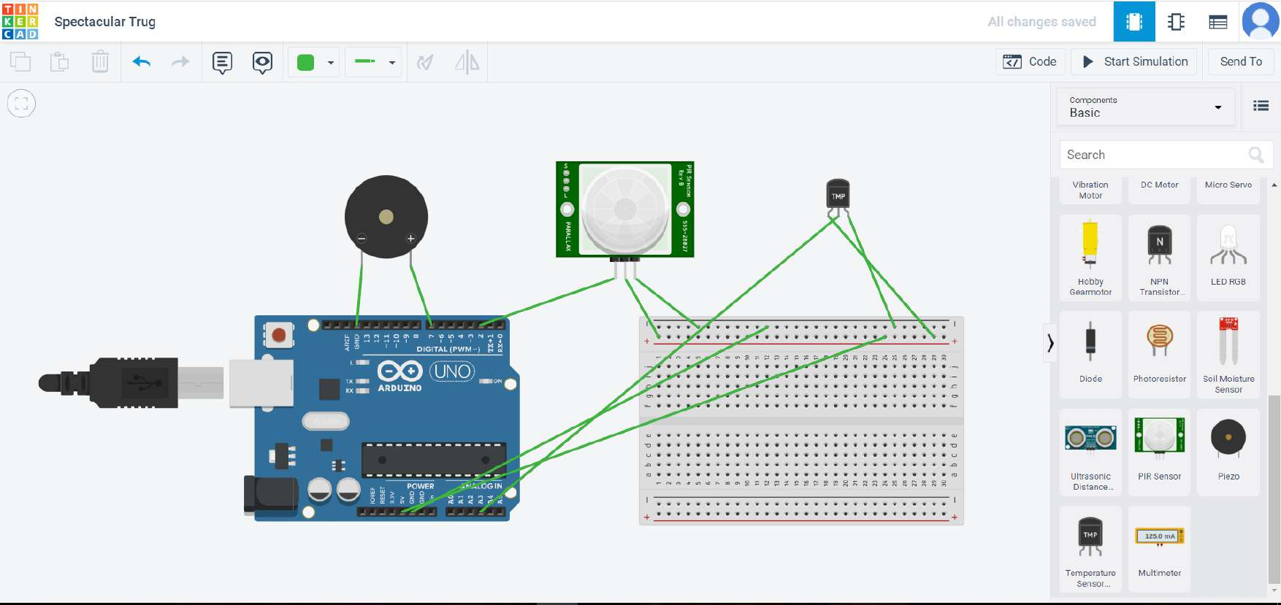

int pinSensor =2;
int pinBuzzer =7;
int pirSensor =0;
float sensor=A3;
float analog;
float tempv;
float tempc;
float tempf;
void setup()
{
pinMode(pinSensor, INPUT);
pinMode(sensor, INPUT);
pinMode(pinBuzzer, OUTPUT);
Serial.begin(9600);
}
void loop()
{
analog=analogRead(sensor);
tempv=analog*5.0/1023;
tempc=(tempv-0.5)*100.0;
tempf=((tempc*9.0)/5.0)+32.0;
Serial.print("temperature:");Serial.println(tempc);
if (tempc >=60)
{
tone(pinBuzzer, 200, 100);
}
delay(100);
pirSensor = digitalRead(pinSensor);
if (pirSensor == HIGH)
{
tone(pinBuzzer, 1000, 500);
}
delay(100);
}

