IBM

Smart Home Automation Assignment – 1

Tinker Cad:
https://www.tinkercad.com/things/69M7VB2bVTE-neat-tumelo/editel?tenant=circuits

Circuit Diagram:
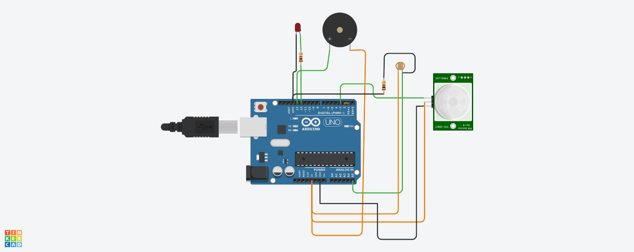

Done By: ArunPriyan.K

