**Assignment -1**

Python Programming

|  |  |
| --- | --- |
| Assignment Date | 1 September 2022 |
| Student Name | Tharika Jayaraj |
| Student Roll Number | 113219071045 |
| Maximum Marks | 2 Marks |

**Question-1:**

1. Split this string

|  |
| --- |
| **Solution:** |
|  | s = "Hi there Sam!" |
|  | print(s.split()) |
|  |  |

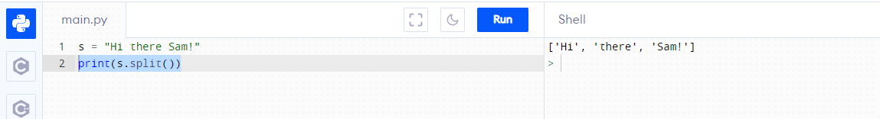

**Question-2:**

2. Use .format() to print the following string.

Output should be: The diameter of Earth is 12742 kilometers.

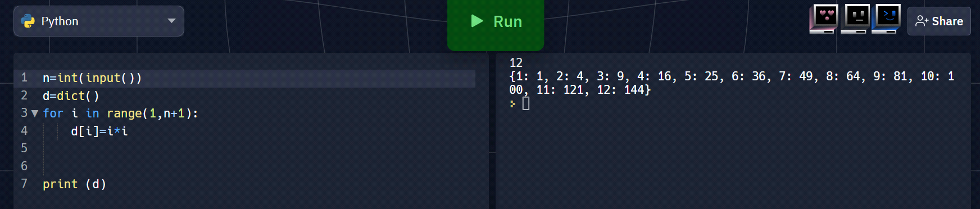

**Question-3:**

3. In this nest dictionary grab the word "hello"

|  |  |
| --- | --- |
| **Solution:** | |
|  | d = {'k1':[1,2,3,{'tricky':['oh','man','inception',{'target':[1,2,3,'hello']}]}]} | |
|  | print(d['k1'][3]['tricky'][3]['target'][3]) | |
|  |  | |

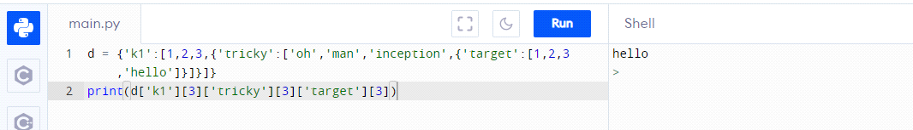

**Question-4:**

4.1 Create an array of 10 zeros?

4.2 Create an array of 10 fives?

|  |
| --- |
| **Solution:** |
|  | import numpy as np |
|  | print(np.zeros(10)) |
|  |  |

|  |
| --- |
| **Solution:** |
|  | import numpy as np |
|  | print(np.ones(10)*5)) |
|  |  |

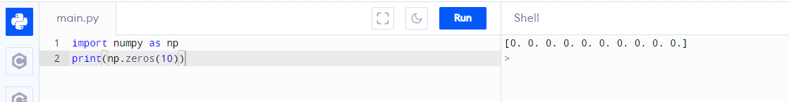

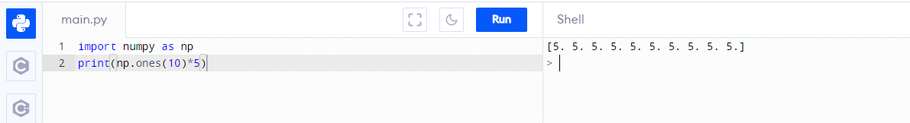

**Question-5:**

5. Create an array of all the even integers from 20 to 35

|  |
| --- |
| **Solution:** |
|  | import numpy as np |
|  | print(np.arange(20,35,2)) |
|  |  |

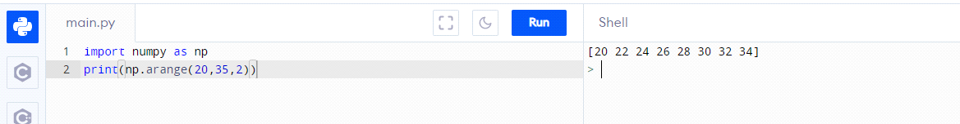

**Question-6:**

6. Create a 3x3 matrix with values ranging from 0 to 8

|  |
| --- |
| **Solution:** |
|  | import numpy as np |
|  | print(np.arange(0,9).reshape(3,3))) |
|  |  |

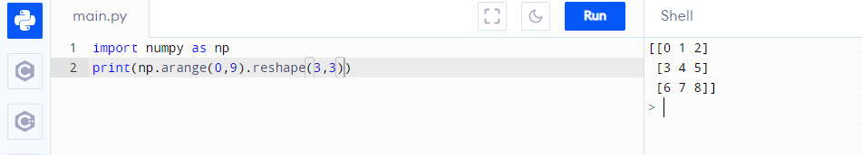

**Question-7:**

7. Concatinate a and b

a = np.array([1, 2, 3]), b = np.array([4, 5, 6])

|  |
| --- |
| **Solution:** |
|  | import numpy as np |
|  | a = np.array([1, 2, 3]) |
|  | b = np.array([4, 5, 6]) |
|  | print(np.concatenate((a,b))) |
|  |  |

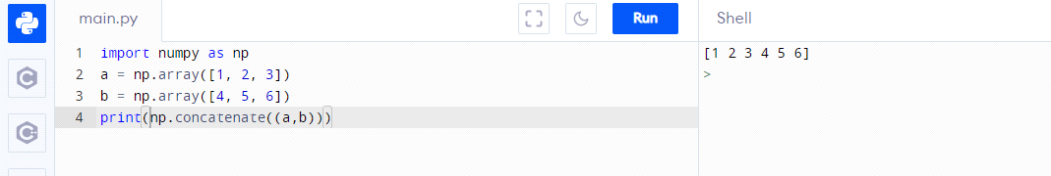

**Question-8:**

8. Create a dataframe with 3 rows and 2 columns

|  |
| --- |
| **Solution:** |
|  | import pandas as pd |
|  | data = {'col_1': [6,1,2], |
|  | 'col_2': [5,3,8], |
|  | } |
|  | df=pd.DataFrame(data) |
|  | print(df) |

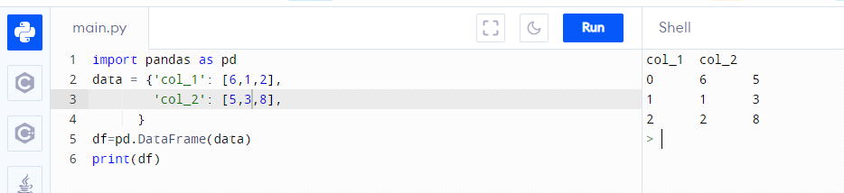

**Question-9:**

9. Generate the series of dates from 1st Feb, 2023 to 10th March, 2023

|  |
| --- |
| **Solution:** |
|  | import pandas as pd |
|  | date=pd.date_range(start='01.02.2023',end='10.03.2023') |
|  | print(date) |

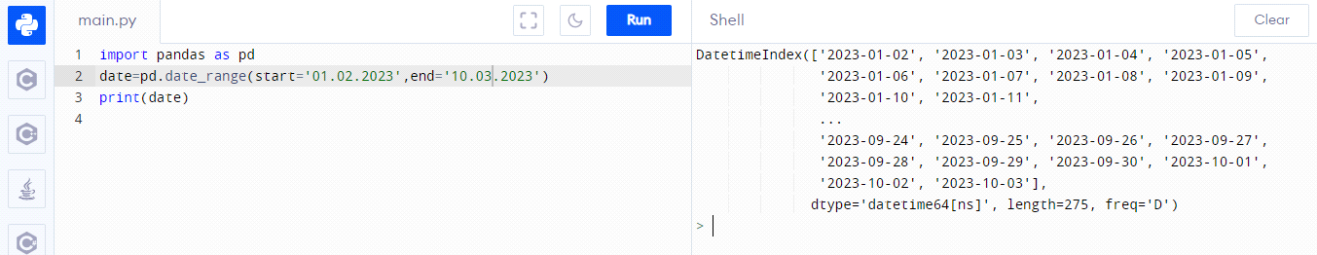

**Question-10:**

**10. Create 2D list to DataFrame**

**lists = [[1, 'aaa', 22], [2, 'bbb', 25], [3, 'ccc', 24]]**

|  |
| --- |
| **Solution:** |
|  | import pandas as pd |
|  | lists = [[1, 'aaa', 22], [2, 'bbb', 25], [3, 'ccc', 24]] |
|  | df=pd.DataFrame(lists) |
|  | print(df) |

