**ASSIGNMENT-03**

**Build CNN Model for Classification Of Flowers**

|  |  |
| --- | --- |
| **Assignment Date** | 5 October 2022 |
| **Student Name** | K.S.Naveen kumar |
| **Student Roll Number** | 113219071025 |
| **Maximum Marks** | 2 Marks |

QUESTION 1:

Download the Dataset

Dataset is downloaded and uploaded

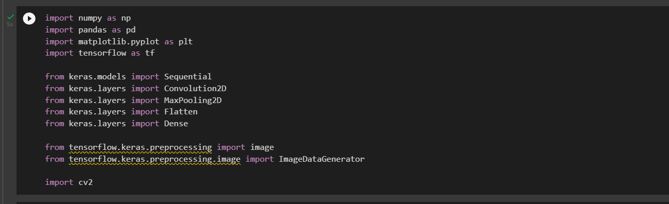

QUESTION 2:

Image Augmentation

data_path **=** '/content/drive/MyDrive/CNN/flowers'

batch_size **=** 32

target_size **=** (64, 64)

train_datagen **=** ImageDataGenerator(rescale**=**1.**/**255,

shear_range**=**0.2,

zoom_range**=**0.2,

width_shift_range**=**0.1,

height_shift_range**=**0.1,

horizontal_flip**=True**,

validation_split**=**0.2)

test_datagen **=** ImageDataGenerator(rescale**=**1. **/** 255, validation_split**=**0.2)

X_train **=** train_datagen**.**flow_from_directory(data_path,

target_size**=**target_size,

batch_size**=**batch_size,

subset**=**"training",

class_mode **=** 'categorical')

X_test **=** test_datagen**.**flow_from_directory(data_path,

target_size**=**target_size,

batch_size**=**batch_size,

subset**=**"validation",

class_mode**=**'categorical')

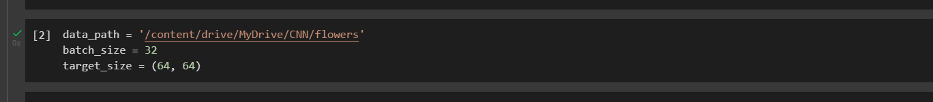

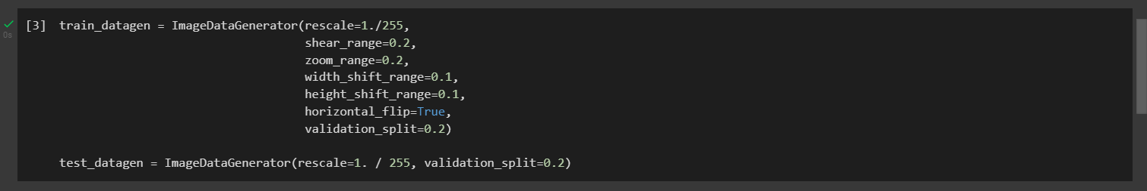

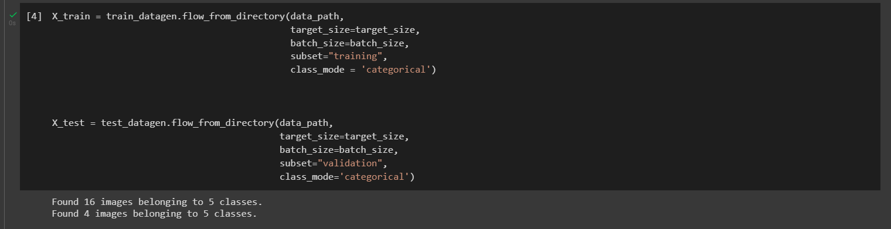

QUESTION 3:

Create Model

model **=** Sequential()

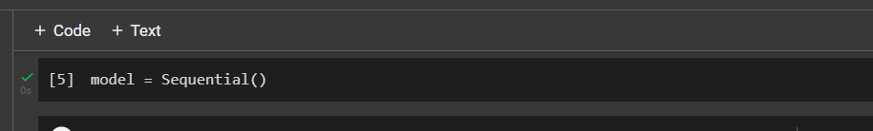

QUESTION 4:

Add Layers (Convolution,MaxPooling,Flatten,Dense-(Hidden Layers),Output

model**.**add(Convolution2D(32, (3, 3), input_shape**=**(64, 64, 3), activation**=**'relu'))

model**.**add(MaxPooling2D(pool_size**=**(2, 2)))

model**.**add(Convolution2D(32, (3, 3), activation**=**'relu'))

model**.**add(MaxPooling2D(pool_size**=**(2, 2)))

model**.**add(Convolution2D(64, (3, 3), activation**=**'relu'))

model**.**add(MaxPooling2D(pool_size**=**(2, 2)))

model**.**add(Flatten())

model**.**add(Dense(units**=**64, activation**=**'relu'))

model**.**add(Dense(units**=**5, activation**=**'softmax'))

model**.**summary()

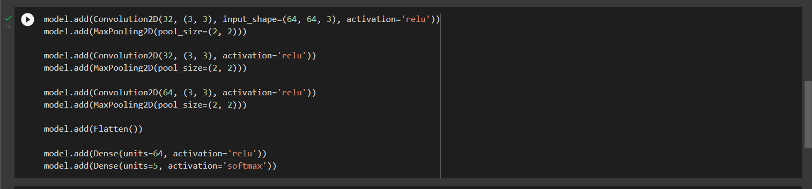

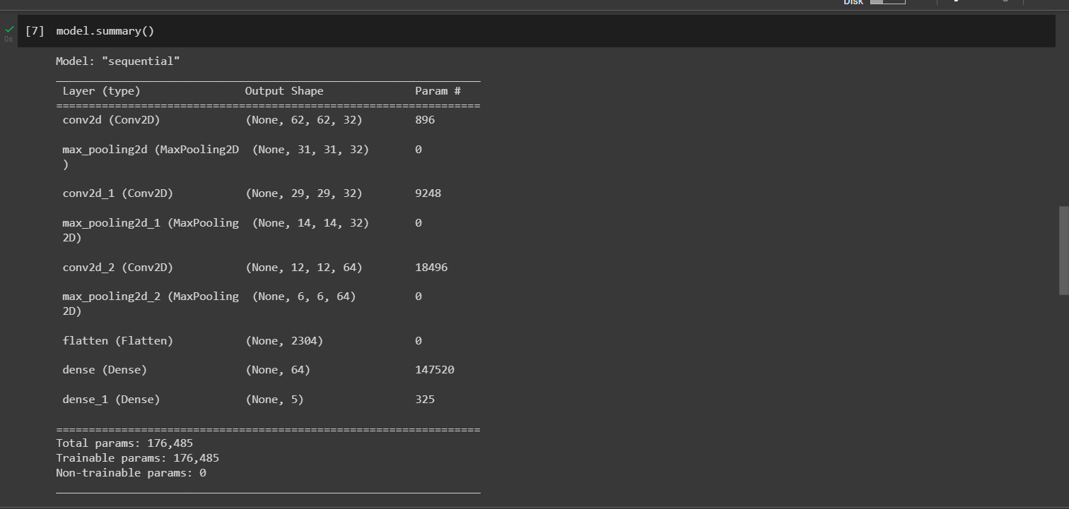

QUESTION 5:

Compile the Model

model**.**compile(optimizer**=**'adam', loss**=**'categorical_crossentropy', metrics**=**['accuracy'])

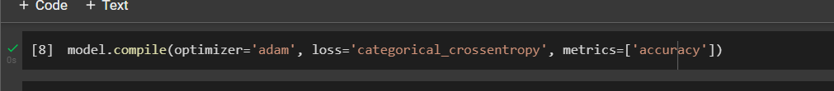

QUESTION 6:

Fit the model

model**.**fit(X_train, steps_per_epoch**=**100, epochs**=**20)

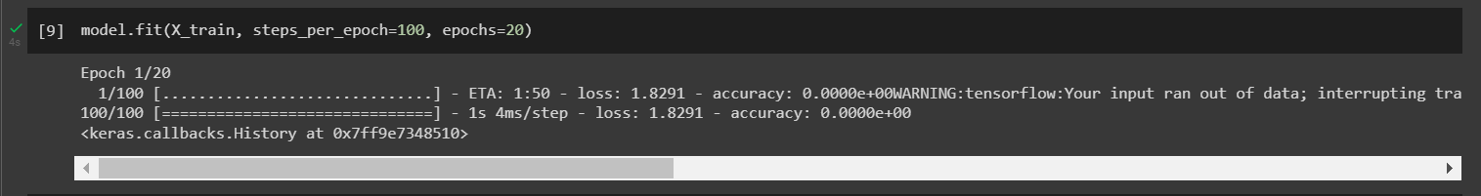

QUESTION 7:

Save the Model

model**.**save("model.h5")



QUESTION 8:

Test the Model

**def** predict():

img **=** image**.**load_img("/content/drive/MyDrive/CNN/flowers/rose/118974357_0faa23cce9_n.jpg", target_size**=**target_size)

x **=** image**.**img_to_array(img)

x **=** tf**.**expand_dims(x,0)

labels **=** ['daisy', 'dandelion', 'rose', 'sunflower', 'tulip']

pred **=** model**.**predict(x)

prediction **=** labels[np**.**argmax(pred[0])]

print(f'The given image is a {prediction}')

plt**.**imshow(plt**.**imread("/content/drive/MyDrive/CNN/flowers/rose/118974357_0faa23cce9_n.jpg"))

plt**.**axis('off')

plt**.**show()

predict()

