**Assignment -1**

Python Programming

|  |  |
| --- | --- |
| Assignment Date | 17 September 2022 |
| Student Name | Angalappan P |
| Student Roll Number | 113219071002 |
| Maximum Marks |  |

# **Basic Python**

## **1. Split this string**

s = "Hi there Sam!"

Solution :

s.split(" ")

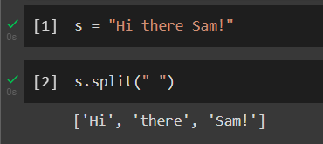

## **2. Use .format() to print the following string.**

## **Output should be: The diameter of Earth is 12742 kilometers.**

planet = "Earth"

diameter = 12742

Solution :

print("The diameter of {} is {} kilometers.".format(planet,diameter))

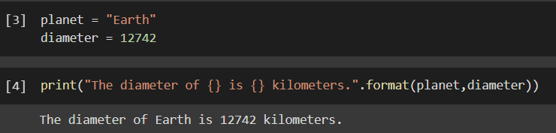

## **3. In this nest dictionary grab the word "hello"**

d = {'k1':[1,2,3,{'tricky':['oh','man','inception',{'target':[1,2,3,'hello']}]}]}

Solution :

d['k1'][3]['tricky'][3]['target'][3]

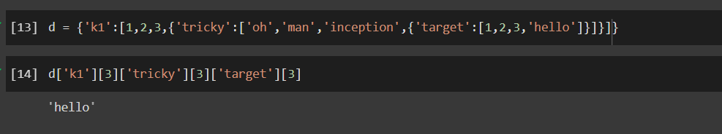

## **Numpy**

## **4.1 Create an array of 10 zeros?**

Solution :

import numpy as np

x=np.zeros(10)

print(x)

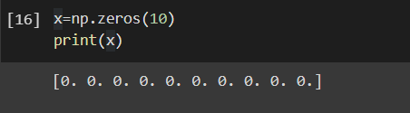

## **4.2 Create an array of 10 fives?**

Solution :

import numpy as np

x=np.zeros(10)*5

print(x)

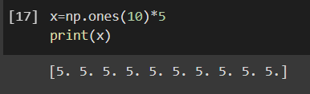

## **5. Create an array of all the even integers from 20 to 35**

Solution :

import numpy as np

x=np.arange(20,36,2)

print(x)

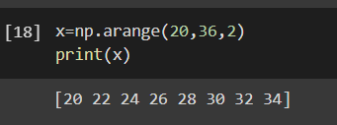

## **6. Create a 3x3 matrix with values ranging from 0 to 8**

Solution :

import numpy as np

x=np.arange(0,9).reshape(3,3)

print(x)

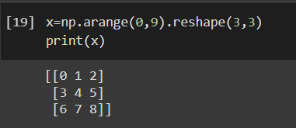

## **7. Concatenate a and b**

a = np.array([1, 2, 3]), b = np.array([4, 5, 6])

Solution :

import numpy as np

a=np.array([1,2,3])

b=np.array([4,5,6])

c=np.concatenate((a,b))

print(c)

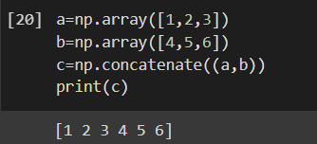

## **Pandas**

## **8. Create a dataframe with 3 rows and 2 columns**

Solution :

import pandas as pd

df={'a':[1,2,3], 'b':[4,5,6]}

y=pd.DataFrame(df)

print(y)

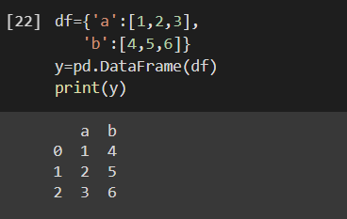

## **9. Generate the series of dates from 1st Jan, 2023 to 10th Feb, 2023**

Solution :

import pandas as pd

x=pd.date_range(start='1-1-2023',end='2-10-2023')

for val in x:

print(val)

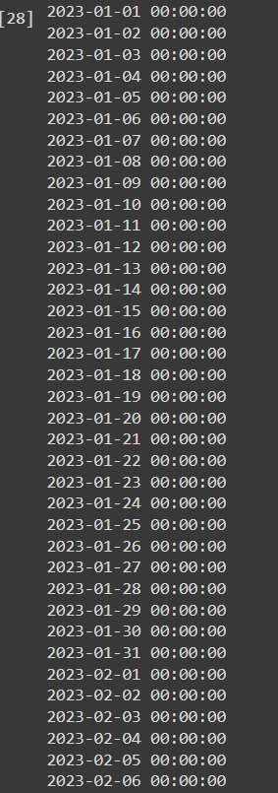

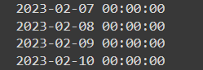

## **10. Create 2D list to DataFrame**

lists = [[1, 'aaa', 22], [2, 'bbb', 25], [3, 'ccc', 24]]

Solution :

import pandas as pd

df=pd.DataFrame(lists)

print(df)

