ASSIGNMENT –2 PYTHON PROGRAMMING

|  |  |
| --- | --- |
| Assignment Date | 27 September 2022 |
| Student Name | SHREEYAZHINI.A |
| Student Roll Number | 727819TUCS219 |
| Maximum marks | 2 Marks |

# QUESTION-1:

Build a python code, Assume u get temperature and humidity values (generated with random function to a variable) and write a condition to continuously detect alarm in case of high temperature?

# SOLUTION:

import random import time while(1):

temp=random.randint(0,200) humidity=random.randint(0,200) if temp>150:

print("ALERT!! detected temperature :"+str(temp)+".c") if humidity<100:

print("the humidity values:"+str(humidity)+"%") time.sleep(2)

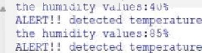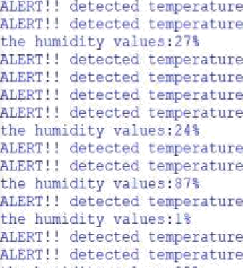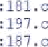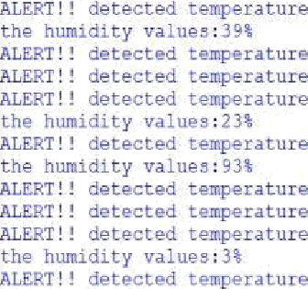

: 182. c

print("the hlmi ty va e•:"+s:r(humidity) ” ’) tlms.sleep{2)

:175.c

: 1S0. c

:1B0.c

:18l.c

: J66. c

: I6 . c

- 18 5 . c

:170.c

rl92.c

t RT e ecte tem e ature :1S1.c

t

ALERT detected tesperaiure :173.u