**PERSONAL EXPENSE TRACKER APPLICATION**

**PROJECT REPORT**

***Submitted by***

**KARTHIC R S (19EUCS060)**

**AJAI BHALAJI S (19EUCS005)**

**BRINDHA K K (19EUCS025)**

**HARESHVAR A R (19EUCS037)**

**TABLE OF CONTENTS**

**CHAPTER NO TITLE ABSTRACT PAGE NO**

**1 INTRODUCTION 06**

1.1 Project Overview

1.2 Purpose

**2 LITERATURE SURVEY 07**

2.1 Existing problems

2.2 References

2.3 Problem Statement Definition

**3 IDEATION & PROPOSED SOLUTION 09**

3.1 Empathy Map Canvas

3.2 Ideation & Brainstorming

3.3 Proposed Solution

3.4 Problem Solution fit

**4 REQUIREMENT ANALYSIS 14**

4.1 Functional requirement

4.2 Non-Functional requirements

**5 PROJECT DESIGN 15**

5.1 Data Flow Diagrams

5.2 Solution & Technical Architecture

5.3 User Stories

**6 PROJECT PLANNING & SCHEDULING 16**

6.1 Sprint Planning & Estimation

6.2 Sprint Delivery Schedule

6.3 Reports from JIRA

**7 CODING & SOLUTIONING 18**

7.1.1 Feature 1 : Login

7.1.2 Feature 2 : Signup

7.1.3 Feature 3 : Home

7.1.4 Feature 4 : Live tracker

7.1.5 Feature 5 : Location history

7.1.6 Feature 6 : Recent notifications

7.1.7 Feature 7 : Change password

7.2 Database Schema

**8 TESTING** **21**

8.1 Test Cases

8.2 User Acceptance Testing

**9 RESULTS 22**

9.1 Performance Metrics

**10 ADVANTAGES & DISADVANTAGES 23**

**11 CONCLUSION 23**

**12 FUTURE SCOPE 23**

**13 APPENDIX 24**

**CHAPTER 1**

**INTRODUCTION**

**1.1 PROJECT OVERVIEW**

Today many people fall into bad financial practices and sometimes even crushing debt owing to lack of awareness about good spending habits and reliable tracking/management resources. An application tailored to young adults to start tracking their expenses, splitting their bills, learning to budget/save and review their spending practices frequently and bring about any necessary changes in order to get a grip on their finances. More portable than traditional systems and equipped to help users between the younger ages/adults of to efficiently manage and track their expenses and non-invasive parent involvement and supervision. Sense of financial freedom, instill good expense management practices in young adults early on, effective parent/guardian participation in teaching financial responsibilities Data Monetization can be employed. Scalability is ensured using micro-service architecture.

# 1.2 PURPOSE

If you don’t check your spending and create a budget, you will have no control whatsoever on your money. Instead, money will control you, and you will either have perpetual lack of funds or you will end up steeped in debt. A money manager app helps you decide between short-term and long-term spending. If you are spending money frivolously, you will not have money to set financial goals. However, when you have a daily expense manager, you will be able to work with limited resources and use your money in a wise manner so that you can create financial goals and ensure you meet them. If you are clueless about how much is your inflow and how much you are spending, you will not know at the end of the month what happened to your money. An expense tracker helps you figure out what is happening to your money, and whether you can afford something you want. If you don’t have great financial management skills, you will not know how to categorize your expenses. However, tracking your expenses and budgeting them will help you become aware of how much you have to allocate to each expense category, and if you are short, you will be able to make adjustments with ease.

**CHAPTER 2**

**LITERATURE SURVEY**

# 2.1 EXISTING PROBLEM

Today many people fall into bad financial practices and sometimes even crushing debt owing to lack of awareness about good spending habits and reliable tracking/management resources. An application tailored to young adults to start tracking their expenses, splitting their bills, learning to budget/save and review their spending practices frequently and bring about any necessary changes in order to get a grip on their finances. More portable than traditional systems and equipped to help users between the younger ages/adults of to efficiently manage and track their expenses and non-invasive parent involvement and supervision..

# 2.2 REFERENCES

[1] Intelligent online budget that manages the expenses. Archived from the original on 2007. Published by Girish Bekaroo.

[2] Managing finances is a practice carried out daily in homes across the world. Archived from the original on December 28, 2015. Published by Stephan snow and Dhayal Vyas.

[3] Online Income and Expense Tracker. Archived from the original on 2019. Published by S. Chandini, T. Poojitha, D. Ranjith, V.J. Mohammed Akram, M.S. Vani, V. Rajyalakshmi.

[4] Family Expense Manager Application. Archived from the original on 2017. Published by Rajaprabha M N.

[5] Personalized Expense Managing Assistant Using Android. Archived from the original on 2016. Published by N.ZahiraJahan MCA.,M.Phil. , K.I.Vinodhini.

[6] Student Expense Tracking Application. Archived from the original on 2022. Published by Saumya Dubey,Pragya Dubey,Rigved Rishabh Kumar,Aaisha Khatoon.

[7] A research at university on Tennessee on expense tracker . Archived from the original on 2011. Published by Dan Underwood.

**2.3 PROBLEM STATEMENT**

Personal finance entails all the financial decisions and activities that a Finance app makes your life easier by helping you to manage your finances efficiently. A personal finance app will not only help you with budgeting and accounting but also give you helpful insights about money management. Personal finance applications will ask users to add their expenses and based on their expenses wallet balance will be updated which will be visible to the user. Also, users can get an analysis of their expenditure in graphical forms. They have an option to set a limit for the amount to be used for that particular month if the limit is exceeded the user will be notified with an email alert.

**CHAPTER 3**

**IDEATION AND PROPOSED SOLUTION**

* 1. **EMPATHY MAP CANVAS**

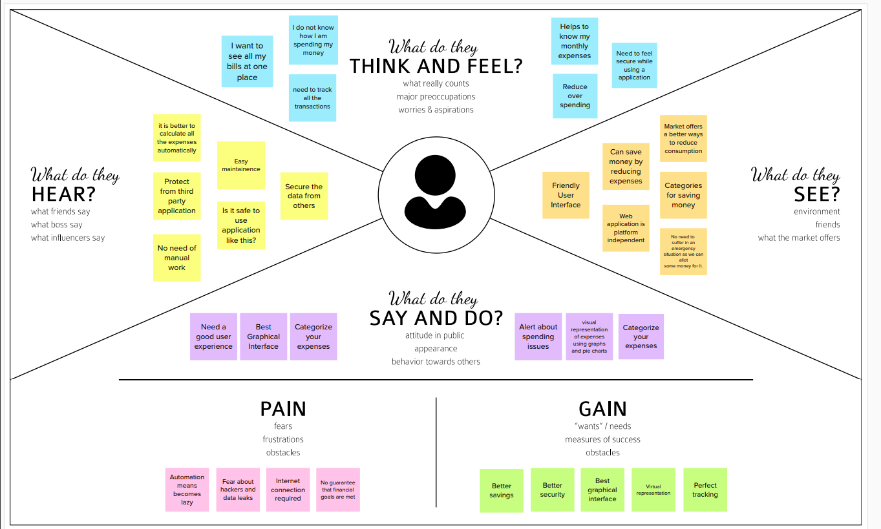

# IDEATION AND BRAINSTORMING

* + 1. **BRAIN STORMING**

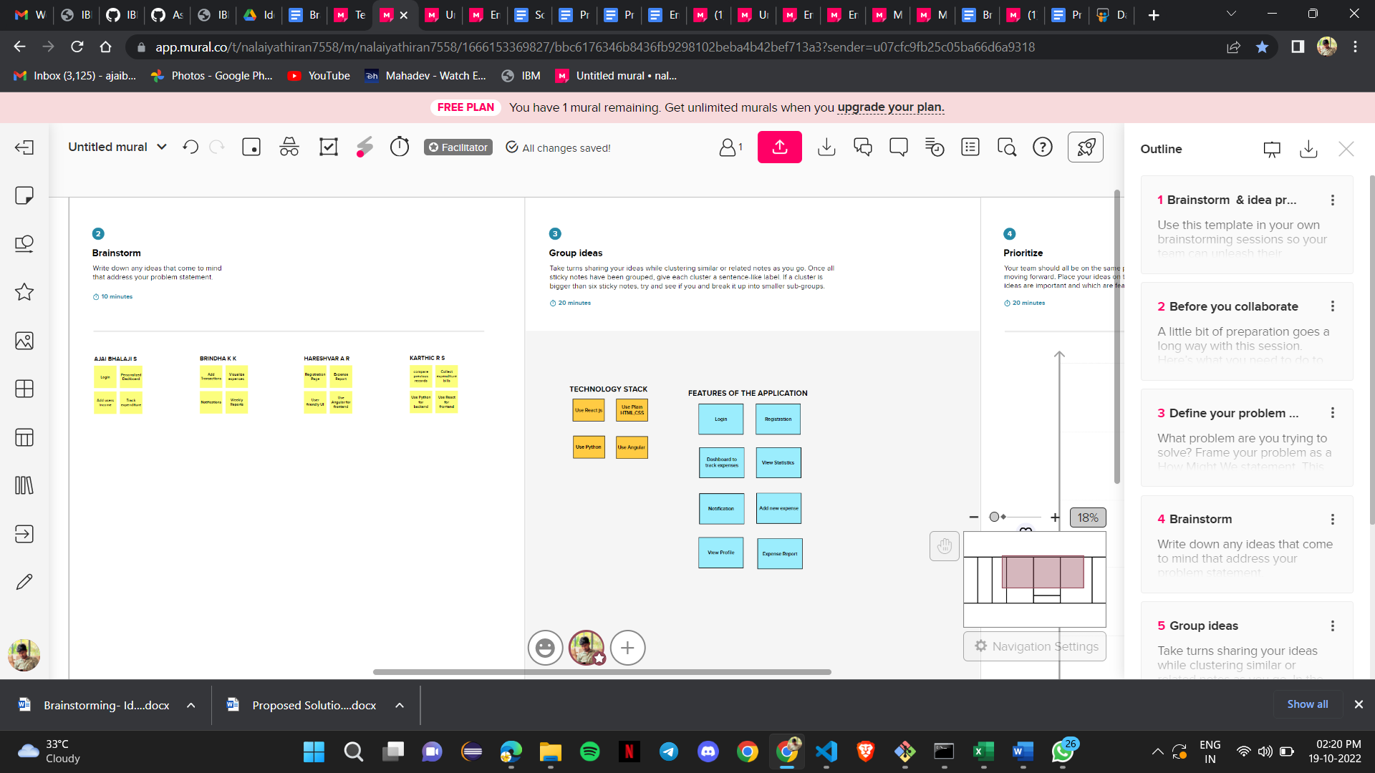

* + 1. **IDEA PRIORITIZATION**

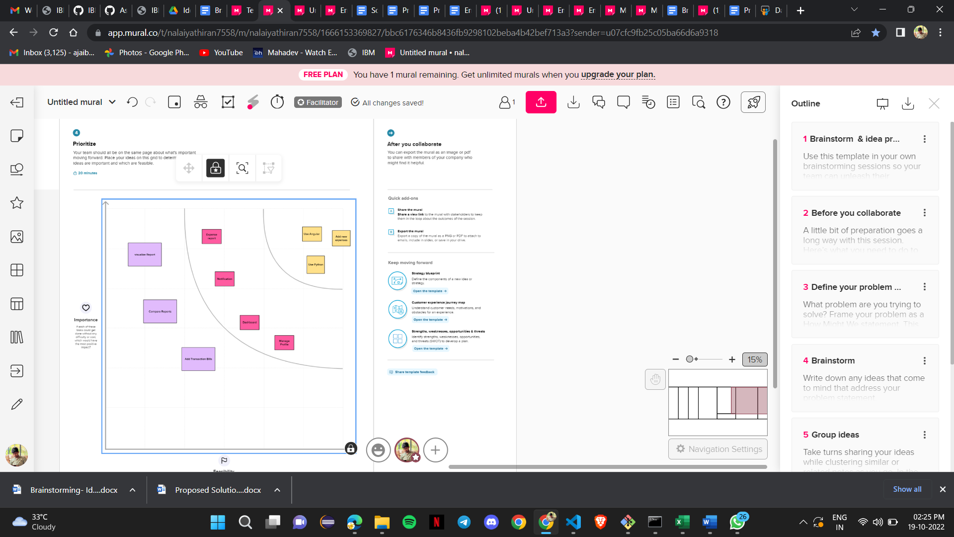

# PROPOSED SOLUTION

|  |  |  |
| --- | --- | --- |
| **S.No.** | **Parameter** | **Description** |
|  | Problem Statement (Problem to be solved) | Young Adults often fall into bad financial  practices and sometimes even crushing debt  owing to lack of awareness about good  spending habits and reliable  tracking/management resources. |
|  | Idea / Solution description | An application tailored to young adults to start  tracking their expenses, splitting their bills,  learning to budget/save and review their  spending practices frequently and bring about  any necessary changes in order to get a grip on  their finances. |
|  | Novelty / Uniqueness | More portable than traditional systems and  equipped to help users between the younger ages/adults of to efficiently manage and track their expenses and non-invasive parent involvement and supervision. |
|  | Social Impact / Customer Satisfaction | Sense of financial freedom, instill good expense  management practices in young adults early on,  effective parent/guardian participation in  teaching financial responsibilities |
|  | Business Model (Revenue Model) | Data Monetization can be employed. |
|  | Scalability of the Solution | Scalability is ensured using micro-service  architecture |

**3.4 PROBLEM SOLUTION FIT**

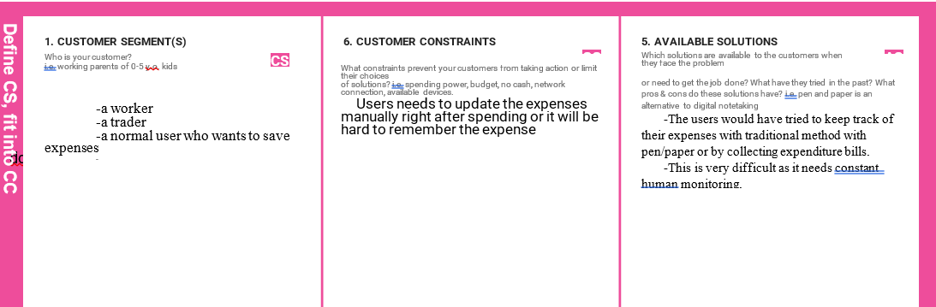

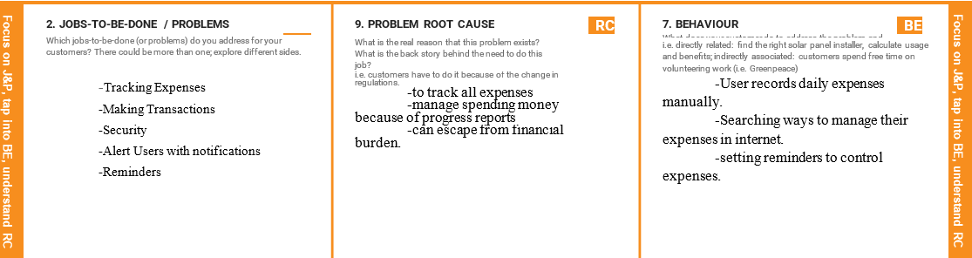

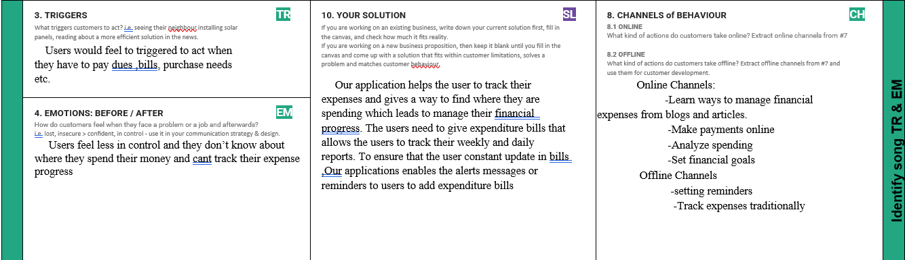

**CHAPTER-4**

**REQUIREMENT ANALYSIS**

# FUNCTIONAL REQUIREMENTS

Following are the functional requirements of the proposed solution.

|  |  |  |
| --- | --- | --- |
| **FR**  **No.** | **Functional**  **Requirement (Epic)** | **Sub Requirement (Story / Sub-Task)** |
| FR-1 | User Registration | Registration through Website |
| FR-2 | User Confirmation | Confirmation via Email |
| FR-3 | User Login | Login through registered Username |
| FR-4 | Add Expense | User should add their expense for tracking their expenditure. |
| FR-5 | Add Wallet | User should add money for comparing with expenses. |

.

**4.2 NON-FUNCTIONAL REQUIREMENTS**

Following are the non-functional requirements of the proposed solution.

|  |  |  |
| --- | --- | --- |
| **NFR**  **No.** | **Non Functional**  **Requirement (Epic)** | **Description** |
| NFR-1 | Usability | The personal expense tracker application is user friendly and does not involve any complex process |
| NFR-2 | Security | We used hashing instead of directly storing the password into the database. |
| NFR-3 | Reliability | The application will have no down time so that you can always rely on and the information provided by it are so reliable |
| NFR-4 | Performance | The application will work efficiently in  all situations with an instant  notification system. |
| NFR-5 | Availability | The application will be available online 24x7 |
| NFR-6 | Scalability | The application can be accessed by  multiple users at the same time and it has  the ability to increase or decrease the IT  resources as needed. |

.

# CHAPTER 5

**PROJECT DESIGN**

**5.1 DATA FLOW DIAGRAM**

refer→project design and planning / project design phase 2 / data flow diagram

**5.2 SOLUTION AND TECHNICAL ARCHITECTURE**

refer→project design and planning / project design phase 1 / solution architecture

refer→project design and planning / project design phase 2 / technology stack

**5.3 USER STORIES**

refer→project design and planning / project design phase 2 / data flow diagram

**CHAPTER 6**

**PROJECT PLANNING AND SCHEDULING**

# SPRINT PLANNING AND ESTIMATION

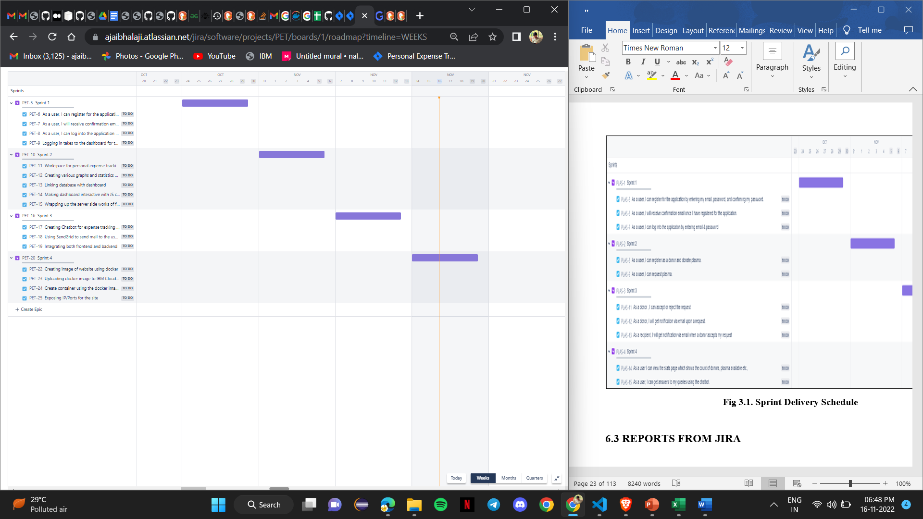

`

**6.2 SPRINT DELIVERY SCHEDULE**

|  |  |  |  |  |  |  |
| --- | --- | --- | --- | --- | --- | --- |
| **Sprint** | **Functional Requirement (Epic)** | **User Story Number** | **User Story / Task** | **Story Points** | **Priority** | **Team Members** |
| Sprint-1 | Registration | USN-1 | As a user, I can register for the application by entering my email, password, and confirming my password | 2 | High | Karthic |
| Sprint-1 |  | USN-2 | As a user, I will receive confirmation email once I have registered for the application | 1 | High | Ajai Bhalaji |
| Sprint-1 | Login | USN-3 | As a user, I can log into the application by entering email & password | 1 | High | Hareshvar |
| Sprint- 1 | Dashboard | USN-4 | Logging in takes to the dashboard for the logged user. | 2 | High | Brindha |
| Sprint- 2 | Workspace | USN-1 | Workspace for personal expense tracking | 2 | High | Hareshvar |
| Sprint- 2 | Charts | USN-2 | Creating various graphs and statistics of customer’s data | 1 | Medium | Ajai Bhalaji |
| Sprint- 2 | Connecting to IBM DB2 | USN-3 | Linking database with dashboard | 2 | High | Karthic |
| Sprint- 2 |  | USN-4 | Making dashboard interactive with JS chatbot | 2 | High | Brindha |
| Sprint- 2 |  | USN-1 | Wrapping up the server side works of frontend | 1 | Medium | Ajai Bhalaji |
| Sprint-3 | Watson Assistant | USN-2 | Creating Chatbot for expense tracking and for clarifying user’s query | 1 | Medium | Karthic |
| Sprint-3 | SendGrid | USN-3 | Using SendGrid to send mail to the user about their expenses | 1 | Low | Brindha |
| Sprint-3 |  | USN-4 | Integrating both frontend and backend | 2 | High | Hareshvar |
| Sprint-4 | Docker | USN-1 | Creating image of website using docker | 2 | High | Karthic |
| Sprint-4 | Cloud Registry | USN-2 | Uploading docker image to IBM Cloud registry | 2 | High | Brindha |
| Sprint-4 | Kubernetes | USN-3 | Create container using the docker image and hosting the site | 2 | High | Hareshvar |
| Sprint-4 | Exposing | USN-4 | Exposing IP/Ports for the site | 2 | High | Ajai Bhalaji |

**CHAPTER 7**

**CODING & SOLUTIONING**

**7.1.1 FEATURE 1 : LOGIN**

**Algorithm :**

1. Enter the credentials and hit enter (email and password).
2. If already logged in user is taken to home page
3. Else , check for validity of credentials entered using query to cloudant db.
4. If wrong credentials entered , notification displayed to user and user stays in login page.
5. On correct credentials , user is taken to home page.

**Login checker :**

if(msg.req==null){

email = msg.payload.email;

}

else{

var email = msg.req.params.email;

}

msg.enteredPassword = msg.payload.password;

msg.payload={

"selector":{

"email":{

"$eq":email

}

},

"fields":["email","password"]

}

return msg;

**7.1.2 FEATURE 2 : SIGNUP**

**Algorithm :**

1. Enter the signup form fields (name , email , password , re-enter password , date of birth ) and hit enter.
2. All credentials are validated at client side.
3. Email is checked if already registered or not in the database.
4. If already registered , notification displayed. Or else, the user is taken to the successful signup page.

**Query to check if email is registered or not :**

var email = msg.enteredFields.email;

msg.payload={

"selector":{

"entry-type":"user",

"email":{

"$eq":email

}

},

"fields":["email"]

}

return msg;

**7.1.3 FEATURE 3 : HOME**

**Algorithm :**

1. If the user is logged out , he/she is taken to the login page.
2. Home page buttons are displayed (Live tracker , Recent emergency notifications , Location history , Change password , Logout)
3. If buttons are clicked , the user is taken to the requested page.

**7.1.4 FEATURE 4 : LIVE TRACKER**

**Algorithm :**

1. If the user is logged out , he/she is taken to the login page.
2. GPS sensor data is received via IBM IoT Watson platform , the location marker is displayed in the world map.
3. Location data is stored to db every 1 minute.

**7.1.5 FEATURE 5 : LOCATION HISTORY**

**Algorithm :**

1. If the user is logged out , he/she is taken to the login page.
2. The location table contents are displayed in the table by querying the database.

**Location query getter :**

msg.payload =

{

"selector":{

"entry-type":{

"$eq":"location"

}

},

"fields":["lat","lon","time","description"]

}

**7.1.6 FEATURE 6 : RECENT NOTIFICATIONS**

**Algorithm :**

1. If the user is logged out , he/she is taken to the login page.
2. The notification table contents are displayed in the table by querying the database.

**Recent notification getter :**

msg.payload =

{

"selector":{

"entry-type":{

"$eq":"notification"

}

},

"fields":["lat","lon","time"]

}

**7.1.7 FEATURE 7 : CHANGE PASSWORD**

**Algorithm :**

1. If the user is logged out , he/she is taken to the login page.
2. User is asked to enter the new password twice and click the change password button.
3. Passwords are validated , and password of requested user is changed by querying the database.

**7.2 DATABASE SCHEMA**

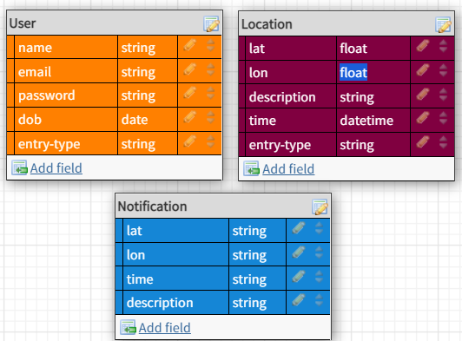

**CHAPTER 8**

**TESTING**

**8.1 TEST CASES**

1. Login button click with wrong credentials entered.
2. Signup with already registered mail ID.
3. Signup with wrong form data entered.
4. Entering home page with logged out session.
5. Clicking home page buttons with logged out session.
6. Invalid data entered in change password page and requested for change in password.

**8.2 USER ACCEPTANCE TESTING**

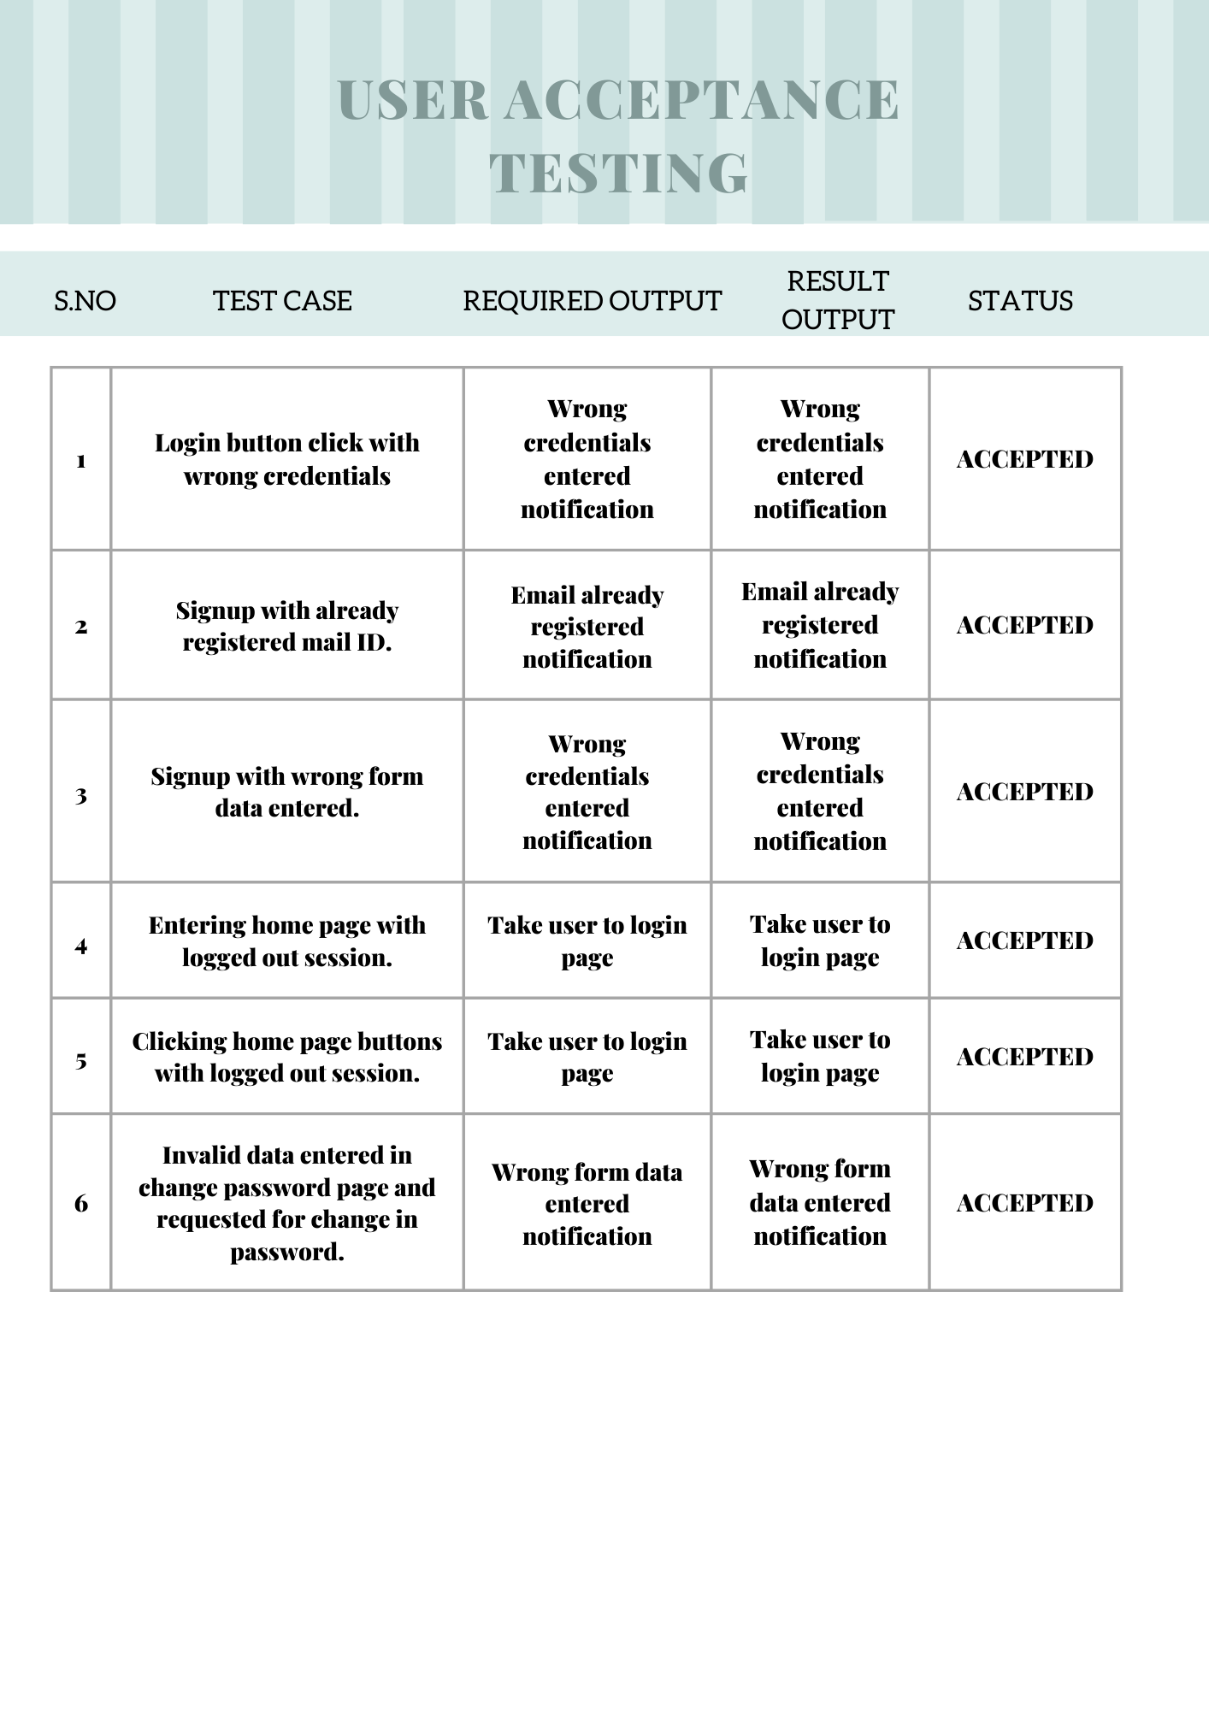

**CHAPTER 9**

**RESULTS**

**9.1 PERFORMANCE METRICS**

1. Planned value : Rs.4000
2. Actual value : Rs.1300
3. Hours worked : 50 hours
4. Stick to Timelines : 100%
5. Stay within budget : 100%
6. Consistency of the product : 75%
7. Efficiency of the product : 80%
8. Quality of the product : 80%

**CHAPTER 10**

**ADVANTAGES AND DISADVANTAGES**

**ADVANTAGES :**

1. Low cost.
2. Simple UI.
3. Faster response due to single page web page.
4. Capability of adding many features with ease and less cost.

**DISADVANTAGES :**

1. Lack of efficiency . Efficiency of the product needs to be improved.
2. Consistency of the product is not 100%.
3. Not a compact sized product. Size needs to be decreased.

**CHAPTER 11**

**CONCLUSION**

The product can be easily made into a business model. With the help of this product, customers can have a happy life , since it is economical and offers a simple user interface to monitor their child . Children can have a safe place to live with the help of this product.This product has the capability of impacting the market if further improvements have been done , due to its low price since , the cost of child safety gadgets in the market is of high cost.

**CHAPTER 12**

**FUTURE SCOPE**

The product can include many other additional features like checking the weather forecast of the child location, interacting with the child etc. If we improve the efficiency of the code and reduce the size of our product , the market will be able to find a new child tracker gadget with low cost and high quality.

**CHAPTER 13**

**APPENDIX**

# INTERNET OF THINGS

The **Internet of things** (**IoT**) describes physical objects (or groups of such objects) with sensors, processing ability, software, and other technologies that connect and exchange data with other devices and systems over the Internet or other communications networks. Internet of things has been considered a misnomer because devices do not need to be connected to the public internet, they only need to be connected to a network and be individually addressable. The field has evolved due to the convergence of multiple technologies, including ubiquitous computing, commodity sensors, increasingly powerful embedded systems, and machine learning. Traditional fields of embedded systems, wireless sensor networks, control systems, automation (including home and building automation), independently and collectively enable the Internet of things. In the consumer market, IoT technology is most synonymous with products pertaining to the concept of the "smart home", including devices and appliances (such as lighting fixtures, thermostats, home security systems, cameras, and other home appliances) that support one or more common ecosystems, and can be controlled via devices associated with that ecosystem, such as smartphones and smart speakers. IoT is also used in healthcare systems.[[10]](https://en.wikipedia.org/wiki/Internet_of_things#cite_note-10)

There are a number of concerns about the risks in the growth of IoT technologies and products, especially in the areas of privacy and security, and consequently, industry and governmental moves to address these concerns have begun, including the development of international and local standards, guidelines, and regulatory frameworks.

# MQTT

MQTT is an OASIS standard messaging protocol for the Internet of Things (IoT). It is designed as an extremely lightweight publish/subscribe messaging transport that is ideal for connecting remote devices with a small code footprint and minimal network bandwidth. MQTT today is used in a wide variety of industries, such as automotive, manufacturing, telecommunications, oil and gas, etc.

# NODE RED

Node-RED is a programming tool for wiring together hardware devices, APIs and online services in new and interesting ways. It provides a browser-based editor that makes it easy to wire together flows using the wide range of nodes in the palette that can be deployed to its runtime in a single-click.

Node-RED provides a browser-based flow editor that makes it easy to wire together flows using the wide range of nodes in the palette. Flows can be then deployed to the runtime in a single-click. JavaScript functions can be created within the editor using a rich text editor. A built-in library allows to save useful functions, templates or flows for re-use.

# IBM WATSON IOT PLATFORM

IBM Watson IoT Platform for Bluemix provides a versatile toolkit that includes gateway devices, device management, and powerful application access. By using Watson IoT Platform, you can collect connected device data and perform analytics on real-time data. The IBM Watson IoT Platform is a fully managed, Cloud-hosted service that provides device management capabilities as well as data collection and management in a time series format. As part of IBM’s Platform as a Service offering, IBM Bluemix, you can use the IBM Watson IoT Platform to rapidly build IoT apps from the catalog of services available in IBM Bluemix. You can choose from such IoT app options as storage services, rules, analytics services, stream analytics, machine learning, visualization, and user apps (Web or mobile). You also can embed cognitive capabilities in your IoT apps by using IBM Watson services available in IBM Bluemix

# CLOUDANT

A fully managed, distributed database optimized for heavy workloads and fast-growing web and mobile apps, IBM Cloudant is available as an IBM Cloud® service with a 99.99% SLA. Cloudant elastically scales throughput and storage, and its API and replication protocols are compatible with Apache CouchDB for hybrid or multicloud architecture.

**PROJECT DEMONSTRATION LINK :** <https://youtu.be/GVXWvharyfU>

**SOURCE CODE LINK :** https://github.com/IBM-EPBL/IBM-Project-9148-1658983674