**Pre-Requisites**

|  |  |  |
| --- | --- | --- |
| **Date** | **19 November 2022** |  |
| **Team Id** | **PNT2022TMID33276** |  |
| **Project Name** | **Machine Learning-Based**  **Analytics for Aircraft Engine** | **Predictive** |

**In order to develop this project we need to installed following software/packages:**

Anaconda Navigator

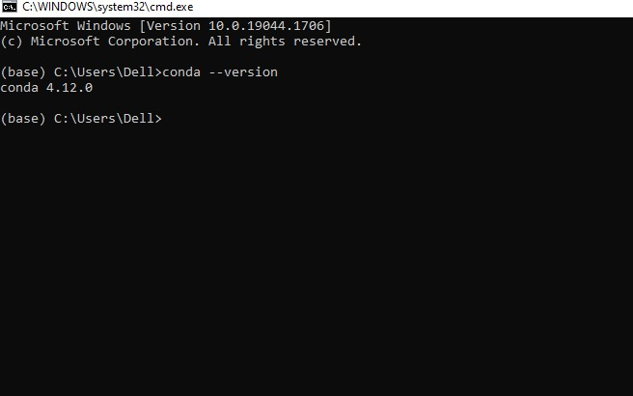

**To build Machine learning models we installed the following packages:**

* Sklearn

* NumPy
* Pandas

* Matplotlib

* Flask

# Prior Knowledge

we refered the given videos and gain the required knowledge