**Ideation Phase**

**Brainstorm & Idea Prioritization Template**

|  |  |
| --- | --- |
| Date | 19 September 2022 |
| Team ID | PNT2022TMID09867 |
| Project Name | A Novel method for Handwritten Digit Recognition System |
| Maximum Marks | 4 Mar**D**ks |

Brainstorm & Idea Prioritization Template:

Step-1: Team Gathering, Collaboration and Select the Problem Statement

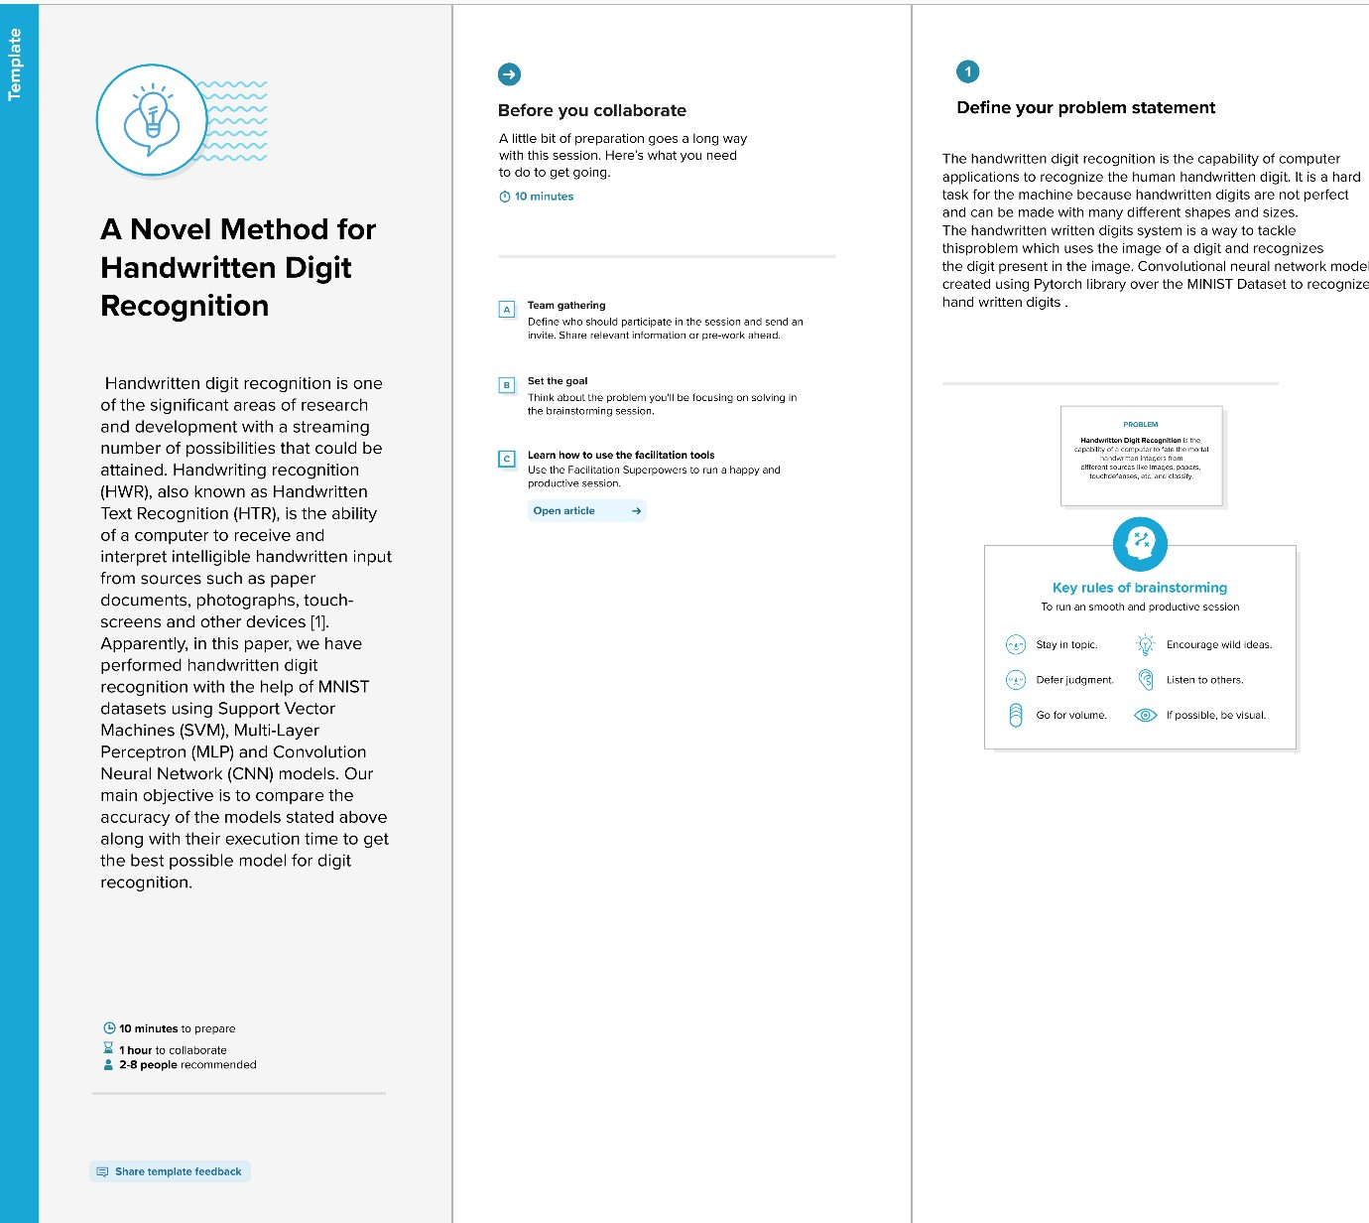

**Step-2: Brainstorm, Idea Listing and Grouping**

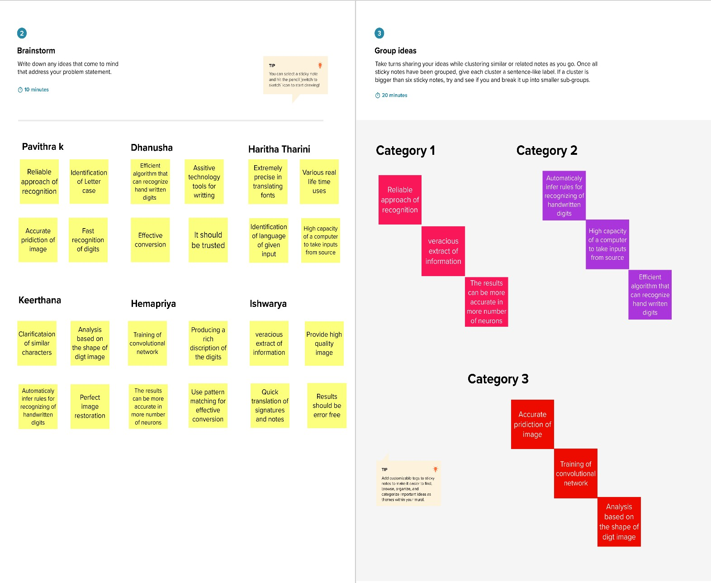

your

your text

text kjbijkbbjkbkjbjkbkbytdtyTdytpyeftyftyftyftyftyftyftyftyftyfytyofutydfdtysfrtytfetyxfttyftyftyftftfty

**Step-3: Idea Prioritization**

