ASSIGNMENT-1

**Name**:Pavya D

**College** :Sona College Of Technology

**CreatecircuitwithPiezoalarm,PIRsensor,tmpsensorwith below functionalities:**

1. Alarmshouldsoundinonemanneriftempisabove60degreeCelsius.
2. Alarmshouldsoundwithanotherfrequencyifmotionisdetected inPIR sensor.

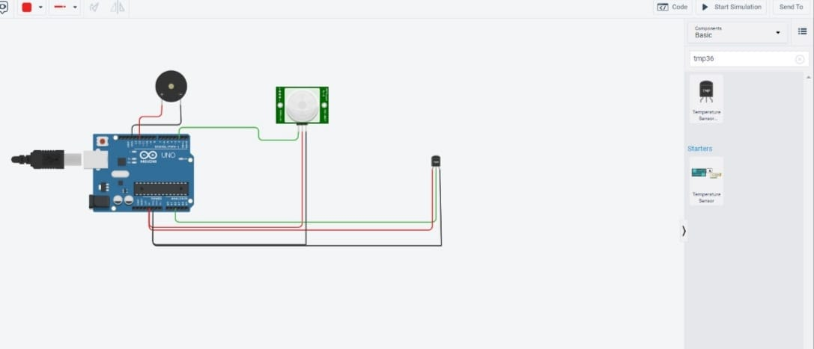

**CODING:**

voidsetup()

{

Serial.begin(9600);pinMode(2,INPUT);pinMode(12,OUTPUT);

}

voidloop()

{

int motion=digitalRead(2);if(motion==1){Serial.println("Motion detected");tone(12,10);

delay(1000);noTone(12);delay(1000);

}

else{

Serial.println("Nomotion");

}

doubledata=analogRead(A2);doublen=data/1024;

double volt=n*5;doubleoff=volt-0.5;

double temperature=off*100;Serial.print("Temperaturedata:");Serial.println(temperature);if(temperature>60.00)

{

tone(12,100);delay(500);noTone(12);delay(500);

}

}

OUTPUTS

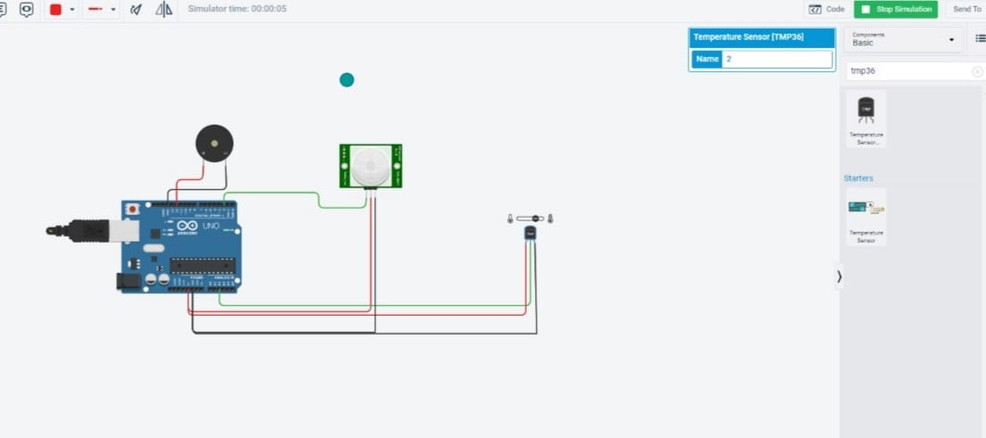

SIMULATIONLINK:

https://drive.google.com/file/d/1WsO0qm42ZsLrhDD1oAiO9JtdkCLeq38Q/view?usp=drivesdk