**IBM ASSIGNMENT 1**

NAME: A.H.Hariharasudan

CRICUIT CONNECTIONS:

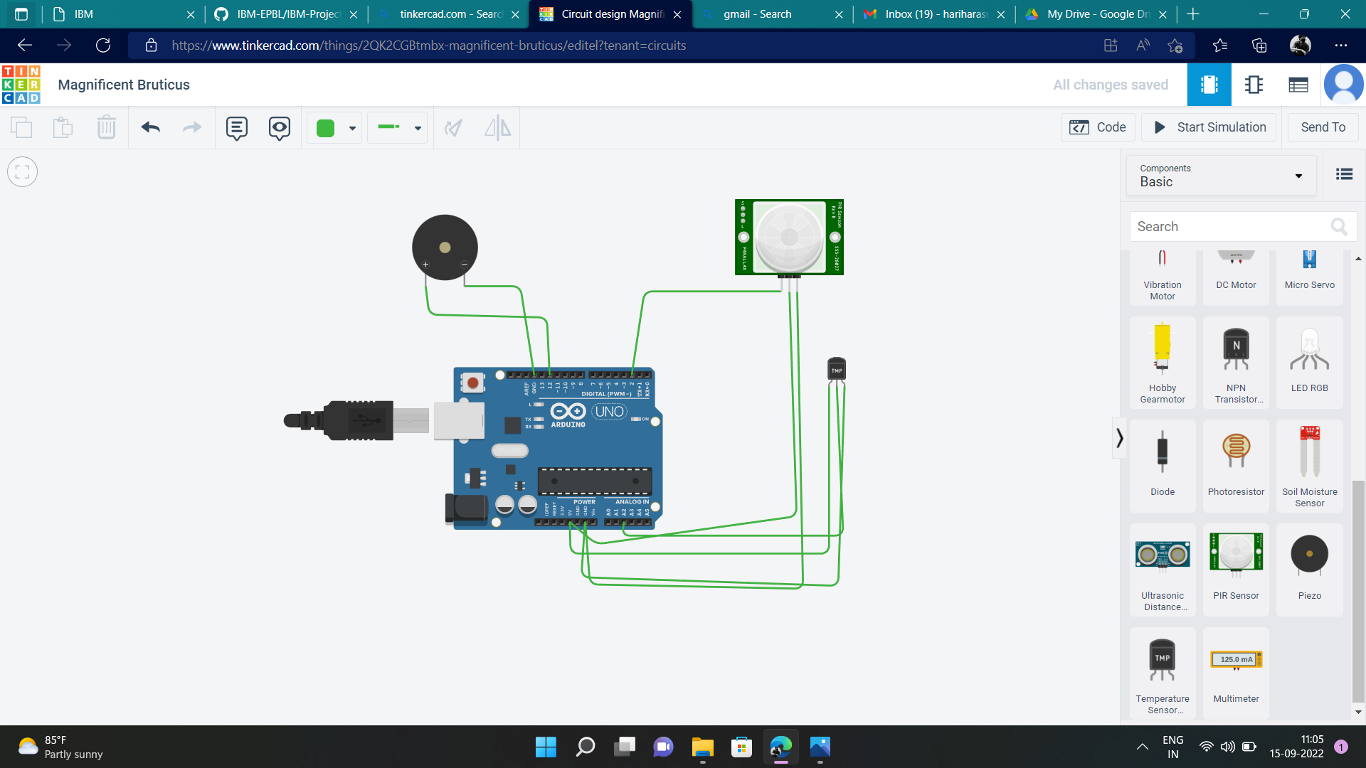

OUTPUT:

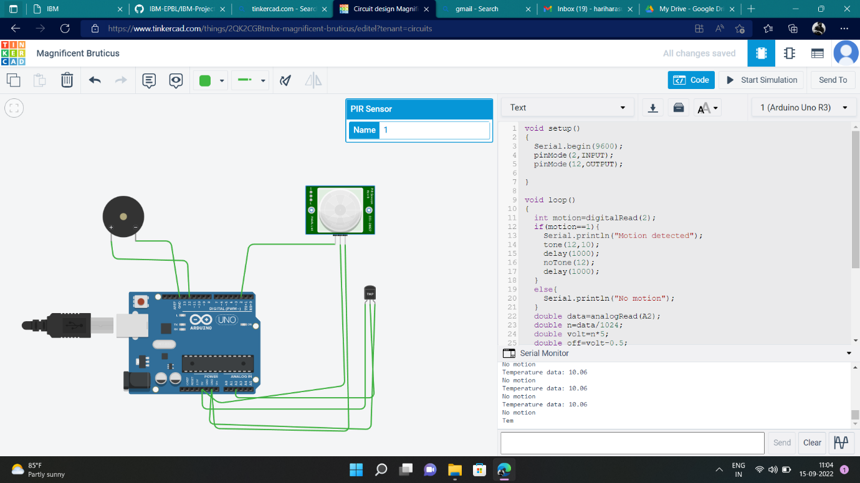

CODE:

void setup()

{

Serial.begin(9600);

pinMode(2,INPUT);

pinMode(12,OUTPUT);

}

void loop()

{

int motion=digitalRead(2);

if(motion==1){

Serial.println("Motion detected");

tone(12,10);

delay(1000);

noTone(12);

delay(1000);

}

else{

Serial.println("No motion");

}

double data=analogRead(A2);

double n=data/1024;

double volt=n*5;

double off=volt-0.5;

double temperature=off*100;

Serial.print("Temperature data: ");

Serial.println(temperature);

if(temperature>60.00)

{

tone(12,100);

delay(500);

noTone(12);

delay(500);

}

}

DEMO LINK:

<https://drive.google.com/file/d/1cqFI3c_a3QwkgMbXWJw2KcpulIA9JLp4/view?usp=sharing>