Assignment -3

Build CNN Model for Classification of Flowers

|  |  |
| --- | --- |
| Assignment Date : | 05-11-2022 |
| Team ID : | PNT2022TMID09649 |
| Project : | Fertilizer Recommendation System for Disease Prediction |

**Question-1:**

**Download the Dataset:Dataset Solution:**

from google.colab import drive

drive.mount('/content/drive')



!unzip /content/drive/MyDrive/Flowers-Dataset.zip

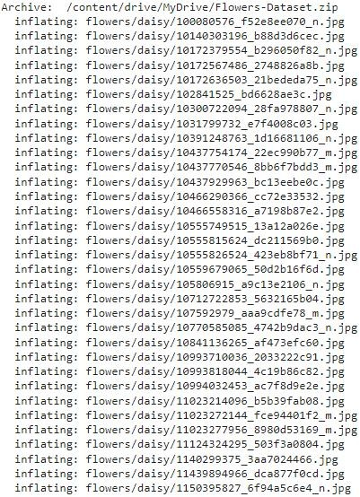

**Question-2:**

**Image Agumentation Solution:**

from tensorflow.keras.preprocessing.image import ImageDataGenerator

train_datagen = ImageDataGenerator(rescale = 1./255, horizontal_flip = True, vertical_fli p = True, zoom_range = 0.2)

test_datagen = ImageDataGenerator(rescale= 1./255)

x_train = train_datagen.flow_from_directory(r"/content/flowers", target_size = (64,64) , class_mode = "categorical", batch_size = 100)

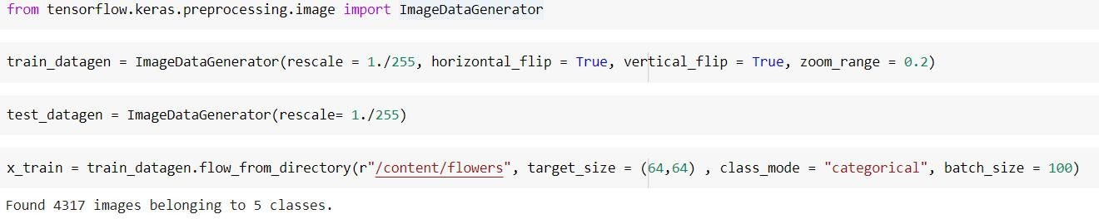

**Question-3:**

**Create Model Solution:**

from tensorflow.keras.models import Sequential model = Sequential()

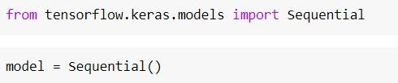

**Question-4:**

**Add layout(Convolution,MaxPooling,Flatten,Dense-(Hidden Layers),Output)**

**Solution:**

from tensorflow.keras.layers import Convolution2D,MaxPooling2D,Flatten,Dense model.add(Convolution2D(32, (3,3), activation = "relu", input_shape = (64,64,3) )) model.add(MaxPooling2D(pool_size = (2,2)))

model.add(Flatten()) model.add(Dense(300, activation = "relu"))

model.add(Dense(150, activation = "relu")) #mulitple dense layers model.add(Dense(5, activation = "softmax")) #output layer

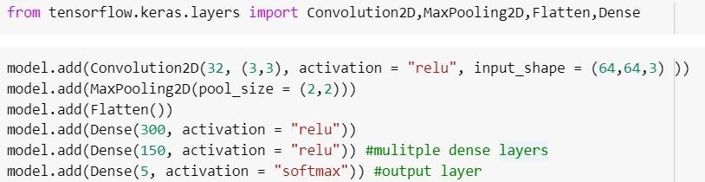

**Question-5:**

**Compile the Model Solution:**

model.compile(loss = "categorical_crossentropy", metrics = ["accuracy"], optimizer = "a dam")

len(x_train)

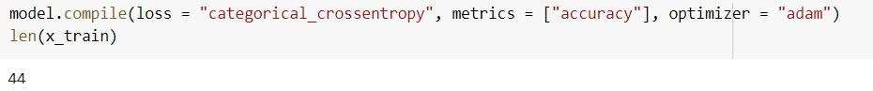

**Question-6:**

**Fit The Model Solution:**

#model.fit(x_train, epochs = 15, validation_data = x_test, steps_per_epoch = len(x_train), validation_steps = len(x_test))

model.fit(x_train, epochs = 15, steps_per_epoch = len(x_train))

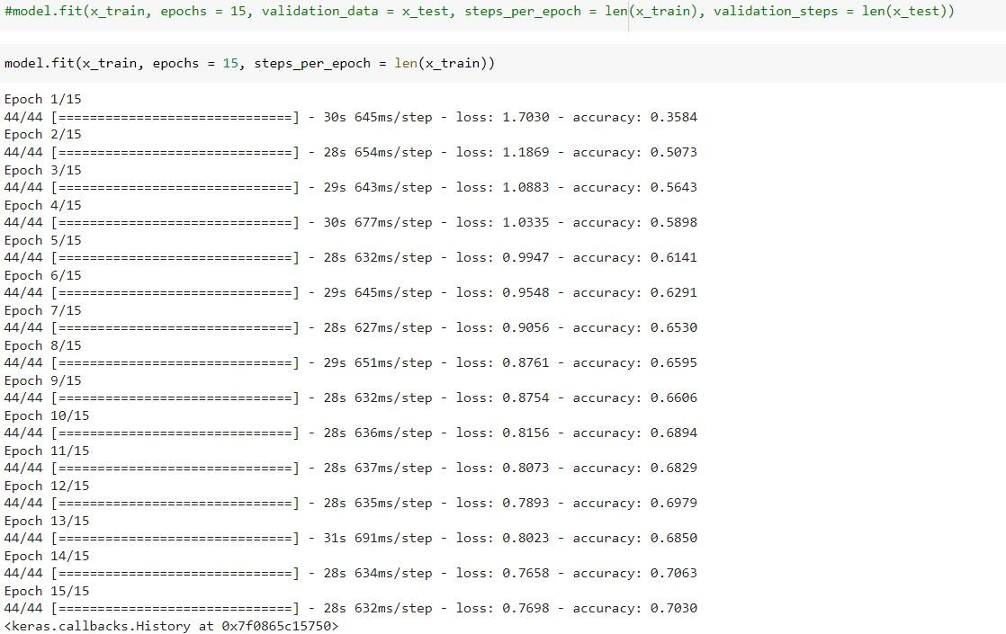

**Question-7:**

**Save The Model Solution:**

model.save("flowers.h5")



**Question-8:**

**Test The Model Solution:**

import numpy as np

from tensorflow.keras.preprocessing import image

Rose = image.load_img('/content/flowers/rose/1562198683_8cd8cb5876_n.jpg',target_si ze=(200,210))

Rose

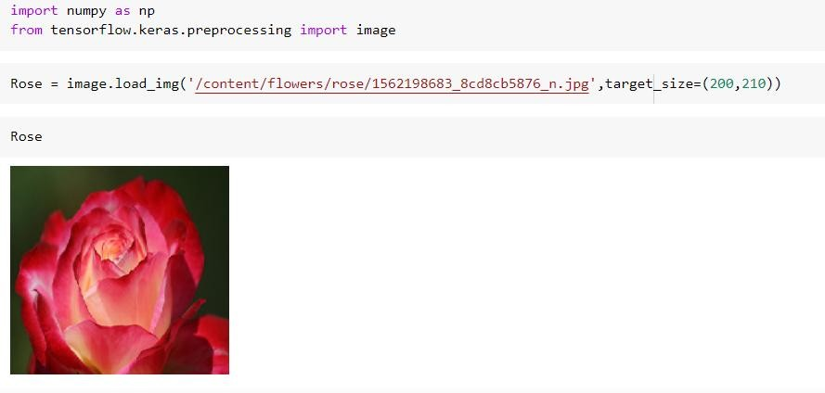

array = image.img_to_array(Rose) array

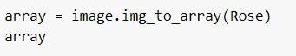

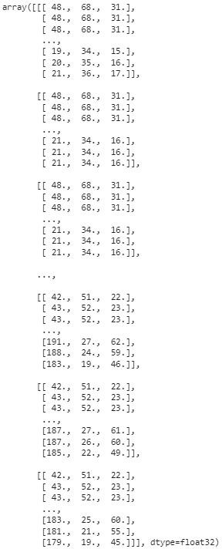

array = np.expand_dims(array,axis=0) array



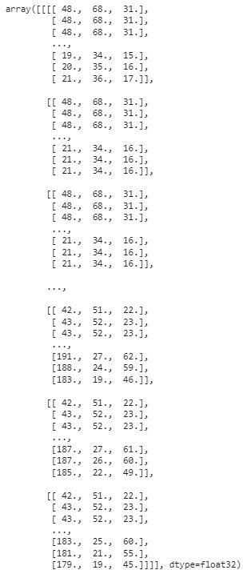

x_train.class_indices

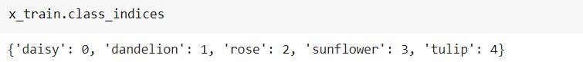

index=['daisy','dandelion','rose','sunflower','tulip']

