# Question-1:

Create a Bucket in IBM object storage.

# Solution:

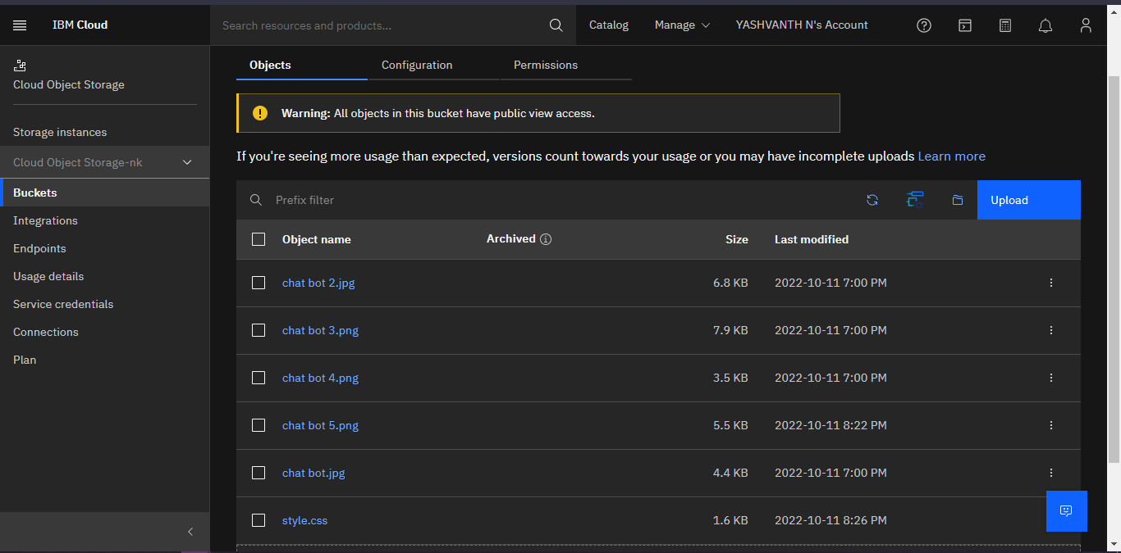

**Question-2:**

Upload an 5 images to ibm object storage and make it public. write html code to displaying all the 5 images.

# Solution:

<!DOCTYPE html>

<html lang="en">

<head>

<meta charset="UTF-8">

<meta http-equiv="X-UA-Compatible" content="IE=edge">

<meta name="viewport" content="width=device-width, initial-scale=1.0">

<title>Bucket</title>

</head>

<body>

<img src="https://s3.au-syd.cloud-object-storage.appdomain.cloud/my- bucket24/chat%20bot.jpg">

<img src="https://s3.au-syd.cloud-object-storage.appdomain.cloud/my-

bucket24/chat%20bot%202.jpg">

<img src="https://s3.au-syd.cloud-object-storage.appdomain.cloud/my- bucket24/chat%20bot%203.png">

<img src="https://s3.au-syd.cloud-object-storage.appdomain.cloud/my- bucket24/chat%20bot%204.png">

<img src="https://s3.au-syd.cloud-object-storage.appdomain.cloud/my- bucket24/chat%20bot%205.png">

</body>

</html>

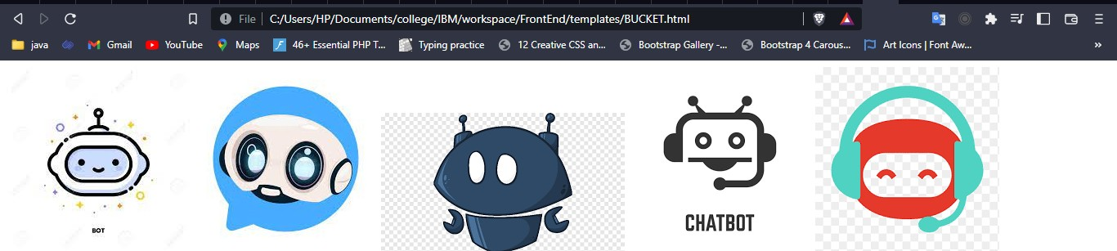

**Question-3:**

Upload a css page to the object storage and use the same page in your HTML code.write html code to displaying all the 5 images.

# Solution:

<html>

<head>

<meta charset="utf-8">

<meta name="viewport" content="width=device-width, initial-scale=1, shrink-to-fit=no">

<link rel="stylesheet" href="https://maxcdn.bootstrapcdn.com/font- awesome/4.7.0/css/font-awesome.min.css">

<link rel="stylesheet" href="https://stackpath.bootstrapcdn.com/bootstrap/4.5.0/css/bootstrap.min.css ">

<link rel="stylesheet" href="https://cdnjs.cloudflare.com/ajax/libs/particlesjs/2.2.3/particles.min.j s">

<link rel="stylesheet" href="https://s3.au-syd.cloud-object- storage.appdomain.cloud/my-

bucket24/style.cssxxxxxxxxxxxxxxxxxxx">

</head>

<body>

<div class="signup">

<form action="\result" method="post">

<h2>LOGIN</h2>

<div class="form-group">

<div class="input-group">

<span class="input-group-addon"><i class="fa fa- envelope"></i></span>

<input type="email" name="email" class=" form- control"placeholder="Email" required>

</div>

</div>

<div class="form-group">

<div class="input-group">

<span class="input-group-addon"><i class="fa fa-

lock"></i></span>

<input type="password" name="password" class=" form- control"placeholder="password" required>

</div>

</div>

<div class="form-group">

<button type="submit" class="btn btn-primary btn-lg btn- block">Login</button>

</div>

</form>

</div>

</body>

</html>

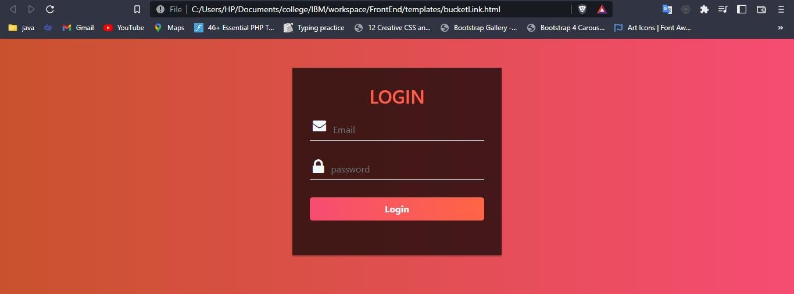

**Question-4:**

Design a chatbot using IBM Watson assistant for hospital. Ex: User comes with query to know the branches for that hospital in your city. Submit the web URL of that chat bot as a assignment.

# Solution:

[https://web-](https://web-chat.global.assistant.watson.appdomain.cloud/preview.html?backgroundImageURL=https%3A%2F%2Fau-syd.assistant.watson.cloud.ibm.com%2Fpublic%2Fimages%2Fupx-f8e994d6-a0d7-422f-a9f3-852a308d5f26%3A%3A9313e8ba-e53d-470d-8fb1-7db9327ba407&integrationID=4eb80521-2d5d-4e2b-ac4b-5124347d8655&region=au-syd&serviceInstanceID=f8e994d6-a0d7-422f-a9f3-852a308d5f26) [chat.global.assistant.watson.appdomain.cloud/preview.html?backgroundImageURL=https%3A%2F%](https://web-chat.global.assistant.watson.appdomain.cloud/preview.html?backgroundImageURL=https%3A%2F%2Fau-syd.assistant.watson.cloud.ibm.com%2Fpublic%2Fimages%2Fupx-f8e994d6-a0d7-422f-a9f3-852a308d5f26%3A%3A9313e8ba-e53d-470d-8fb1-7db9327ba407&integrationID=4eb80521-2d5d-4e2b-ac4b-5124347d8655&region=au-syd&serviceInstanceID=f8e994d6-a0d7-422f-a9f3-852a308d5f26) [2Fau-syd.assistant.watson.cloud.ibm.com%2Fpublic%2Fimages%2Fupx-f8e994d6-a0d7-422f-a9f3-](https://web-chat.global.assistant.watson.appdomain.cloud/preview.html?backgroundImageURL=https%3A%2F%2Fau-syd.assistant.watson.cloud.ibm.com%2Fpublic%2Fimages%2Fupx-f8e994d6-a0d7-422f-a9f3-852a308d5f26%3A%3A9313e8ba-e53d-470d-8fb1-7db9327ba407&integrationID=4eb80521-2d5d-4e2b-ac4b-5124347d8655&region=au-syd&serviceInstanceID=f8e994d6-a0d7-422f-a9f3-852a308d5f26) [852a308d5f26%3A%3A9313e8ba-e53d-470d-8fb1-7db9327ba407&integrationID=4eb80521-2d5d-](https://web-chat.global.assistant.watson.appdomain.cloud/preview.html?backgroundImageURL=https%3A%2F%2Fau-syd.assistant.watson.cloud.ibm.com%2Fpublic%2Fimages%2Fupx-f8e994d6-a0d7-422f-a9f3-852a308d5f26%3A%3A9313e8ba-e53d-470d-8fb1-7db9327ba407&integrationID=4eb80521-2d5d-4e2b-ac4b-5124347d8655&region=au-syd&serviceInstanceID=f8e994d6-a0d7-422f-a9f3-852a308d5f26) [4e2b-ac4b-5124347d8655&region=au-syd&serviceInstanceID=f8e994d6-a0d7-422f-a9f3-](https://web-chat.global.assistant.watson.appdomain.cloud/preview.html?backgroundImageURL=https%3A%2F%2Fau-syd.assistant.watson.cloud.ibm.com%2Fpublic%2Fimages%2Fupx-f8e994d6-a0d7-422f-a9f3-852a308d5f26%3A%3A9313e8ba-e53d-470d-8fb1-7db9327ba407&integrationID=4eb80521-2d5d-4e2b-ac4b-5124347d8655&region=au-syd&serviceInstanceID=f8e994d6-a0d7-422f-a9f3-852a308d5f26) [852a308d5f26](https://web-chat.global.assistant.watson.appdomain.cloud/preview.html?backgroundImageURL=https%3A%2F%2Fau-syd.assistant.watson.cloud.ibm.com%2Fpublic%2Fimages%2Fupx-f8e994d6-a0d7-422f-a9f3-852a308d5f26%3A%3A9313e8ba-e53d-470d-8fb1-7db9327ba407&integrationID=4eb80521-2d5d-4e2b-ac4b-5124347d8655&region=au-syd&serviceInstanceID=f8e994d6-a0d7-422f-a9f3-852a308d5f26)

# Question-5:

Create Watson assistant service with 10 steps and use 3 conditions in it. Load that script in HTML page.

# Solution:

<!DOCTYPE html>

<html lang="en">

<head>

<meta charset="UTF-8">

<meta http-equiv="X-UA-Compatible" content="IE=edge">

<meta name="viewport" content="width=device-width, initial-scale=1.0">

<title>Document</title>

</head>

<body>

<script> window.watsonAssistantChatOptions = {

integrationID: "d5aae4c6-7146-488c-8235-4a7abe46526d", // The ID of this integration.

region: "au-syd", // The region your integration is hosted in. serviceInstanceID: "f8e994d6-a0d7-422f-a9f3-852a308d5f26", // The ID of

your service instance.

onLoad: *function*(*instance*) { *instance*.render(); }

};

setTimeout(*function*(){

*const* t=document.createElement('script'); t.src="https://web-

chat.global.assistant.watson.appdomain.cloud/versions/" + (window.watsonAssistantChatOptions.clientVersion || 'latest') + "/WatsonAssistantChatEntry.js";

document.head.appendChild(t);

});

</script>

</body>

</html>

