NALAIYA THIRAN

WEEK 1 REPORT

Domain: Applied Data Science

Project:University Admit Eligibility Predictor

Phase 1 Description: Preparation Phase (Prerequisites, Registrations, Environment Set-up, etc.)

1.1 Accessed the resources (courses) in project dashboard

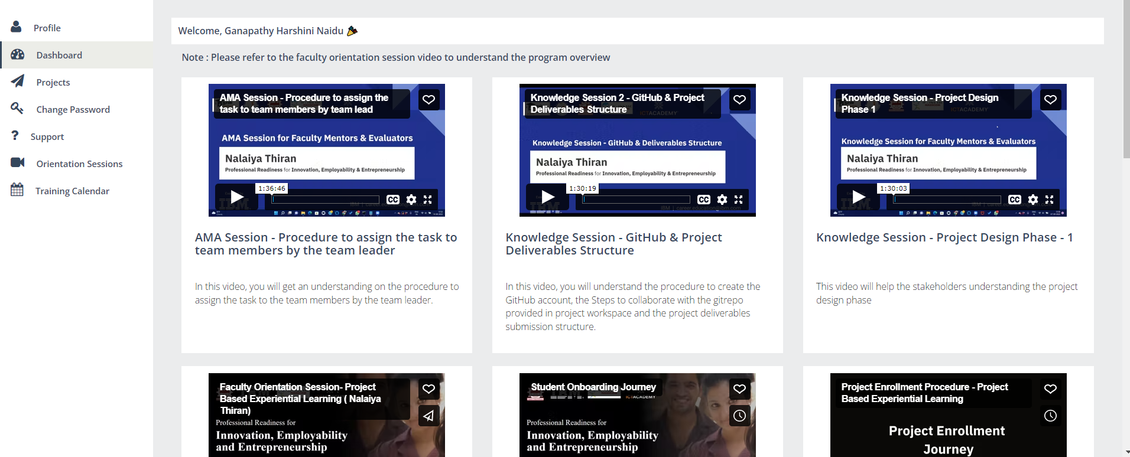

1.2 Joined the mentoring channel via platform & rocket-chat mobile app

1.3 Accessed the guided project workspace

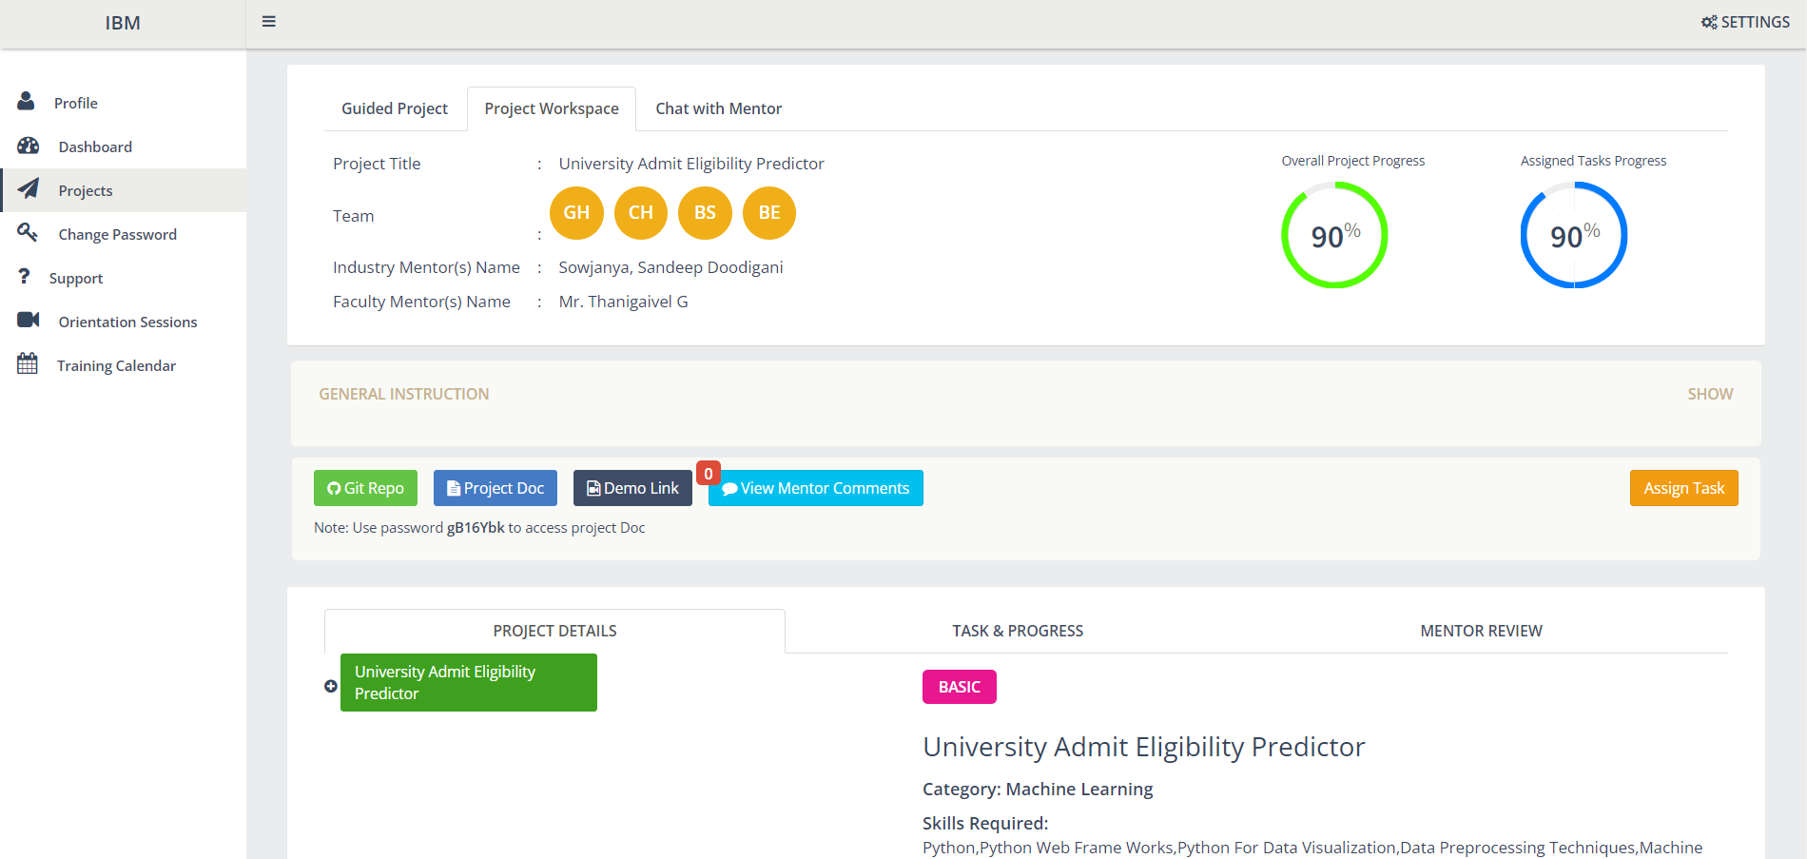

1.4 Registered on IBM Academic Initiative & Apply Feature code for IBM Cloud Credits

1.5 Created GitHub account & collaborate with Project Repository in project workspace

