|  |
| --- |
| **PERSONAL ASSISTANCE FOR SENIORS**  **WHO ARE SELF RELIANT USING IOT**  **IBM Project**      **TEAM LEAD**  M.Vignesh    **TEAM MEMBERS**  Maharaja.S  Sreedhar.A  Xavier Arul Nelson.A    OF  BACHELOR OF TECHNOLOGY  IN  INFORMATION TECHNOLOGY  FRANCIS XAVIER ENGINEERING COLLAGE  TIRUNELVELI |

|  |
| --- |
|  |
| **INDEX**  1.  **INTRODUCTION**     1. Project Overview 2. Purpose 3. **LITERATURE SURVEY**    1. Existing problem    2. References    3. Problem Statement Definition 4. **IDEATION & PROPOSED SOLUTION**    1. Empathy Map Canvas    2. Ideation & Brainstorming    3. Proposed Solution    4. Problem Solution fit 5. **REQUIREMENT ANALYSIS**    1. Functional requirement    2. Non-Functional requirements 6. **PROJECT DESIGN**    1. Data Flow Diagrams    2. Solution & Technical Architecture    3. User Stories 7. **PROJECT PLANNING & SCHEDULING**    1. Sprint Planning & Estimation    2. Sprint Delivery Schedule    3. Reports from JIRA |

|  |
| --- |
| 1. **CODING & SOLUTIONING (Explain the features added in the project along with code)**    1. Feature 1    2. Feature 2    3. Database Schema (if Applicable) 2. **TESTING** |
| 1. Test Cases 2. User Acceptance Testing 3. **RESULTS**   1. Performance Metrics   1. **ADVANTAGES & DISADVANTAGES** 2. **CONCLUSION** 3. **FUTURE SCOPE** 4. **APPENDIX**   Source Code  GitHub & Project Demo Link |

**1.INTRODUCTION:**

Sometimes patients forget to take the medicine at the required time of medicines.

* Also forgets which medicine He/ She have to take at required time.
* To overcome this, we have tried to design the MEDICINE REMINDER
* We are using Arduino to interface the LCD module, buzzer, Real time clock (RTC) 2 Almost half of all people who live in nursing homes are 85 years or older. Relatively few residents are younger than 65 years of age.

* 1. **Project overview:**

1.An app is built for the user(caretaker) which enables him to set the desired time and medicine. These details will be stored in the IBM Cloudant DB.

2.If the medicine time arrives the web application will send the medicine name to the IOT Device through the IBM IOT Platform.

3.The device will receive the medicine name and notify the user with voice commands.

* 1. **Purpose:**

1.Sometimes elderly people forget to take their medicine at the correct time.

2.The difficult for doctors/caretakers to monitor the patients around the clock. To avoid this problem,this medicine remainder system is developed.

3. They also forget which medicine He/She should take at that particular time

.

# 2.LITERATURE SURVEY

A literature review is a comprehensive summary of previous research on a topic. The literature review surveys scholarly articles, books, and other sources relevant to a particular area of research. The review should enumerate, describe, summarize, objectively evaluate and clarify this previous research.

**2.1 Existing problem:**

Elderly people let slip the medicagtions at the correct time and the existing solutions for this problem is setting remainders or using pill boxes,calenders,Personal Assistance. Though the solutions give remainder,the voice commands or assistance given by this system is more efficient.

**2.2 References:**

1.Sawand , S.Djahel, Z.Zhang, and F.Na. Multidisciplinary Approaches to Achieving Efficient and Trustworthy eHealth Monitoring Systems. Commun China(ICCC),2014 IEEE/CIC Int.Conf., pp.187-192; 2014.

2.D.a.Clifton,D.Wong, L. Clifton,S.Wilson,R.Way, R.Pullingar, and L.Tarassenko. a large scale clinical validation of an integrated monitoring system in the Emergency Department.

3.M. Parida, H.C Yang, S.W. Jheng, and C.J Kuo.Application of RFID Technology for In-

House Drug Management System.15th Int. Conf. Network-Based Inf.Syst., pp.577581;2012.

4.L. IKKo and J.Karppinen.UbiPILL A Medicine Dose controller of Ubiquitous Home

Environment. 2009 Third Int. Conf. Mob. Ubiquitous Comput. syst. Serv. Technol., pp.329-2009.

**2.3 Problem Statement Definition**

Skipping medicines can be serious for some medical health conditions; Sometimes elderly people forget to take their medicine at the correct time. they also forget which medicine one should take at that particular time. and it is difficult for doctors/caretakers to monitor the patients around the clock.

# 3.IDEATION & PROPOSED SOLUTION

**3.1 Emapthy Map Canvas:**

An empathy map is a collaborative tool teams can use to gain a deeper insight into their customers. Much like a user persona, an empathy map can represent a group of users, such as a customer segment. The empathy map was originally created by Dave Gray and has gained much popularity within the agile community.

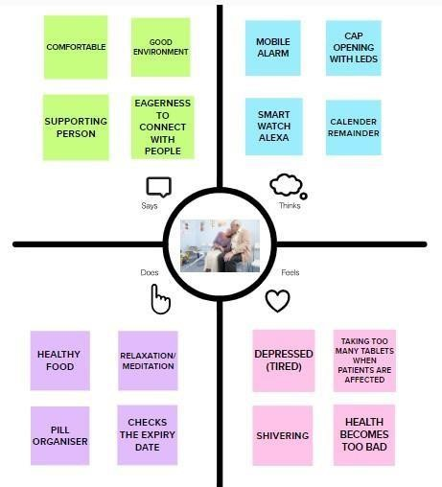

## Figure: Empathy Map

**3.2 Ideation & Brainstorming:**

Brainstorming is a group problem-solving method that involves the spontaneous contribution of creative ideas and solutions. This technique requires intensive, freewheeling discussion in which every member of the group is encouraged to think aloud and suggest as many ideas as possible based on their diverse knowledge

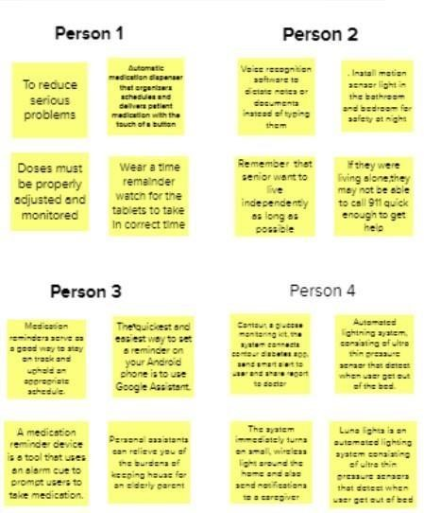

## Figure : Brainstorming

**3.3 Proposed Solution:**

The proposed solution is to maintain the robot's position inside, but close, to the boundary of the target's field of view. My proposed solution is to refuse these oppositions altogether. Their proposed solution is the use of complex objects, comprising several components, to express structure and relationships.

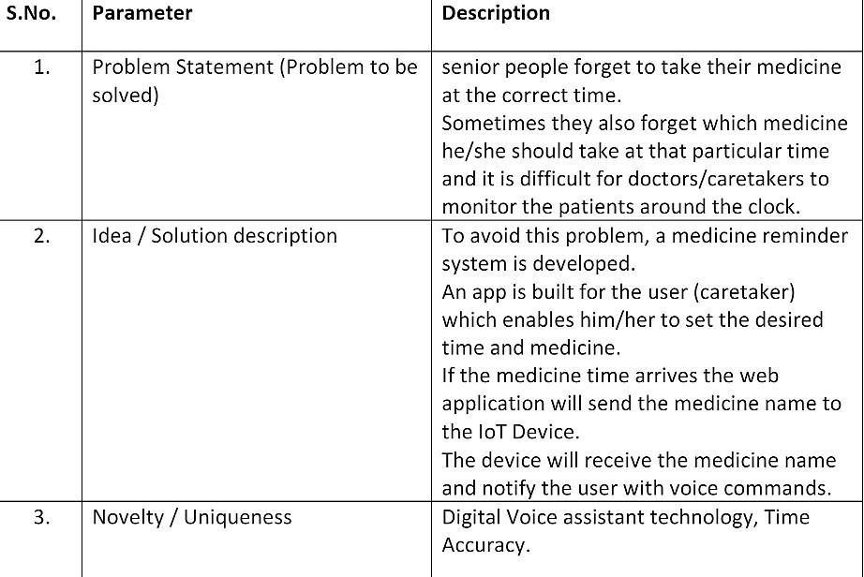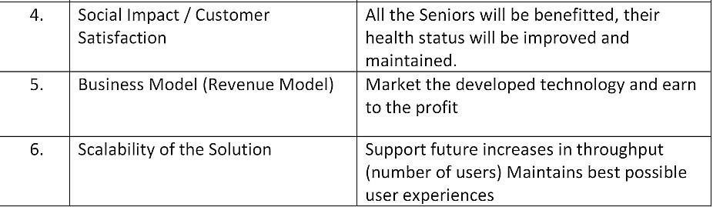

**3.4 Problem Solution fit:**

Problem-Solution canvas is a tool for entrepreneurs, marketers and corporate innovators, which helps them identify solutions with higher chances for solution adoption, reduce time spent on solution testing and get a better overview of current situation.

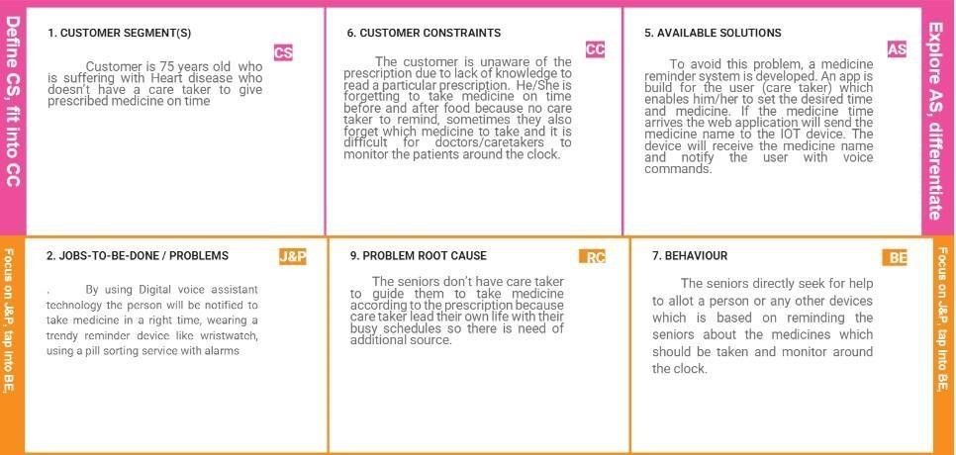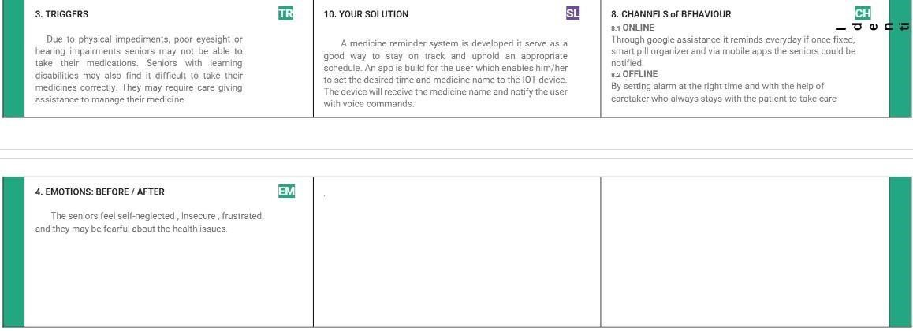

**4.REQUIREMENT ANALYSIS:**

The first phase in system engineering is requirements analysis. This is an iterative process, and continues as more specific requirements become clear.

**4.1. Functional Requirements:**

Functional requirements may involve calculations, technical details, data manipulation and processing, and other specific functionality that define what a system is supposed to accomplish. Behavioral requirements describe all the cases where the system uses the functional requirements, these are captured in use cases.

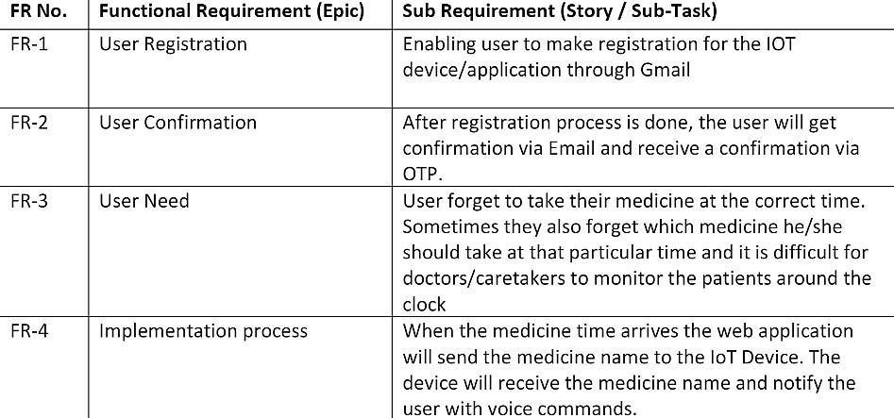

**4.2. Non-functional Requirements:**

Nonfunctional Requirements (NFRs) define system attributes such as security, reliability, performance, maintainability, scalability, and usability. They serve as constraints or restrictions on the design of the system across the different backlogs

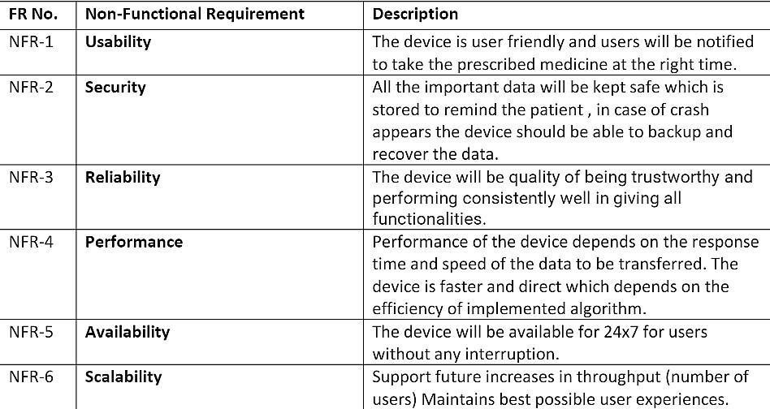

# 5.PROJECT DESIGN

Project design is an early phase of the project lifecycle where ideas, processes, resources, and deliverables are planned out. A project design comes before a project plan as it's a broad overview whereas a project plan includes more detailed

**5.1. Data Flow Diagrams :**

data flow diagram (DFD) is a graphical or visual representation using a standardized set of symbols and notations to describe a business's operations through data movement. They are often elements of a formal methodology such as Structured Systems Analysis and Design Method (SSADM).

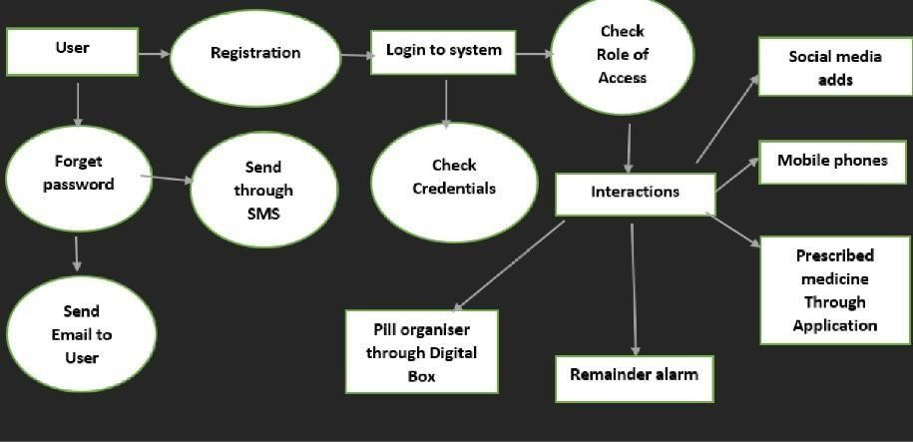

## Figure: Data Flow Diagram

**5.2 Solution & Technical Architecture**

An architectural diagram is a visual representation that maps out the physical implementation for components of a software system. It shows the general structure of the software system and the associations, limitations, and boundaries between each element.

Software environments are complex—and they aren't static.

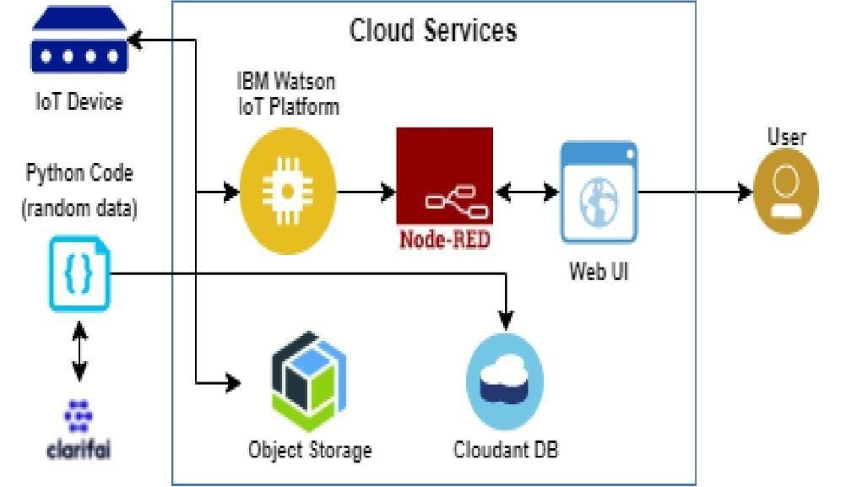

## Figure: Architecture

**5.3 User stories:**  user story is an informal, general explanation of a software feature written from the perspective of the end user or customer. The purpose of a user story is to articulate how a piece of work will deliver a particular value back to the customer.

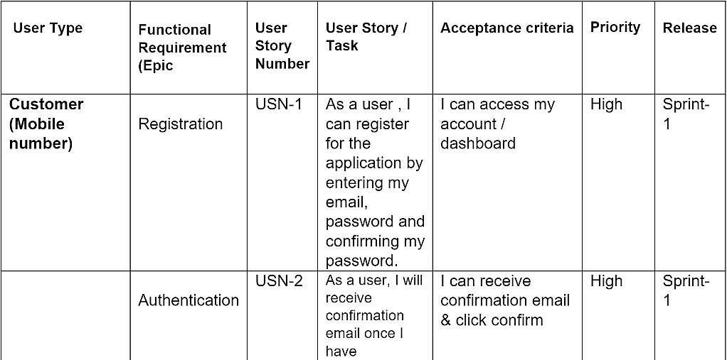

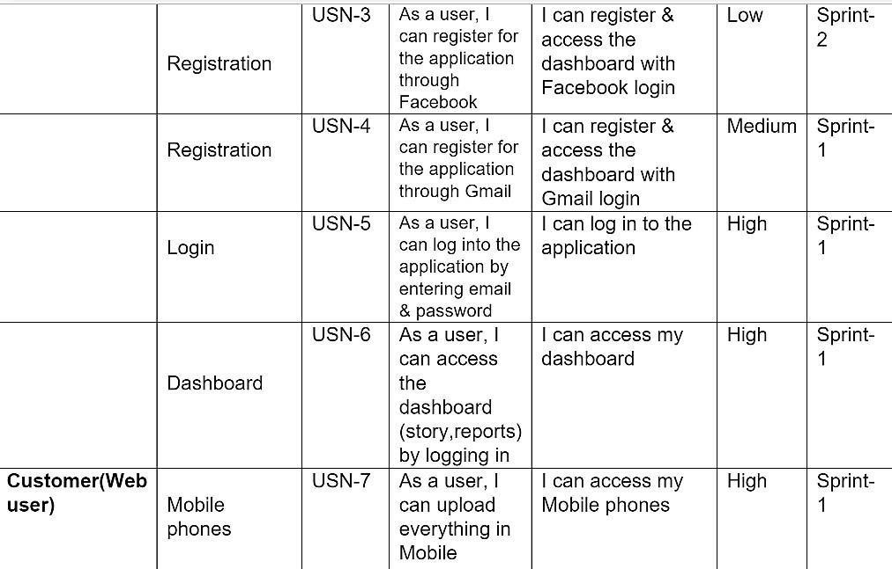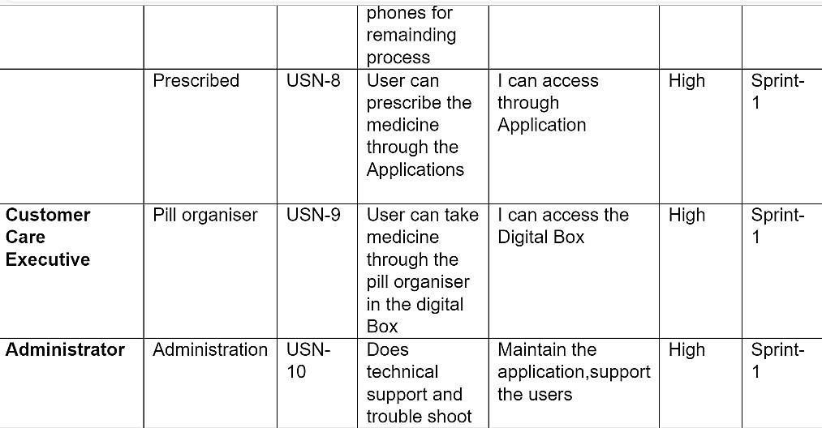

# 6.PROJECT PLANNING &SCHEDULING

**6.1 Sprint planning & Estimation:**

In Scrum Projects, Estimation is done by the entire team during Sprint Planning

Meeting. The objective of the Estimation would be to consider the User Stories for the Sprint by Priority and by the Ability of the team to deliver during the Time Box of the Sprint.

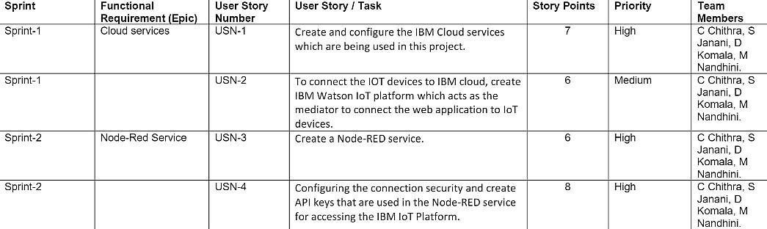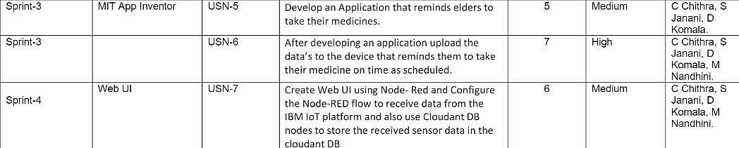

**6.2 Sprint Delivery schedule:**

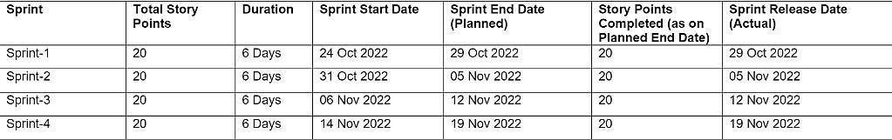

**6.3 Reports from JIRA:**

# 7.CODING & SOLUTIONING

**7.1 Feature 1**

**7.2 Feature 2**

# 8.TESTING

A method of software testing that examines the functionality of an application without peering into its internal structures or workings. This method of test can be applied to virtually every level of software testing: unit, integration, system and acceptance.

**8.1 Test Cases:**

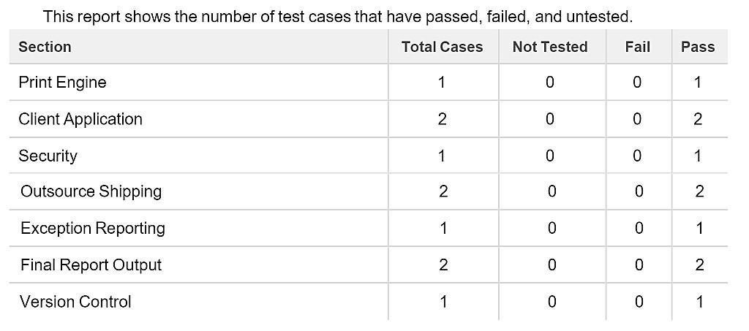

**8.2 User Acceptance Testing:**

The User Acceptance Testing (UAT) phase is likely to be the most expensive type of testing undertaken due to the number of people, timescales, and repeated cycles involved.

It is well worth optimizing UAT testing to get the best outcome and do it in the most efficient and cost-effective way.

# RESULTS

**9.1 Performannce Metrics:**

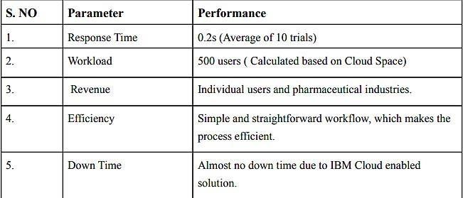

# ADVANTAGES & DISADVANTAGES

**Advantages:**

1. Help the elderly people to take their medicine at the correct time.
2. Avoid personal assistants or caretakers needed for medically sick people.
3. Cost efficient
4. Can store multiple data and many notifications can be generated.
5. Since it includes voice assistance, even blind people can use our device.

**Disadvantage:**

1. Makes people lethargic and makes them dependent always on others.
2. Requires a stable internet connection

# 11.CONCLUSION

The project offers the elderly or medically sick people a personal assistant which reminds them of the medicines to be consumed at the particular time. Skipping tablets may lead to serious problems if the person has a severe illness and this can be avoided. Since the cloud is integrated with the mobile application, numerous data can be fed into the database and notifications can be generated. The mobile application developed is highly customisable by the user and easy to use.

# 12.FUTURE SCOPE

The project can be further developed by bringing into the feature of informing the medicine name during the notification. The voice assistance which is given can be customized by adding the user's voice or the caretaker’s voice. Further the mobile application can update medicines by taking voice commands as an input from the user.

# 13.APPENDIX

**Source Code:**

#include <DS3231.h> **//RTC3231Library**

#include <Wire.h> **// i2Conection Library**

#include<LiquidCrystal.h> **//Libraries**

#include<EEPROM.h>LiquidCrystal lcd(2, 3, 4, 5, 6, 7); **//Arduino pins to lcd**

#define bt_timeA0

#definebt_up A1

#define bt_downA2

#define bt_alarmA3

#define buzzer8 **//InitDS3231**

DS3231rtc(SDA,SCL); **// Init a Time-data** structureTimet; **//pencacah** str ingtime() int hh = 0, mm = 0, ss = 0, dd = 0, bb = 0, set_day;int yy=0; StringDay=""; int AlarmHH= 21, AlarmMM= 22, AlarmSS= 23, setMode = 0, setAlarm = 0, alarmMode=0;intstop=0,mode=0, flag=0; uint8_t HH;uint8_tMM; byte bell_symbol[8] ={B00100,B01110, B01110, B01110, B01110,

B11111,B01000,B00100};

byte thermometer_symbol[8]

= {B00100,B01010,B01010,B01110,B01110,B11111,B11111,B01110}; voidsetup(){

// Setup Serial connectionSerial.begin

(9600);rtc.begin(); pinMode(bt_time,INPUT_PULLUP); pinM ode(bt_up,INPUT_PULLUP); pinMode(bt_down,INPUT_PULLUP); pinMode(bt_alarm,INPUT_PULLUP);pinMode(buzze

r, OUTPUT); lcd.createChar(1, thermometer_symbol);lcd.createChar(2, bell_symbol);lcd.begin(16,2); lcd.setCursor(0,0);//Show "TIME" on the LCDlcd.setCursor(0,0); lcd.print(" Medicine "); lcd.setCursor (0,1); lcd.print("Remind er "); delay(2000);

lcd.clear();

stop=EEP

ROM.read(50); if(stop==0){

}

Else

{

WriteEeprom();

}

EEPROM.write(50,0);

ReadEeprom();

//SetRTCUntukPertamakali

//rtc.setDOW(2); //SetDay-of-WeektoSUNDAY

//rtc.setTime(00,9,50);

//rtc.setDate(12,11,2017);

}

voidloop(){ t=rtc.getTime(); Day =rtc.getDOWStr(1);

if(se tMode==0){ hh=t.hour,DEC;mm=t.min,DEC;s s=t. sec,DEC;dd =t.date,DEC;bb

=t.mon,DEC;yy=t. year,DEC;

}

if(setAlarm==0){lcd.se tCursor(0,0); lcd.print(( hh/10)%10); lcd.print(hh %10); lcd.print(":"); lcd.pri nt((mm/10)%10); lcd.pr int(mm %10); lcd.print(":"); lcd.pri nt((ss/10)%10); lcd.prin t(ss % 10); lcd.print(""); if(mode==1){lcd.write(2);} else{lcd.print("");

} lcd.print(" "); lcd.write( 1); lcd.print(rtc.getTemp(), 0); lcd.write(223); lcd.pri nt("C"); lcd.print(""); lcd.setCursor(1,1); lcd. print(Day); lcd.print(" "); lcd.print((dd/10)%10); lcd.print(dd %10); lcd.print("/"); lcd.pr int((bb/10)%10); lcd.pri nt(bb %10); lcd.print("/"); lcd.pri nt((yy/1000)%10); lcd. print((yy/100)%10); lcd. print((yy/10)%10); lcd.print(yy%10);

}

setupClock() ;

setTimer(); delay

(100);blinki ng(); //Alarm if (alarmMode==1 && mode==1 && hh==AlarmHH && mm==AlarmMM &&ss>=AlarmSS) {digitalWrite(buzzer,HIGH);

lcd.clear();lcd.setCursor( 0,0);lcd.print(" Time totake"); lcd.setCursor (0,1); lcd.print("Medicine"); delay(300); digitalWrite(buzzer,LOW); lcd.clear();

}

Else

{

digitalWrite(buzzer,LOW);

}

delay(100);

}

voidblinking(){

**//BLINKINGSCREEN**  if(setAlarm <2 && setMode == 1){lcd.setCursor(0,0);

lcd.print("");} if(setAlarm <2 && setMode==2){lcd.setCursor(3,0); lcd.print("");} if (setAlarm <2 && setMode == 3){lcd.setCursor(6,0); lcd.print("");} if (setAlarm <2 && setMode == 4){lcd.setCursor(1,1); lcd.print("");} if (setAlarm <2 && setMode == 5){lcd.setCursor(5,1); lcd.print("");} if(setAlarm<2&&setMode==6){lcd.setCursor(8,1);

lc d.print("");}

if(setAlarm<2&&setMode==7){lcd.setCursor(11,1);lcd.print("");}

**//Alarm** if(setMode==0&&setAlarm==1){lcd.setCursor(6,0); lcd.print(" ");

}

if(setMode ==0&& setAlarm==2){lcd.setCursor(4,1); lcd.print("");

}

if (setMode == 0 && setAlarm == 3){lcd.setCursor(7,1); lcd.print("");

}

if(setMode==0&&setAlarm==4){lcd.setCursor(10,1)

;lcd.print("");}

}

**//Seting Jam**

,Tanggal,Alarm/Timervoidsetup

Clock(void) { if (setMode ==8){lcd.setCursor(0,0); lcd.print (F("Set Date Finish ")); lcd.setCursor(0,1); lcd.print (F("Set Time Finish ")); delay(1000); rtc.setTime (hh, mm, ss); rtc.setDate (dd, bb, yy); lcd.clear();

setMode=0;

}

if (setAlarm ==5){lcd.setCursor(0,0); lcd.print (F("Set Alarm Finish")); lcd.setCursor(0,1);

lcd.print (F("-EEPROM Updated")); WriteEeprom(); delay (2000); lcd.cle ar(); setAlarm =0; alarmMod e=1;

}if(setAlarm>0){alarmMode=0;} if(digitalRead (bt_time) == 0 && flag==0) {flag=1;if(setAlarm>0){setAlarm=5;}

else{setMode=setMode+1;}

}

if(digitalRead (bt_alarm) == 0 && flag==0){flag=1; if(setMode>0){setMode=8;}

else{setAlarm = setAlarm+1;}

lcd.clear();}

if(digitalRead(bt_time)==1&& digitalRead(bt_alarm)==1){flag=0;} if(digitalRead(bt_up)==0){ if(setAlarm<2&&setMode==1)hh=hh+1;

if (setAlarm<2

&&setMode==2)mm=mm+1;if(setAlarm<2&

&setMode==3)ss=ss+1; if (setAlarm<2 && setMode==4)set_day=set_day+1;if(setAlarm<2

&&setMode==5)dd=dd+1; if (setAlarm<2 && setMode==6)bb=bb+1;if(setAlarm<2&

&setMode==7)yy=yy+1;

**//Alarm** if(setMode==0&&setAlarm==1)mode=1; if(setMode==0&&setAlarm==2&&AlarmHH<23)AlarmHH=AlarmHH+1; if

(setMode==0 && setAlarm==3 &&

AlarmMM<59)AlarmMM=AlarmMM+1;if(setMode==0&&setAlarm==4&

&AlarmSS<59)AlarmSS=AlarmSS+1;

if(hh>23)hh=0;if(mm> 59)mm=0;if(ss>59)ss =0;if(set_day>7)set_d ay=0;if(dd>31)dd=0;if( bb>12)bb=0;if(yy>203

0)yy=2000;rtc.setDO

W(set_day);

}

if(digitalRead(bt_down)==0){ if(setAlarm<2&&setMode==1)hh=hh-1; if (setAlarm<2 && setMode==2)mm=mm- 1;if(setAlarm<2&&setMode==3)ss=ss-1; if

(setAlarm<2 && setMode==4)set_day=set_day1;if(setAlarm<2&&se tMode==5)dd=dd-1; if (setAlarm<2 && setMode==6)bb=bb-

1;if(setAlarm<2&&setMode==7)yy=yy

-1;

**//Alarm** if(setMode==0&&setAlarm==1)mode=0; if(setMode==0&&setAlarm==2&&AlarmHH>0)AlarmHH=AlarmHH-1; if (setMode==0 && setAlarm==3 && AlarmMM>0)AlarmMM=AlarmMM-

1;if(setMode==0&&setAlarm==4&&AlarmSS>0)AlarmSS=AlarmSS-1; if(hh<0)hh=23;if(mm< 0)mm=59;if(ss<0)ss= 59;if(set_day<0)set_d ay=7;if(dd<0)dd=31;if( bb<0)bb=12;if(yy<0)yy =2030;rtc.setDOW(set

_day);

}

}

voidsetTimer()

{

**//Alarm** if(setMode==0&&setAlarm>0){lcd.setCu rsor

(0,0);lcd.print("Alarm "); if(mode==0){lcd.print("Deactivate");

}

Else

{

lcd.print("Activated");

}

lcd.setCursor(4,1);

lcd.print((AlarmHH/10)%10); lcd.print(AlarmHH %10); lcd.print(":"); lcd.print((Ala rmMM/10)%10); lcd.print(Ala rmMM %10); lcd.print(":"); lcd.print((Al armSS/10)%10); lcd.print(Ala rmSS%10);

}

}

void ReadEeprom ()

{AlarmHH=EEPROM.read(1);AlarmMM= EEPROM.read(2);AlarmSS=EEPROM.rea d(3);

mode=EEPROM.read(4);

}

void WriteEeprom ()

{EEPROM.write(1,AlarmHH);

EEPROM.write(2,Alarm MM);

EEPROM.write(3,Alar mSS);

EEPROM.write(4,mode);

}



  
  
  