**Assignment -2**

Python Programming

|  |  |
| --- | --- |
| Assignment Date | 28-09-2022 |
| Student Name | Kavinaya N |
| Student Roll Number | 310619205046 |

Question 1.

Create registration page in html with username, email and phone number and by using POST method display it in next html page.

Program:

**register.html**

<!DOCTYPE html>

<html>

<head>

<meta charset="UTF-8">

<meta http-equiv="X-UA-Compatible" content="IE=edge">

<meta name="viewport" content="width=device-width, initial-scale=1.0">

<title>Registration form</title>

</head>

<body>

<center>

<form action="{{ url_for("register")}}" method="post">

Name : <input type="text" name="user"><br><br>

Email id : <input type="text" name="email"><br><br>

Phone Number : <input type="text" name="phone"><br><br>

<input type="submit" value="Submit"><br>

</form>

</center>

</body>

</html>

**app.py:**

from flask import Flask, request, render_template

app = Flask(__name__)

@app.route('/', methods =["GET", "POST"])

def register():

if request.method == "POST":

name = request.form.get("user")

email = request.form.get("email")

phone = request.form.get("phone")

return "Name is : " + name + ", Email is : " + email + ", Mobile Number is : "+ phone

return render_template("register.html")

if __name__=='__main__':

app.debug=True

app.run()

Question 2.

Develop a flask program which should contain atleast 5 packages used from pypi.org

**base.html:**

<!DOCTYPE html>

<html>

<head>

<title>Page Title</title>

{% block head %} {% endblock %}

<link href="https://cdn.jsdelivr.net/npm/bootstrap@5.2.1/dist/css/bootstrap.min.css"

rel="stylesheet" integrity="sha384-

iYQeCzEYFbKjA/T2uDLTpkwGzCiq6soy8tYaI1GyVh/UjpbCx/TYkiZhlZB6+fzT"

crossorigin="anonymous">

<script src="https://cdn.jsdelivr.net/npm/bootstrap@5.2.1/dist/js/bootstrap.bundle.min.js"

integrity="sha384-

u1OknCvxWvY5kfmNBILK2hRnQC3Pr17a+RTT6rIHI7NnikvbZlHgTPOOmMi466C8"

crossorigin="anonymous">

</script>

</head>

<body>

<a href="/">HOME</a>

<a href="/Blog">BLOG</a>

<a href="/Signin">SIGN IN</a>

<a href="/Signup">SIGN UP</a>

<hr><br>

<div class="container">

{% block body %} {% endblock %}

</div>

</body>

</html>

**blog.html:**

{% extends 'base.html' %}

{% block head %}

<title>Blog Page</title>

{% endblock %}

{% block body %}

<h1>This is Jeffrey Blog</h1>

<h2><p>Hello, from Jeffrey</p></h2>

{% endblock %}

**index.html:**

{% extends 'base.html' %}

{% block head %}

<title>Home Page</title>

{% endblock %}

{% block body %}

<h1>Hello everyone,</h1>

<div class="p-5 mb-4 bg-light rounded-3">

<div class="container-fluid py-5">

<h1 class="dispay-5 fw-bold">WIFI TECHNOLOGY<h1>

<p class="col-md-8 fs-4"> Wi-Fi is a wireless networking technology that allows

devices such as computers (laptops and desktops), mobile devices (smart phones

and wearables), and other equipment (printers and video cameras) to interface with

the Internet.

</p>

</div>

</div>

{% endblock %}

**signup.html:**

{% extends 'base.html' %}

{% block head %}

<title>Signup Page</title>

{% endblock %}

{% block body %}

<h1>Signup Page</h1>

<form action="Signup" method="POST">

<label>Name</label><br>

<input type="text" name="name"><br><br>

<label>Email</label><br>

<input type="email" name="email"><br><br>

<label>Phone</label><br>

<input type="text" name="phone"><br><br>

<label>Password</label><br>

<input type="password" name="name"><br><br>

<label>Retype Password</label><br>

<input type="password" name="name"><br><br><br>

<input type="submit" class="btn btn-primary">

</form>

{% endblock %}

**signin.html:**

{% extends 'base.html' %}

{% block head %}

<title>Signin Page</title>

{% endblock %}

{% block body %}

<h1>Signin Page</h1>

<form action="/Signin" method="POST">

<label>Email</label><br>

<input type="email" name="email"><br><br>

<label>password</label><br>

<input type="password" name="name"><br><br>

<input type="submit" class="btn btn-primary">

</form>

{% endblock %}

**app.py:**

from flask import Flask, render_template

app = Flask(__name__ )

@app.route('/', methods =["GET", "POST"])

def Index():

return render_template('index.html')

@app.route('/Blog')

def Blog():

return render_template('blog.html')

@app.route('/Signup')

def Signup():

return render_template('signup.html')

@app.route('/Signin')

def Signin():

return render_template('signin.html')

if __name__ =='__main__':

app.debug = True

app.run()

OUTPUT:

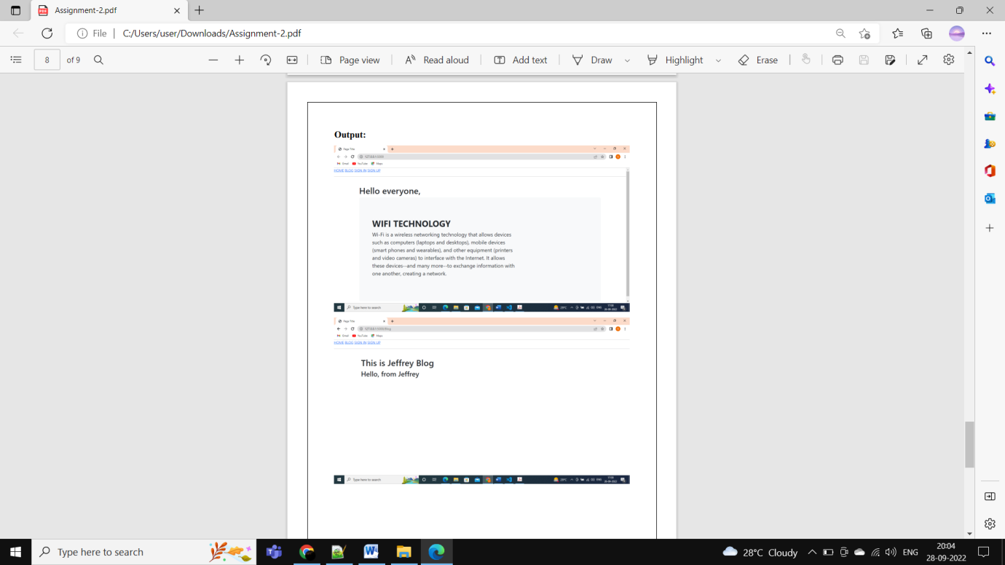

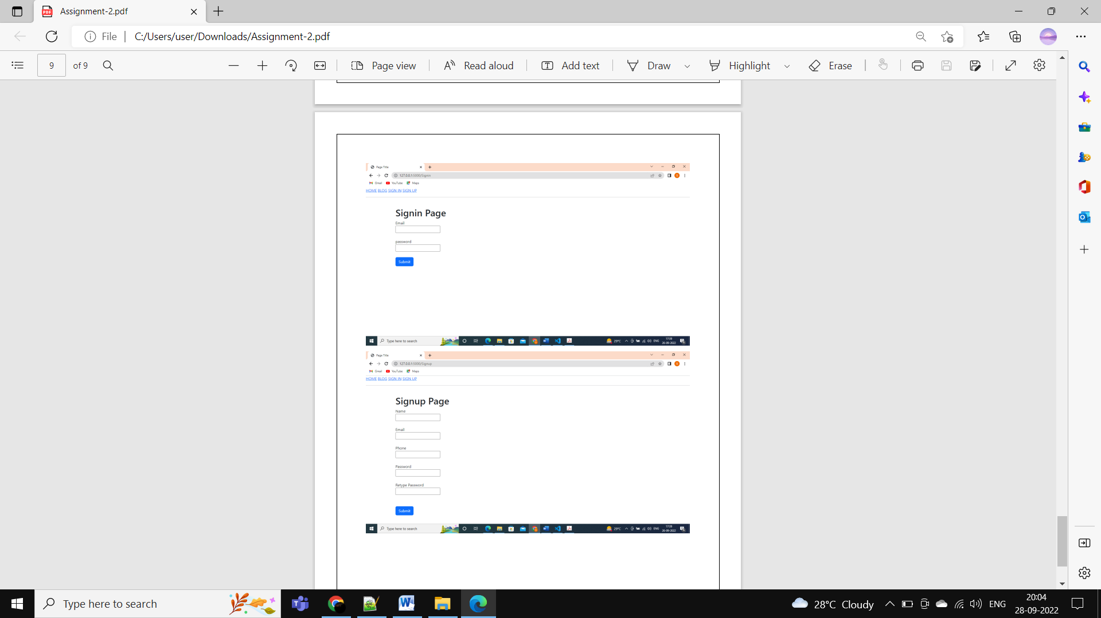

**Question-3:**

1. Create a User table with Username, email, roll number, password
2. Perform UPDATE and DELETE queries
3. Connect python code to database
4. Create Flask app for a User registration and User login

**Solution:**

**App.py**

from flask import Flask, render_template, request, redirect

import sqlite3 as sql

import models as dbHandler

app = Flask(__name__)

app.secret_key = 'fasdgfdgdfg'

@app.route('/')

def home():

   return render_template('home.html')

@app.route('/adduser')

def new_user():

   return render_template('add_user.html')

@app.route('/addrec',methods = ['POST', 'GET'])

def addrec():

   if request.method == 'POST':

      try:

         email = request.form['email']

         un = request.form['username']

         rn = request.form['rollnumber']

         pin = request.form['pin']

         with sql.connect("User_database.db") as con:

            cur = con.cursor()

            cur.execute("INSERT INTO users (email,username,rollnumber,pin) VALUES (?,?,?,?)",(email,un,rn,pin) )

            con.commit()

            msg = "Record successfully added!"

      except:

         con.rollback()

         msg = "error in insert operation"

      finally:

         return render_template("list.html",msg = msg)

         con.close()

@app.route('/list')

def list():

   con = sql.connect("User_database.db")

   con.row_factory = sql.Row

   cur = con.cursor()

   cur.execute("select * from users")

   users = cur.fetchall()

   return render_template("list.html", users = users)

if __name__ == '__main__':

   app.run(debug = True)

@app.route("/delete")

def delete():

    return render_template("delete.html")

@app.route('/deleterecord',methods = ["POST"])

def deleterecord():

    un = request.form['username']

    with sql.connect("User_database.db") as con:

        try:

            cur = con.cursor()

            cur.execute("DELETE FROM users WHERE username = ?",[un])

            con.commit()

            msg = "Record successfully deleted"

        except:

            msg = "can't be deleted"

        finally:

            return render_template("home1.html",msg = msg)

if __name__ == '__main__':

   app.run(debug = True)

@app.route('/deldb', methods = ["POST"])

def deldb():

   con = sql.connect('User_database.db')

   cur = con.cursor()

   cur.execute('DELETE FROM users;')

   con.commit()

   con.close()

   msg = 'All the data has been deleted'

   return render_template("home1.html",msg = msg)

@app.route("/log")

def log():

    return render_template("login.html")

@app.route('/login', methods =['GET', 'POST'])

def login():

   un = request.form['username']

   if request.method=='POST':

         users = dbHandler.retrieveUsers()

         msg = 'Logged in successfully!'

         return render_template('welcome.html', users=un, msg=msg)

   else:

         msg = 'You are not registered, would you like to be registered'

         return render_template('home1.html', msg=msg)

if __name__ == '__main__':

    app.run(debug=False, host='0.0.0.0')

**Models.py**

**import sqlite3 as sql**

def retrieveUsers():

    con = sql.connect("User_database.db")

    cur = con.cursor()

    cur.execute("SELECT username, pin FROM users")

    users = cur.fetchone()

    con.close()

    return users

**sqlite_db_setup.py**

**import sqlite3**

conn = sqlite3.connect('User_database.db')

print("Opened database successfully")

conn.execute('CREATE TABLE users (email TEXT, username TEXT, rollnumber INTEGER, pin INTEGER)')

print("Table created successfully")

conn.close()

**Home.html**

**<h1>Welcome to User DB APP</h1><br><br>**

<a href="/">HOME</a><br><br>

<a href="/adduser">User Registration</a><br><br>

<a href="/list">List User</a><br><br>

<a href="/log">Log in</a><br><br>

<a href="/delete">Remove a User</a>

**Add_user.html**

**<form action = "{{ url_for('addrec') }}" method = "POST">**

    <h3>User Information</h3>

    E-mail<br>

    <input type = "email" name = "email" /></br>

    Username<br>

    <input type = "text" name = "username" /></br>

    Rollnumber<br>

    <input type = "text" name = "rollnumber" /><br>

    PIN<br>

    <input type = "password" name = "pin" min="4" max="8" /><br><br>

    <input type = "submit" value = "submit" /><p>     </p>

    <input type = "reset"/>

 </form>

**list.html**

**<!doctype html>**

<html>

   <body>

    <a href="/">HOME</a><br><br>

    <a href="/adduser">Add New Student</a><br><br>

    <a href="/list">List Student</a><br><br>

    <br><hr>

    {{ msg }}

      <table border = 1>

         <thead>

            <td>   Email   </td>

            <td>  Username  </td>

            <td> Roll Number </td>

            <td>   Pin   </td>

         </thead>

         {% for row in users %}

            <tr>

               <td>{{row["email"]}}</td>

               <td>{{row["username"]}}</td>

               <td> {{ row["rollnumber"]}}</td>

               <td>{{row['pin']}}</td>

            </tr>

         {% endfor %}

      </table>

   </body>

</html>

