**Assignment -1**

Python Programming

|  |  |
| --- | --- |
| Assignment Date | 27 September 2022 |
| Student Name | Adhishwar R |
| Student Roll Number | 412519104003 |
| Maximum Marks | 2 Marks |

**Question-1:**

Split the string

Solution :  
 s="hi there sam!"

print(s.split())

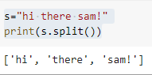

**Question-2:**

Use .format() to print the following string

Output should be: The diameter of the Earth is 12742 kilometers.

Solution:  
 planet="Earth"

diameter=12742

star ="The diameter of {p} is {k} Kilometers."

print(star.format(p=planet,k=diameter))

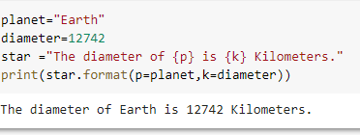

**Question-3:**

In this nest dictionary grab the word "hello"

Solution:  
 d = {'k1':[1,2,3,{'tricky':['oh','man','inception',{'target':[1,2,3,'hello']}]}]}

d['k1'][3]['tricky'][3]['target'][3]

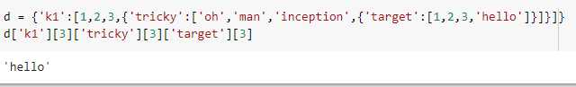

**Question-4:**

Create an array of 10 zeros?

Create an array of 10 fives?

Solution:  
 array=np.zeros(10)

print("An array of 10 zeros")

print(array)

array=np.ones(10)*5

print("An array of 10 fives")

print(array)

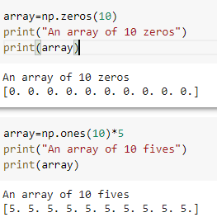

**Question-5:**

Create an array of all the even integers from 20 to 35

Solution:  
 a=np.arange(20,35,2)

print(a)

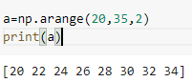

**Question-6:**

Create a 3x3 matrix with values ranging from 0 to 8

Solution:  
 x=np.arange(0,9).reshape(3,3)

print(x)

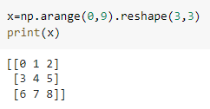

**Question-7:**

Concatenate a and b

Solution:  
 a=np.array([1,2,3])

b=np.array([4,5,6])

print(a)

print(a)

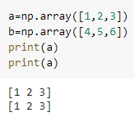

**Question-8:**

Create a dataframe with 3 rows and 2 columns

Solution:  
 import pandas as pd

data=[['vamsi',10],['mahesh',20],['sai',30]]

a=pd.DataFrame(data,columns=['Name','Age',])

print(a)

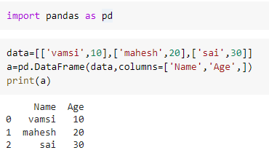

**Question-9:**

Generate the series of dates from 1st Jan, 2023 to 10th Feb, 2023

Solution:

from datetime import datetime, timedelta

def date_range(start, end):

delta = end - start # as timedelta

days = [start + timedelta(days=i) for i in range(delta.days + 1)]

return days

start_date = datetime(2023, 1, 1)

end_date = datetime(2023, 2, 10)

print(*date_range(start_date,end_date)) 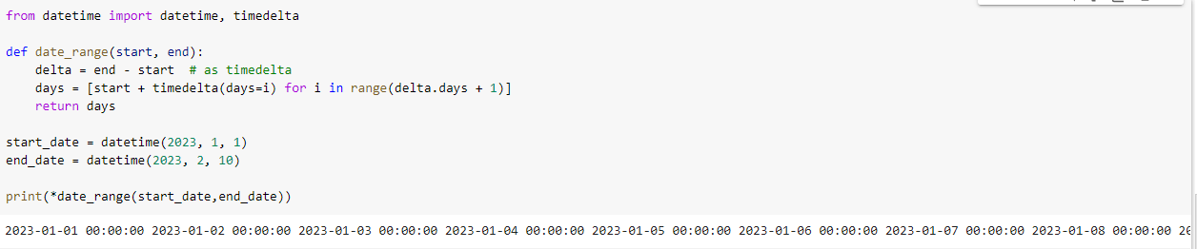

**Question-10:**

Create 2D list to DataFrame

Solution:

lists = [[1, 'aaa', 22], [2, 'bbb', 25], [3, 'ccc', 24]]

df=pd.DataFrame(lists,columns=['Number','FName','Age'])

print(df)

