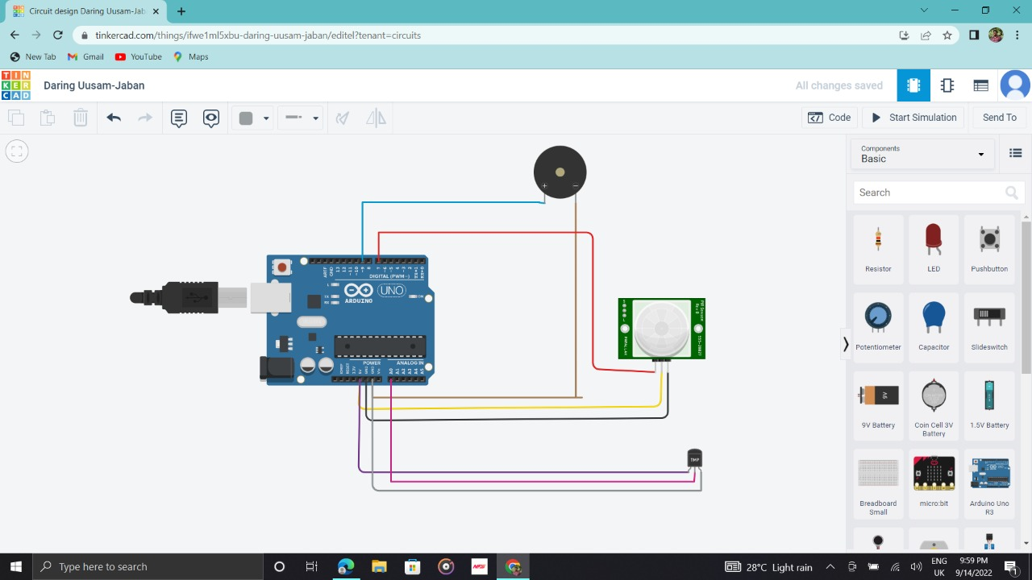

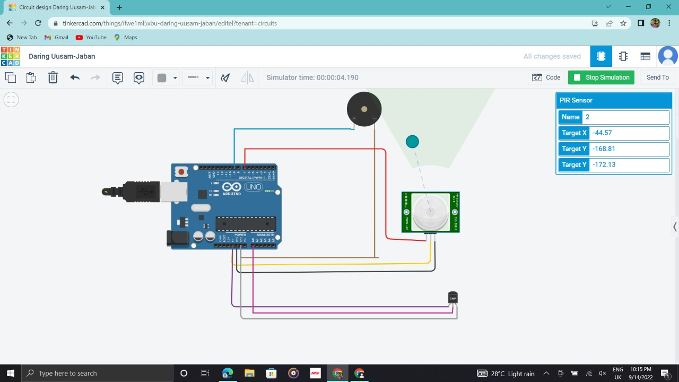

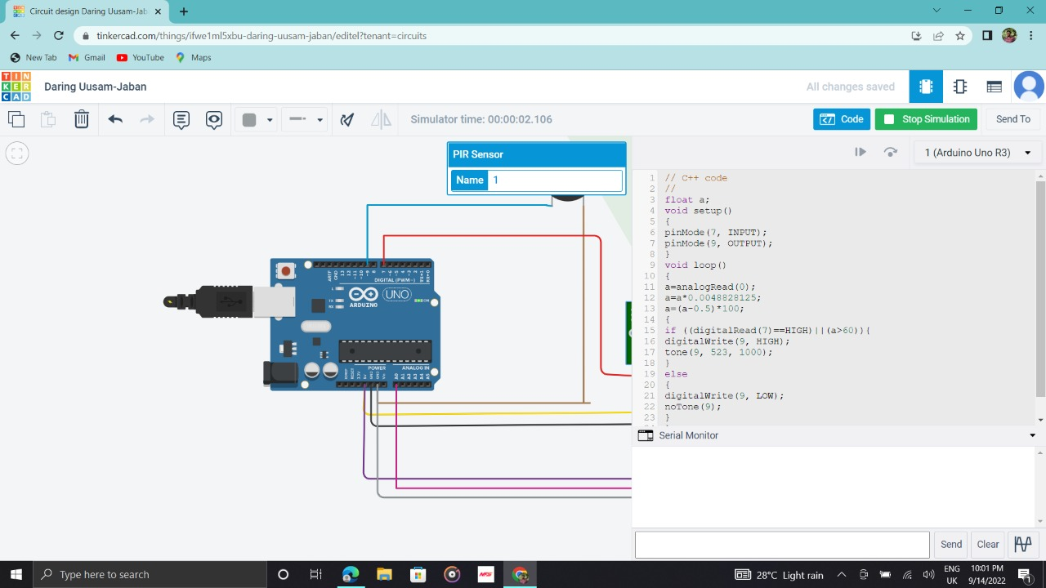

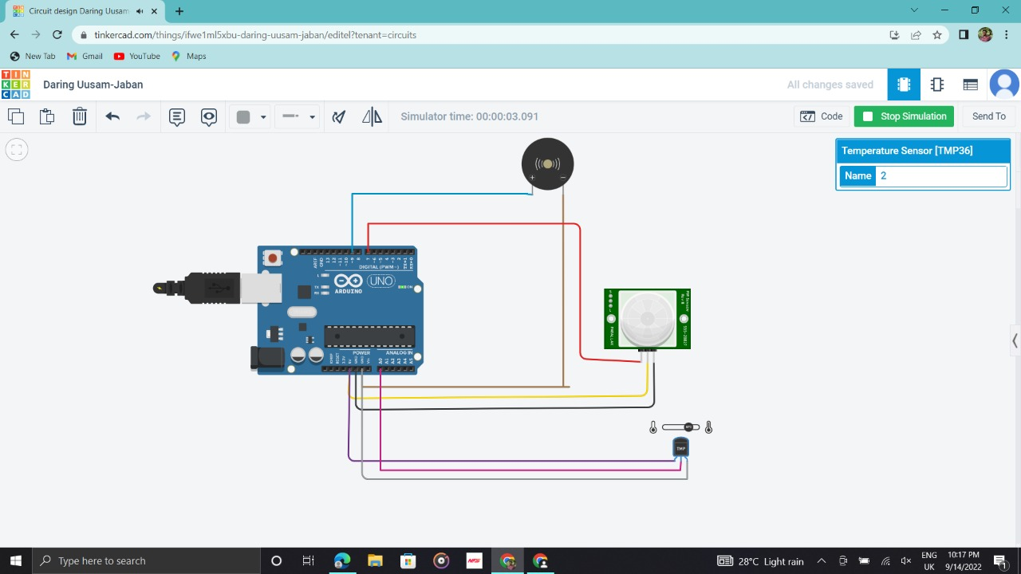

float a;

void setup()

{

pinMode(7, INPUT);

pinMode(9, OUTPUT);

}

void loop()

{

a=analogRead(0);

a=a\*0.0048828125;

a=(a-0.5)\*100;

{

if ((digitalRead(7)==HIGH)||(a>60)){

digitalWrite(9, HIGH);

tone(9, 523, 1000);

}

else

{

digitalWrite(9, LOW);

noTone(9);

}

}

}