**Prerequisites for Artificial Intelligence**

***Hardware Specifications****:*

● Windows (minimum 10), Mac & Linux

● Ram - 4GB ( minimum)

● Hard Disk - 100GB (minimum)

● Processor - Intel i3 (minimum), Mac M1

***Software Specifications***:

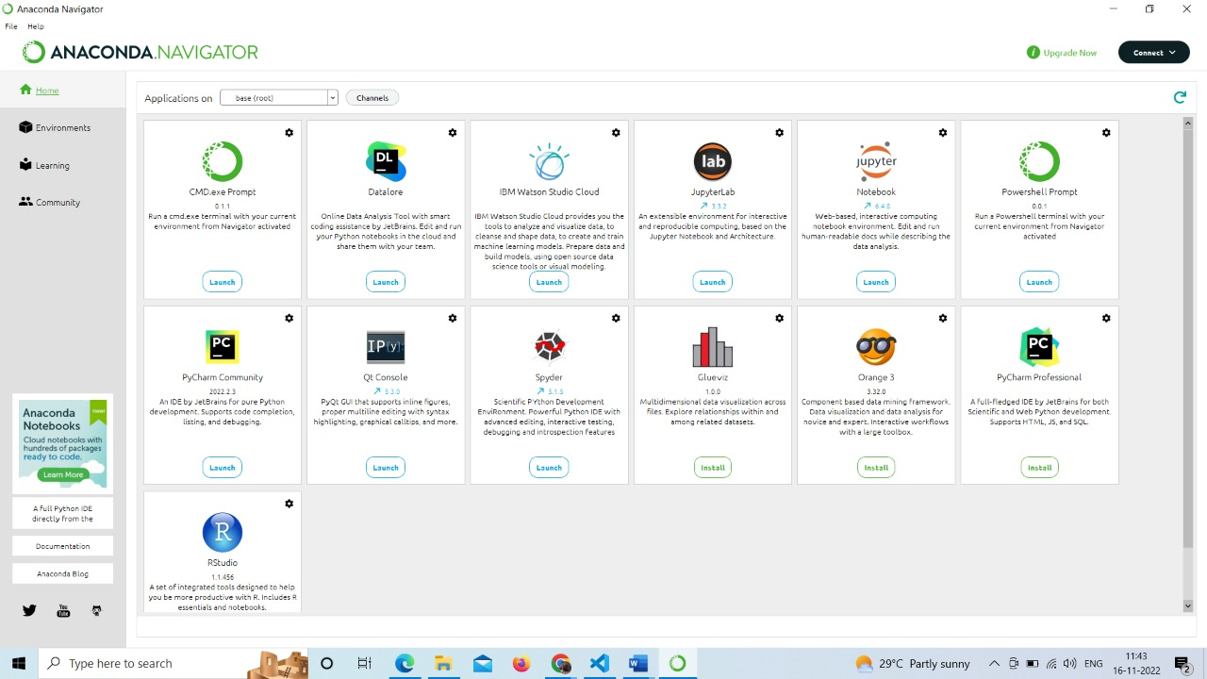● Anaconda Navigator - <https://www.anaconda.com/products/distribution>

● Jupyter notebook.

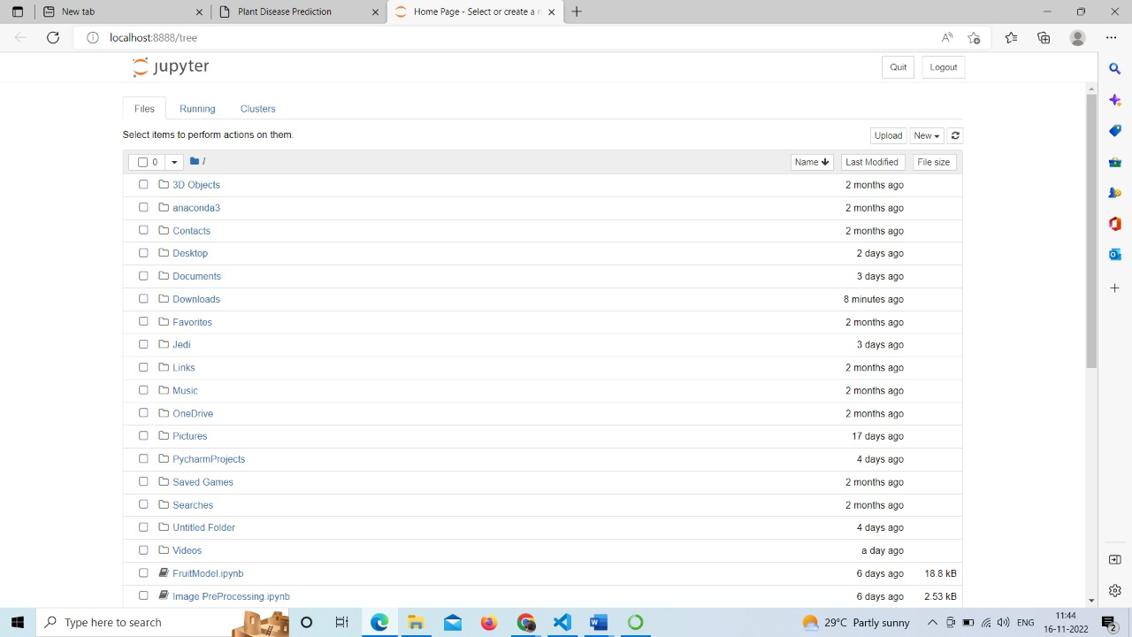

● Google Colab - <https://colab.research.google.com/>

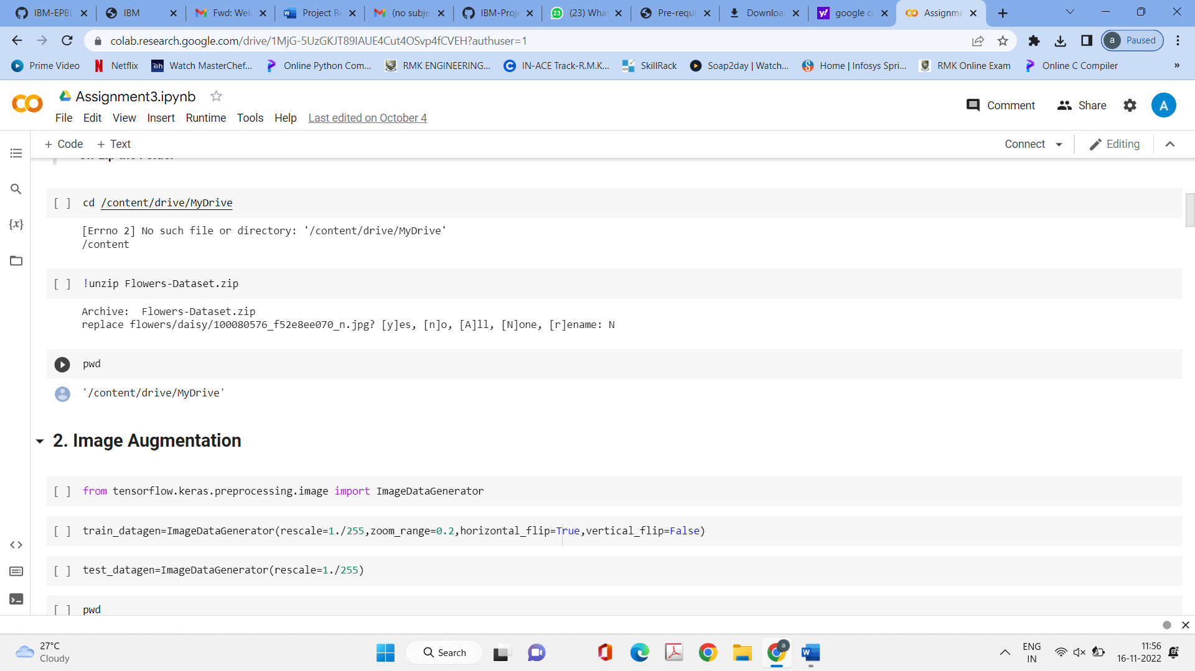

● Spyder / VS Code / Pychar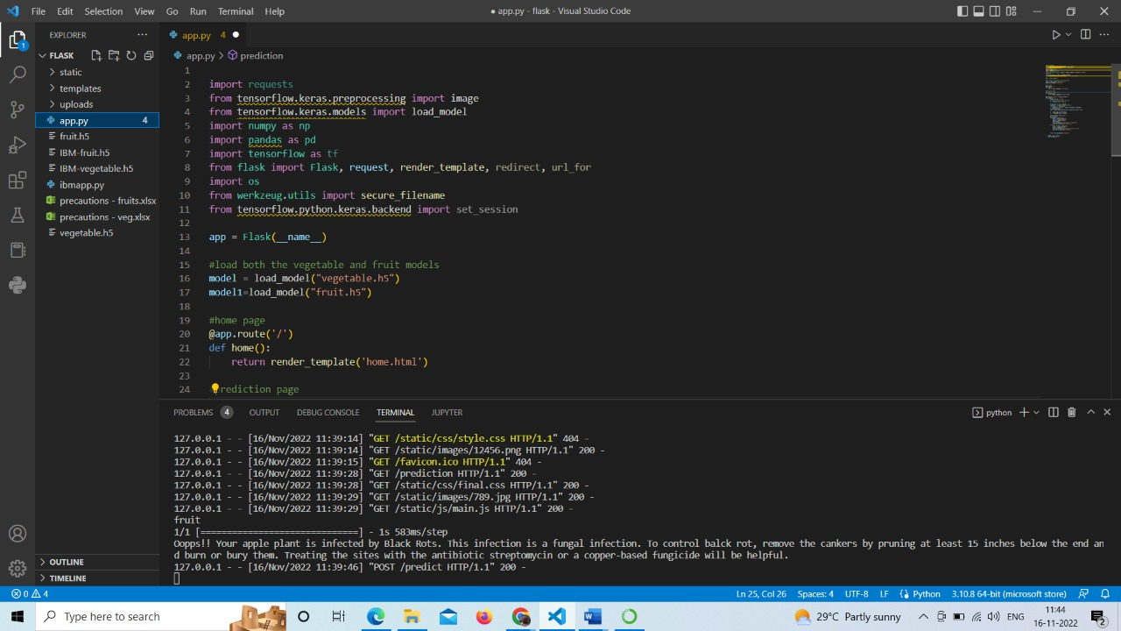m

***IBM****:*

● IBM Account Creation - <https://vimeo.com/742609168/1824d26a5b>

● IBM Skill Build - <https://www.ibm.com/academic/home>

● Webmail - <https://sg2plmcpnl492529.prod.sin2.secureserver.net:2096/>

● IBM Cloud - <https://cloud.ibm.com/login>

