**Project Design Phase-II**

**Technology Stack (Architecture & Stack)**

|  |  |
| --- | --- |
| Team ID | PNT2022TMID36001 |
| Project Name | Smart Lender – Applicant Credibility Prediction for Loan Approval |
| Maximum Marks | 4 Marks |

**Technical Architecture**

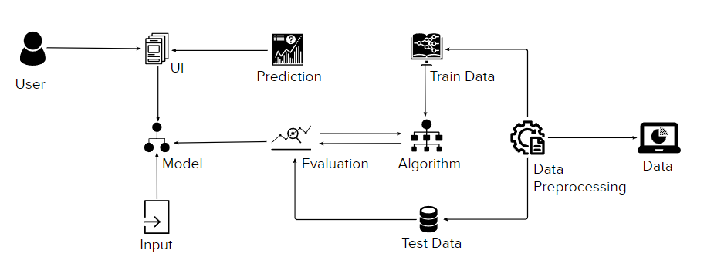

**Table-1 : Components and Technologies**

|  |  |  |  |
| --- | --- | --- | --- |
| **1.** | **User Interface** | Users interact with the application with the help of a web UI. | HTML, CSS, Java script |
| **2.** | **Building Applications** | Getting user information from UI and feeding it to ML model | Python Flask |
| **3.** | **Visualizing and analyzing data** | Reading and understanding the data properly with the help of visualization and analyzing techniques | Python pandas, numpy, matplotlib, seaborn |
| **4.** | **Pre-processing or cleaning data** | Handling missing values, Handling categorical data, Handling outliers, Scaling Techniques | Python pandas |
| **5.** | **Database** | Loan Approval dataset. | csv file |
| **6.** | **Cloud Database** | Deploying the model on cloud | IBM cloud |
| **7.** | **Machine Learning Model** | Using machine learning model for predicting loan approval | Model building using classification algorithms such as Decision tree, Random forest, KNN, and xg boost |

**Table-2 : Application Characteristics**

|  |  |  |  |
| --- | --- | --- | --- |
| **S. No** | **Characteristics** | **Description** | **Technology** |
| **1.** | Open-Source Frameworks | Flask is used to host the website. Scikit, numpy and tensorflow are all open source python machine learning frameworks. | Scikit, Numpy |
| **2.** | Security Implementations | OpenSSL is a program and library that supports many different cryptographic operations, including: Symmetric key | OpenSSL Encryption |
|  |  | Encryption. Public/private key pair generation. Public key encryption. Hash functions. |  |
| **3.** | Scalable Architecture | Since the application servers can be deployed on many machines. Also, the database does not make longer connections with every client – it only requires connections from a smaller number of application servers. It improves data integrity. | 3 Tier Architecture |
| **4.** | Availability | Decentralized storage and distribution along-with web application approach make the service highly available. | IBM Cloud file storage, MySQL Online |
| **5.** | Performance | Long term header expiration. Cacheable AJAX Cookie Free Domain Compress zip components. | AJAX, CDN |