Project Planning Phase

**Project Planning Template (Product Backlog, Sprint Planning, Stories, Story points)**

|  |  |
| --- | --- |
| Date | 18 October 2022 |
| Team ID | PNT2022TMID18353 |
| Project Name | Project - Personal Expense Tracker |
| Maximum Marks | 8 Marks |

# Product Backlog, Sprint Schedule, and Estimation (4 Marks)

|  |  |  |  |  |  |  |
| --- | --- | --- | --- | --- | --- | --- |
| **Sprint** | **Functional Requirement (Epic)** | **User Story Number** | **User Story / Task** | **Story Points** | **Priority** | **Team Members** |
| Sprint-1 | Registration | USN-1 | As a user, I can register for the application by entering my email, password, and confirming  my password. | 3 | High |  |
| Sprint-1 | USN-2 | As a user, I will receive confirmation email once I have registered for the application | 3 | High |  |
| Sprint-1 | Login | USN-3 | As a user, I can log into the application by entering email & password | 5 | High |  |
| Sprint-1 | Dashboard & Logout | USN-4 | As a user, once I logged in I can access all the  features of the web app and Logout once I completed all the work. | 5 | High |  |
| Sprint-1 | USN-5 | Once logged In, Keep me logged for few hours to avoid repeated login if the page is refreshed | 4 | Medium |  |
| Sprint-2 | Expense | USN-6 | Add total income for the month and Allow for edit option | 6 | High |  |
| Sprint-2 | USN-7 | Split the total income based on usage like entertainment, food, shopping etc. | 2 | Low |  |
| Sprint-2 | USN-8 | Add the day to day expense. | 6 | High |  |
| Sprint-2 | USN-9 | Display the user added expense | 6 | High |  |
| Sprint-3 | USN-10 | Filter the expense data based on criteria | 6 | Medium |  |
| Sprint-3 | Charts | USN-11 | As a user I can display it in graphs | 4 | Low |  |
| Sprint-3 | Alerts | USN-12 | As a user I create custom alert for the balance | 10 | High |  |
| Sprint-4 | Deployment | USN-13 | As a user I should able to access it anywhere in the net | 20 | High |  |

**Project Tracker, Velocity & Burndown Chart: (4 Marks)**

|  |  |  |  |  |  |  |
| --- | --- | --- | --- | --- | --- | --- |
| **Sprint** | **Total Story Points** | **Duration** | **Sprint Start Date** | **Sprint End Date (Planned)** | **Story Points Completed (as on**  **Planned End Date)** | **Sprint Release Date (Actual)** |
| Sprint-1 | 20 | 6 Days | 24 Oct 2022 | 29 Oct 2022 | 20 | 29 Oct 2022 |
| Sprint-2 | 20 | 6 Days | 31 Oct 2022 | 05 Nov 2022 | 20 | 05 NOV 2022 |
| Sprint-3 | 20 | 6 Days | 07 Nov 2022 | 12 Nov 2022 | 20 | 12 NOV 2022 |
| Sprint-4 | 20 | 6 Days | 14 Nov 2022 | 19 Nov 2022 | 20 | 19 NOV 2022 |
|  |  |  |  |  |  |  |
|  |  |  |  |  |  |  |
|  |  |  |  |  |  |  |
|  |  |  |  |  |  |  |

**Velocity:**

Imagine we have a 10-day sprint duration, and the velocity of the team is 20 (points per sprint). Let’s calculate the team’s average velocity (AV) per iteration unit (story points per day)



|  |  |  |  |
| --- | --- | --- | --- |
| Sprint | Total story points | Duration | Average velocity |
| Sprint 1 | 20 | 6 Days | 20 / 6 = 3.33 |
| Sprint 2 | 20 | 6 Days | 20 / 6 = 3.33 |
| Sprint 3 | 20 | 6 Days | 20 / 6 = 3.33 |
| Sprint 4 | 20 | 6 Days | 20 / 6 = 3.33 |
| Total | 80 | 24 Days | 80 / 24 = 3.33 |

# Burndown Chart:

A burn down chart is a graphical representation of work left to do versus time. It is often used in agile software development methodologies such as Scrum. However, burn down charts can be applied to any project containing measurable progress over time.

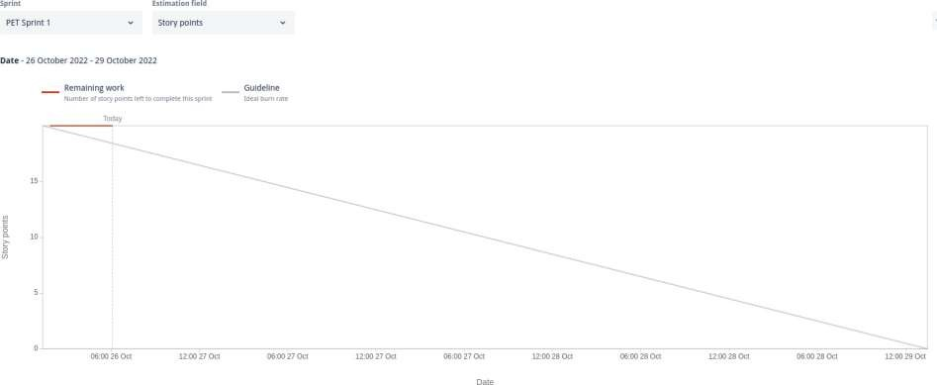

# Project Planning:

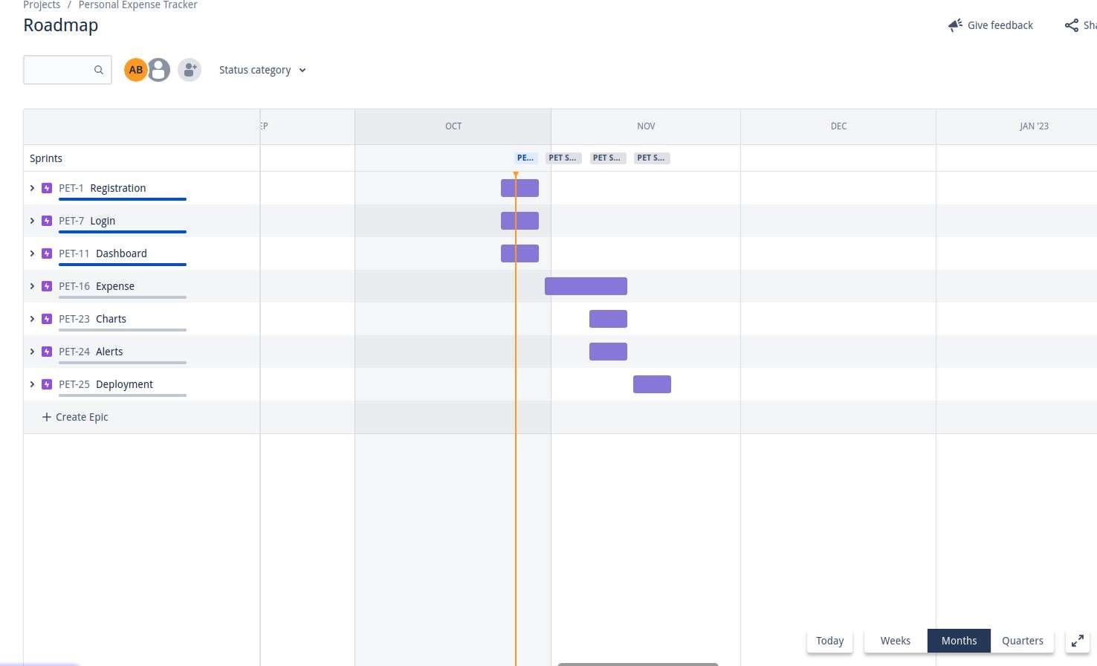

Projects / Personal Expense Tracker

**Backlog**

Q **AB** ••• Epic ,, Insights

,, **PET Sprint** 1 26 Oct - 29 Oct (3 Issues) o **Ci) C!)** Complete sprint

IJ PET-2 User Registration page REGISTRATION

IJ PET-8 User Login Page LOGIN

IJ PET-12 User Dashboard DASHBOARD

+ Create Issue

*l,, 6* IN PROGRESS,, **e** *l,,* 5 IN PROGRESS ,, **e n 9 IN PROGRESS.., e**

,, **PET Sprint 2** 31 Oct - 5 Nov **(1** Issue) **Ci) C!)** Start sprint

IJ PET-17 Expense functionality EXPENSE *l,,* TODOv **e**

+ Create Issue

*v* **PET Sprint** 3 7 Nov - 12 Nov (3 Issues)

**C** PET-35 Expense Functionality E>Prns,

**C** PET-26 DIsplay charts CHARTS

**C** PET-30 Show Alerts ALERTS

+ create Issue

o **CU!>** Start sprint *l,,* **TODOv e** *I-.* **TODOv e**

*l,,* **TODOv e**

----";-;--

*v* **PETSprint4** 14 Nov-19 Nov **(1** Issue) o **Ci) t)** Start sprint

**C** PET-31 Deployment of App DEPLOYMENT *l,,* TODOv **e**

+ Create Issue

--;;-

v **Backlog** (0 Issues) o **t) Ci)** Create sprint

+ Create Issue

**Your backlog is empty.**

**f** Qu1ckstart **x**