INTERNET OF THINGS

ASSIGNMENT_1:

1. Alarm should give one sound when there is amotion near PIR sensor.

ARDUINO CODE:

const int motion = 2;

const int alarm= 4;

int currentState = LOW;

int previousState = LOW;

void setup()

{

Serial.begin(9600);

pinMode(motion, INPUT);

pinMode(alarm, OUTPUT);

}

void loop()

{

previousState = currentState;

currentState = digitalRead(motion);

if (previousState == LOW && currentState == HIGH)

{

Serial.println("Motion detected!");

digitalWrite(alarm, HIGH);

}

else

if (previousState == HIGH && currentState == LOW)

{

Serial.println("Motion stopped!");

digitalWrite(alarm, LOW);

}

}

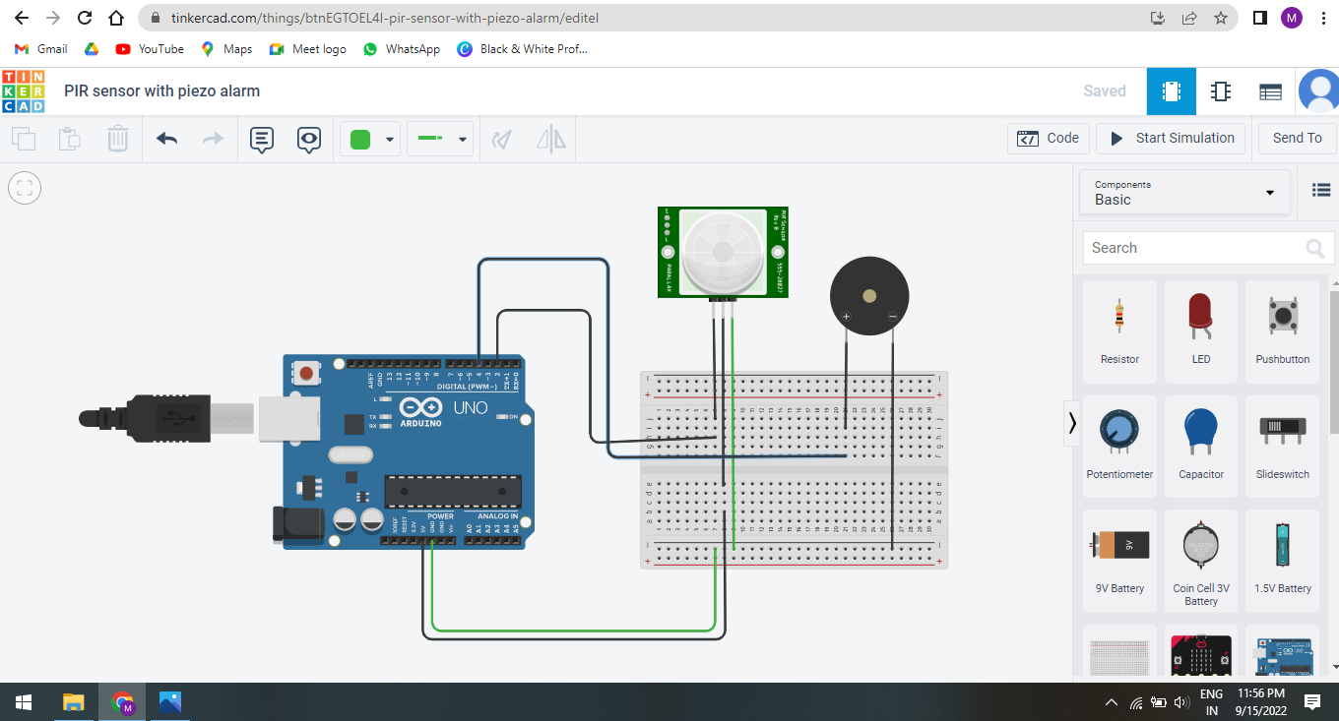

1. Alarm should sound when the temperature is greater that 80 degrees.

ARDUINO CODE:

const int cold = 80;

const int alarm= 4;

void setup()

{

pinMode(A0, INPUT);

pinMode(alarm, OUTPUT);

Serial.begin(9600);

}

void loop() {

int sensor = analogRead(A0);

float voltage = (sensor / 1024.0) * 5.0;

float tempC = (voltage - .5) * 100;

float tempF = (tempC * 1.8) + 32;

Serial.println("temp: ");

Serial.println(tempF);

if (tempF > cold)

{

digitalWrite(alarm, HIGH);

}

else

{

digitalWrite(alarm, LOW);

}

delay(10);

}

