PREREQUISITES

SOFTWARE

|  |  |
| --- | --- |
| **Team ID** | **PNT2022TMID03711** |
| **Project Name** | **Smart Solutions For Railways** |

**TASK**: The software Requirements are installed and the task is completed.

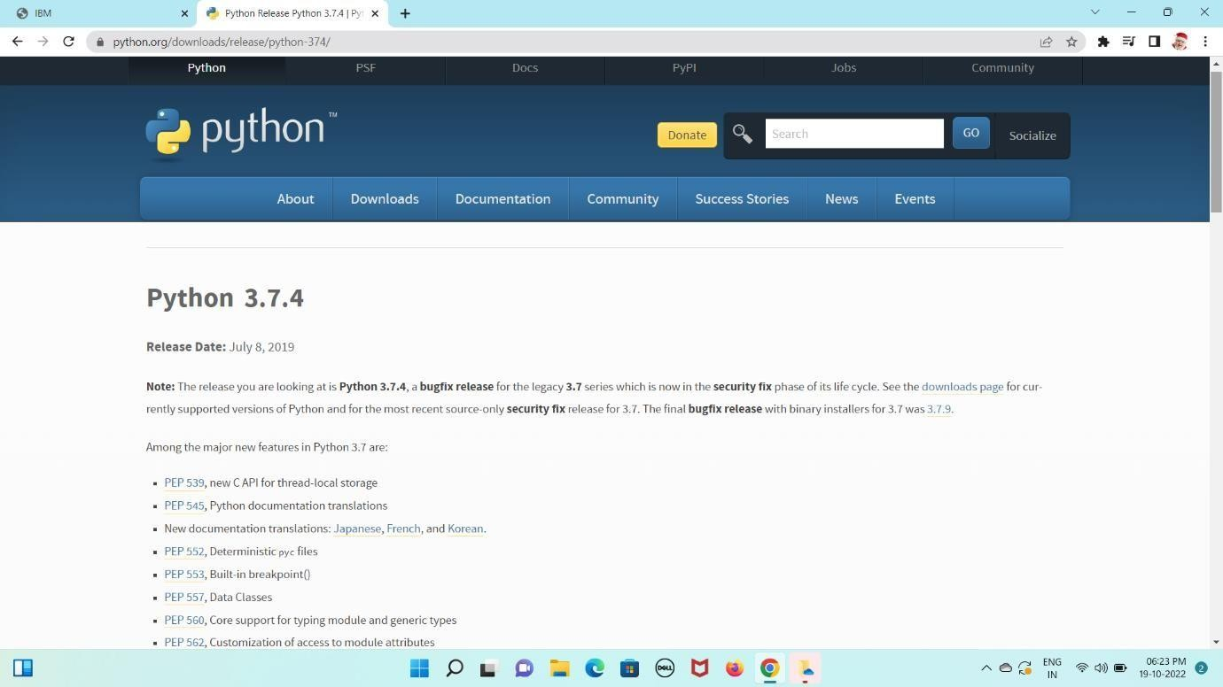

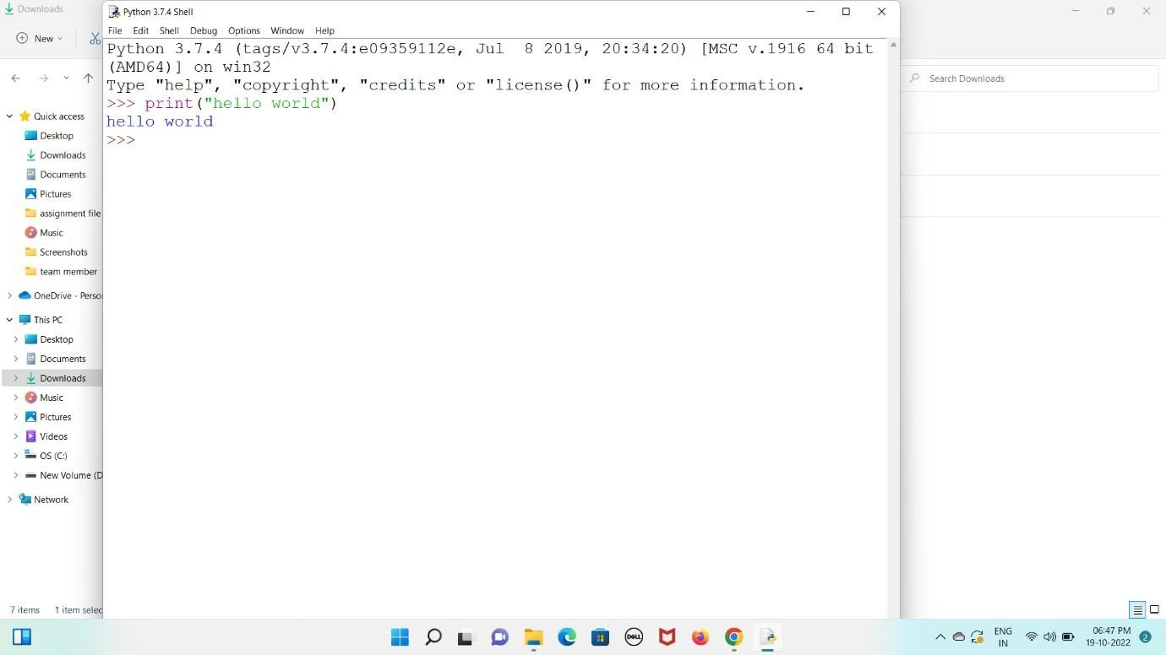

**Program & Output in Python IDLE 3.6.5 - 64bit**

