|  |  |
| --- | --- |
| Team ID | PNT2022TMID18930 |
| Title | Gas Leakage Monitoring & Alerting System for Industries |
| Team Members | Hari Vignesh S  Ezhilarasan M  Abhishek M  Gokul Chandru S |

[**PREREQUISITES**](https://careereducation.smartinternz.com/Student/guided_project_workspace/26793#collapse1) **:**

**[1] Installing Python software**

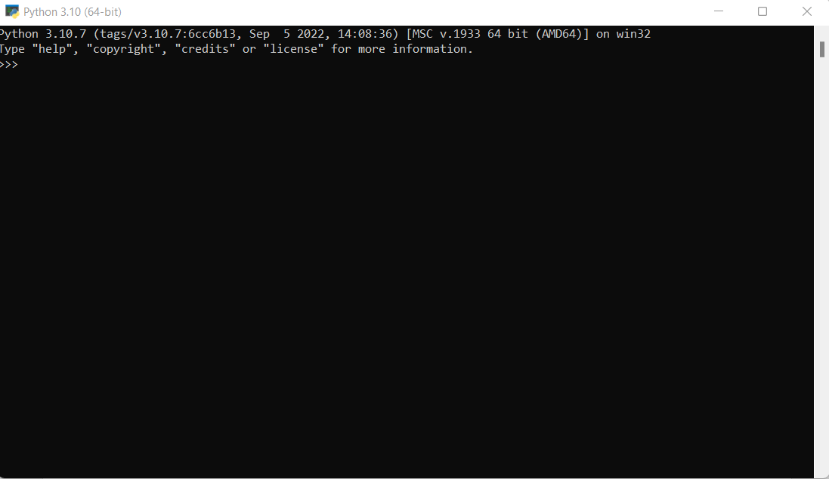

**[2] IBM cloud Services**

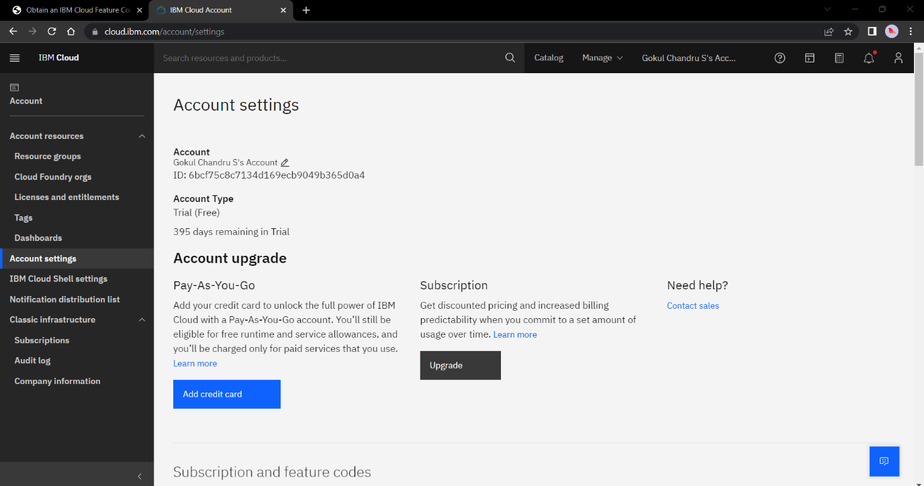

**NODE RED**

