Build a python code by assuming temperature and humidity values using random function. And write a condition to continuously buzz an alarm in case of high temperature

Video Link:

https://drive.google.com/file/d/1efBuA9W68UEpXBI-MtaCvwR1pEClg_NP/view?usp=sharing

Program:

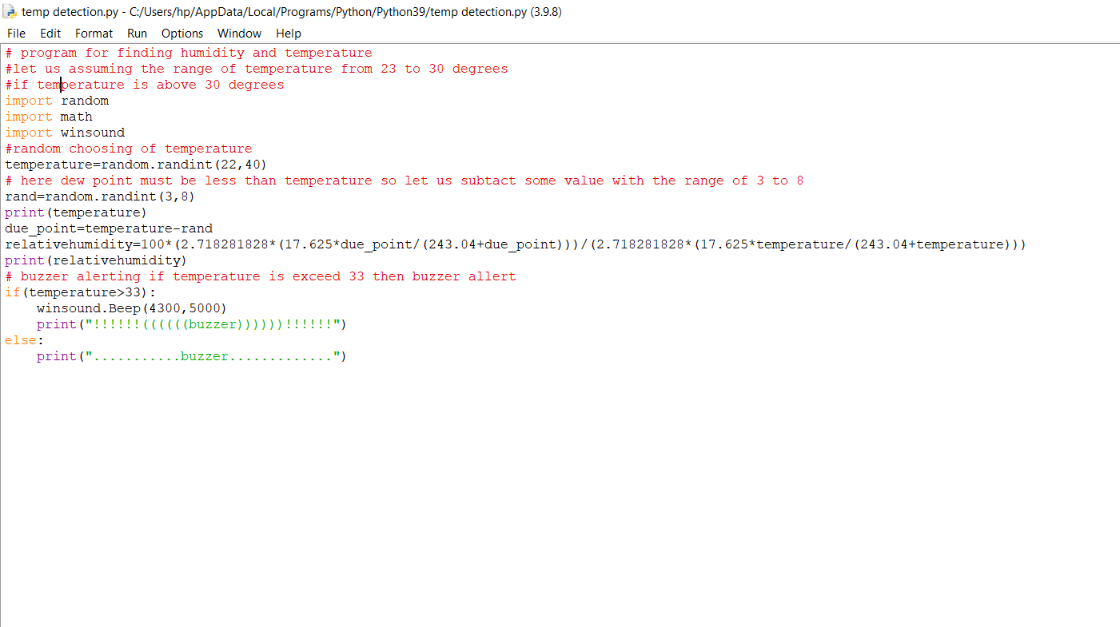

Output:

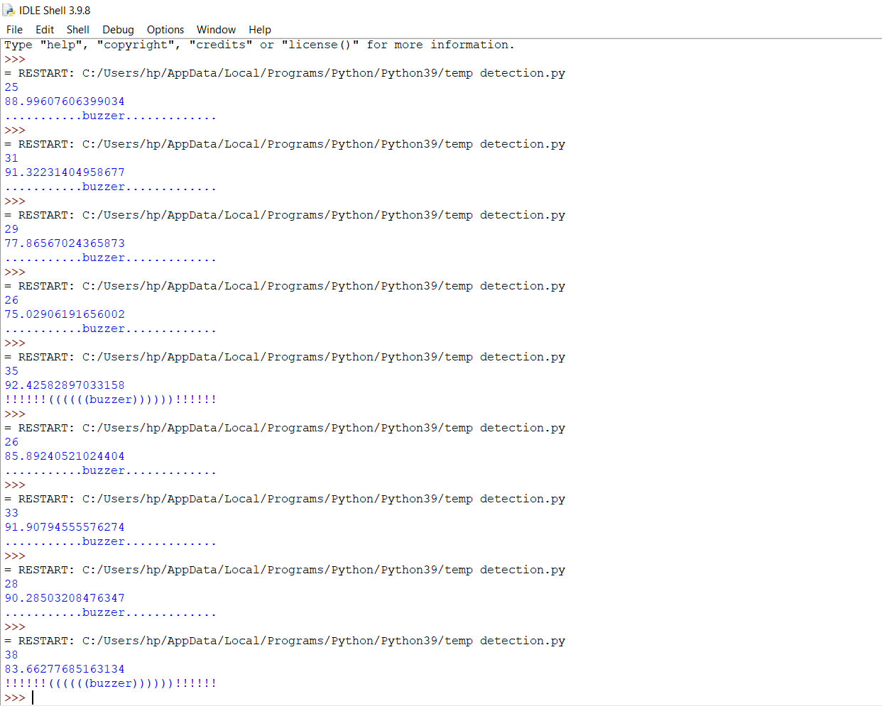

KANDRA YASWANTH (11151910604)