Build a python code by assuming temperature and humidity values using random function. And write a condition to continuously buzz an alarm in case of high temperature

Video Link:

https://drive.google.com/file/d/1k7Ro6li1X_C1k6lKa_xBPmfE7IJTxiTH/view?usp=sharing

Program:

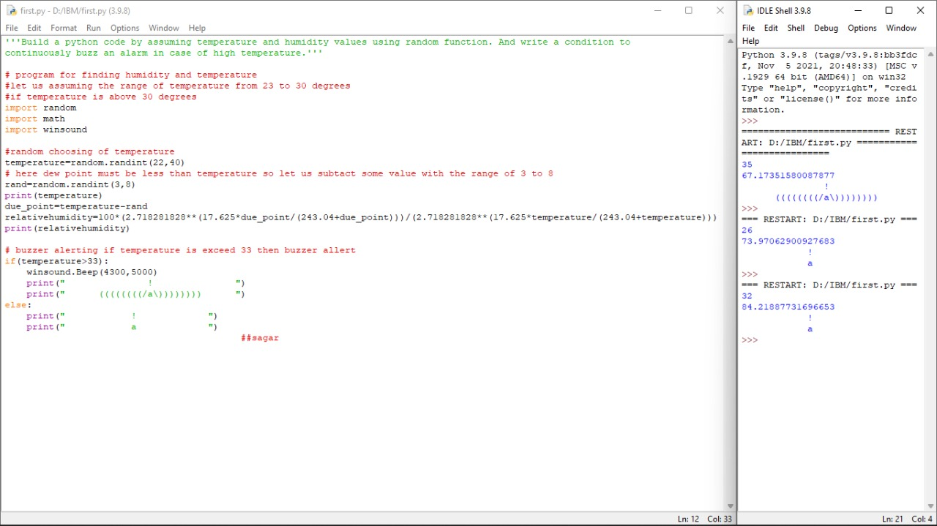

Output:

Python 3.9.8 (tags/v3.9.8:bb3fdcf, Nov 5 2021, 20:48:33) [MSC v.1929 64 bit (AMD64)] on win32

Type "help", "copyright", "credits" or "license()" for more information.

>>>

=========================== RESTART: D:/IBM/first.py ===========================

35

67.17351580087877

!

((((((((/a\))))))))

>>>

=== RESTART: D:/IBM/first.py ===

26

73.97062900927683

!

a

>>>

=== RESTART: D:/IBM/first.py ===

32

84.21887731696653

!

a

Phanindra Reddy Karuvadi(111519106111)