Prerequisites Software ( Python 3.6.5 )

|  |  |
| --- | --- |
| Date | 03 November 2022 |
| Team ID | PNT2022TMID13605 |
| Project Name | SMART SOLUTION FOR RAILWAYS |
| Maximum Marks | 4 Marks |

SMART SOLUTION FOR RAILWAYS

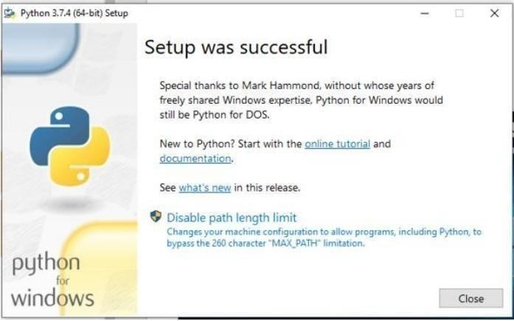

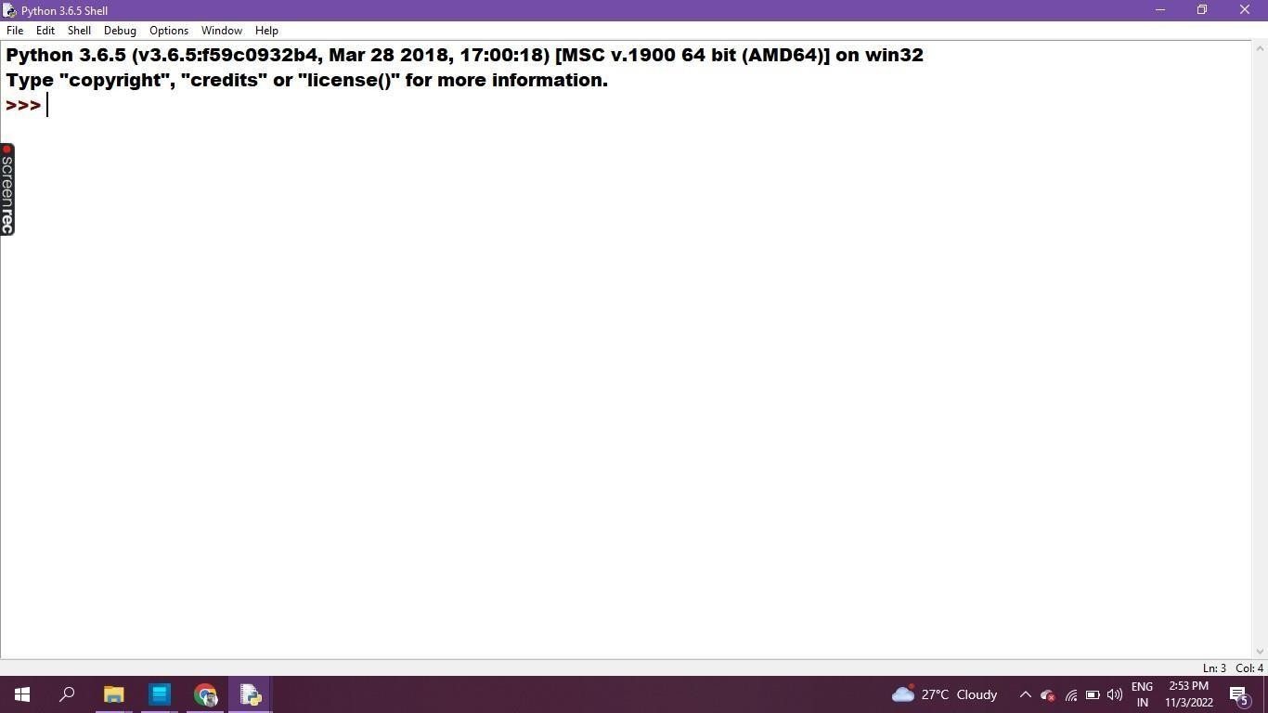

**Program & Output in Python IDLE 3.6.5 - 64bit**

