**PREREQUISITES**

**Date:-29/10/2022**

**Team ID:-** PNT2022TMID06505

**Project Name:- A Novel Method for Handwritten Digit Recognition System**

**Anaconda Navigator :**

Anaconda Navigator is a free and open-source distribution of the Python and R programming languages for data science and machine learning related applications. It can be installed on Windows, Linux, and macOS. Conda is an open-source, cross-platform,  package management system. Anaconda comes with so very nice tools like JupyterLab, Jupyter Notebook, QtConsole, Spyder, Glueviz, Orange, Rstudio, Visual Studio Code. For this project, we will be using Jupiter notebook and spyder.

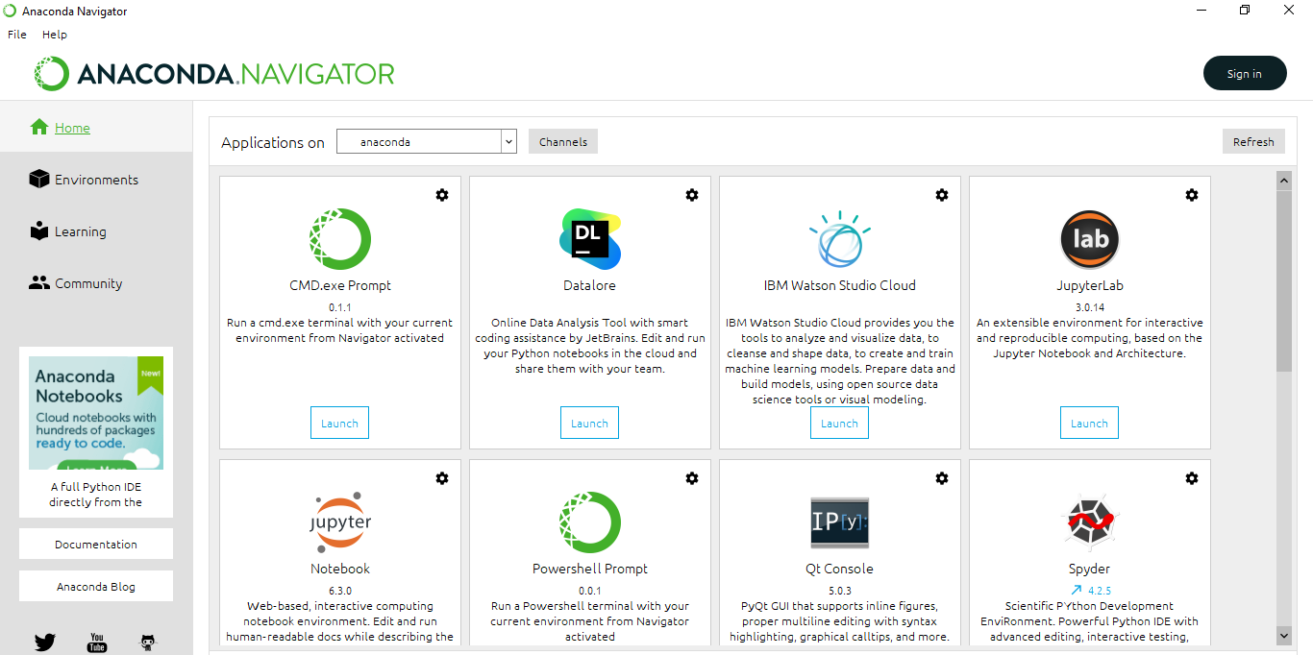

**Tensor flow:** TensorFlow is an end-to-end open-source platform for machine learning. It has a comprehensive, flexible ecosystem of tools, libraries, and community resources that lets researchers push the state-of-the-art in ML and developers can easily build and deploy ML powered applications.

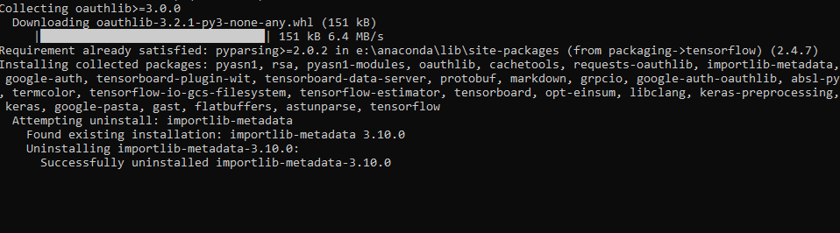

**Keras :** Keras leverages various optimization techniques to make high level neural network API easier and more performant. It supports the following features:

* Consistent, simple and extensible API.
* Minimal structure - easy to achieve the result without any frills.
* It supports multiple platforms and backends.
* It is user friendly framework which runs on both CPU and GPU.
* Highly scalability of computation.



**Flask:**Web frame work used for building  Web applications

