PREREQUISITES SOFTWARE

|  |  |
| --- | --- |
| Team ID | PNT2022TMID06442 |
| Project Name | SMART WASTE MANANGEMENT SYSTEM FOR METROPOLITAN CITIES  – IOT |

**Submitted by:**

* **K.Ramyaa gowri**
* **Parimala.N**
* **Gowsalya .M**
* **Deepa .G**

INSTALLATION OF PYTHON 3.7.4

* STEP 1: Type python in google and click on the first link.

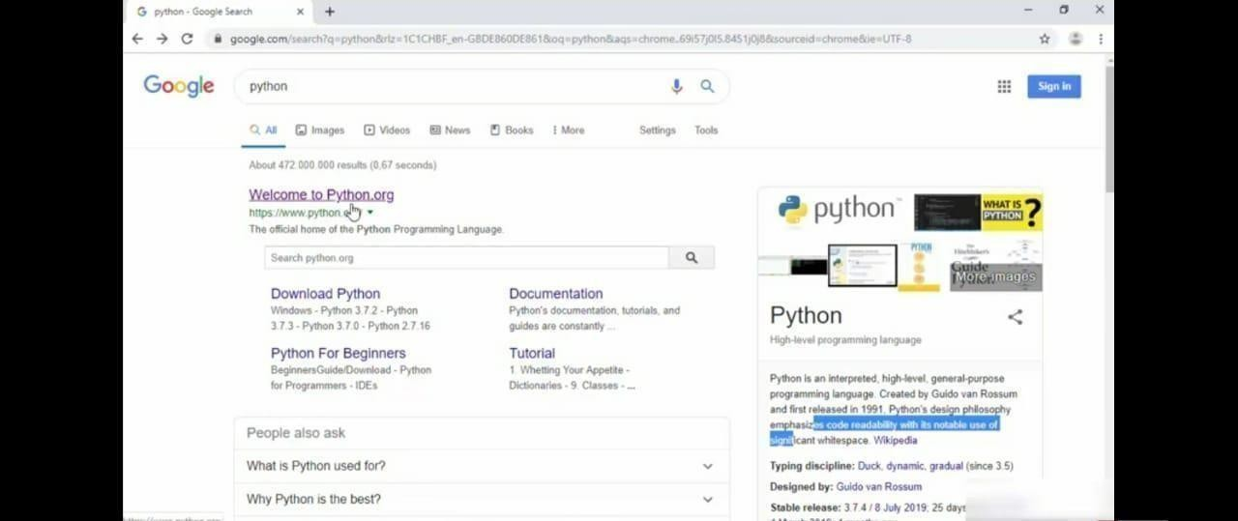

* STEP 2: Click the python 3.7.4

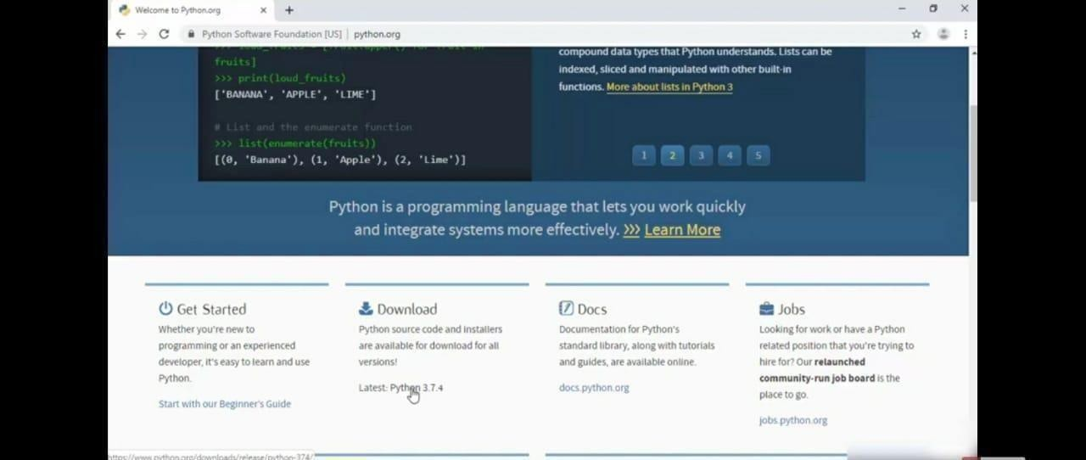

* STEP 3: Scroll down to reach the Files and click windows x86-64 executable installer.

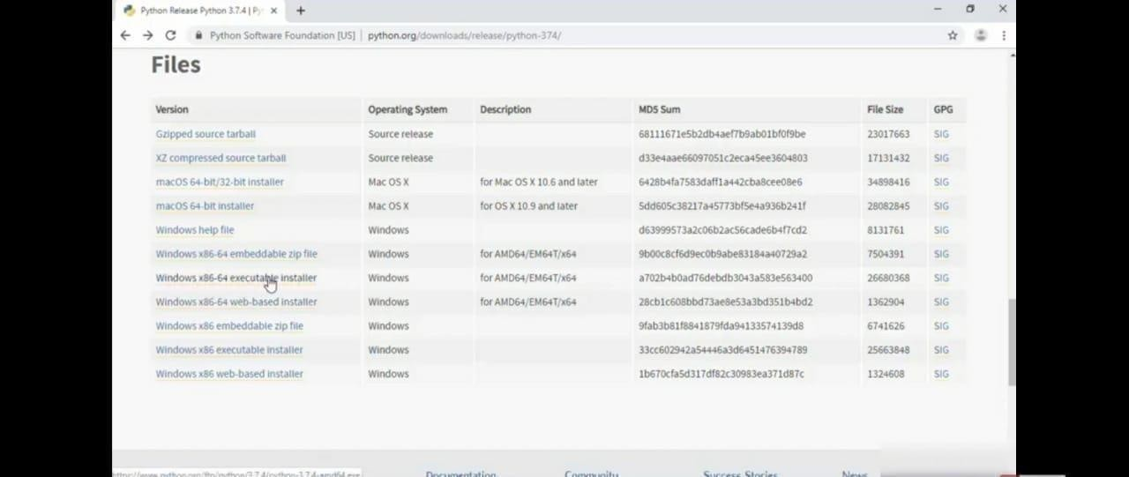

* STEP 4: Click on the executable file.

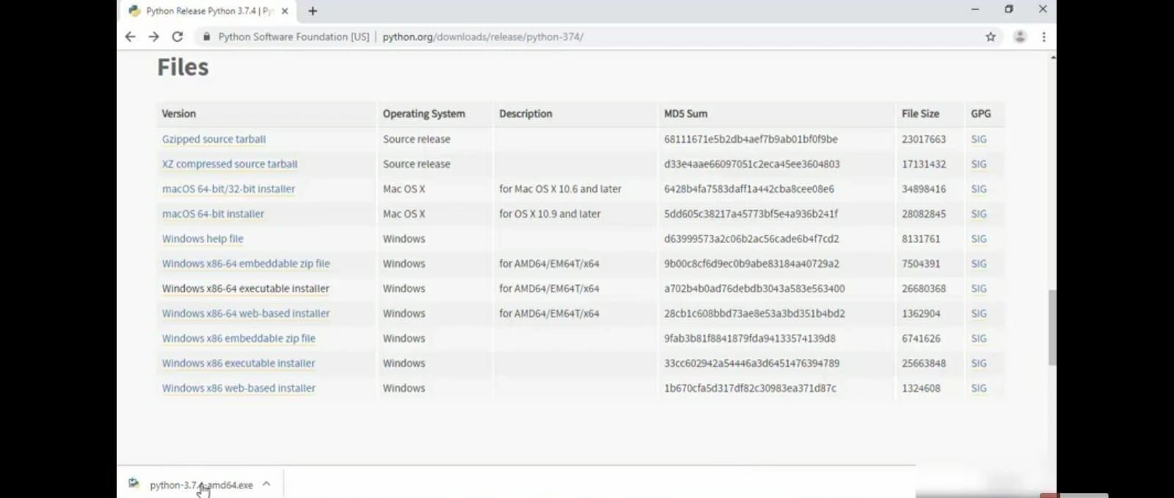

.

* STEP 5: Click on the Run button

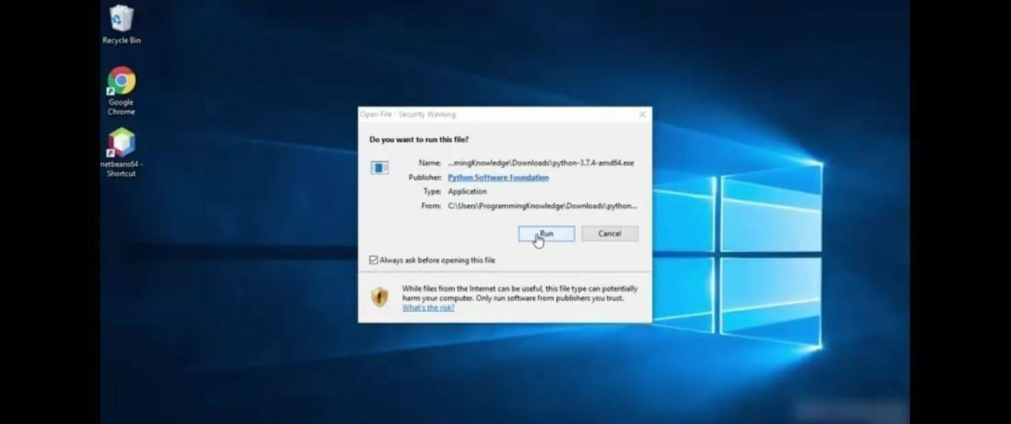

* STEP 6: To change the path click on the second check box Add python 3.7 to PATH and then click thecustomize installation.

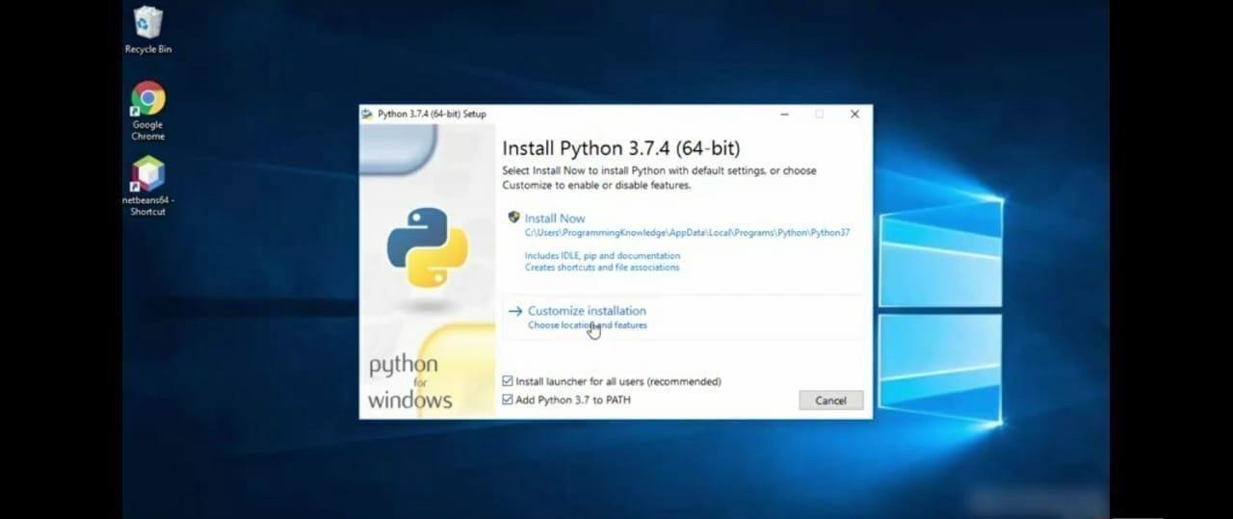

.

* STEP 7: Click the Next button.

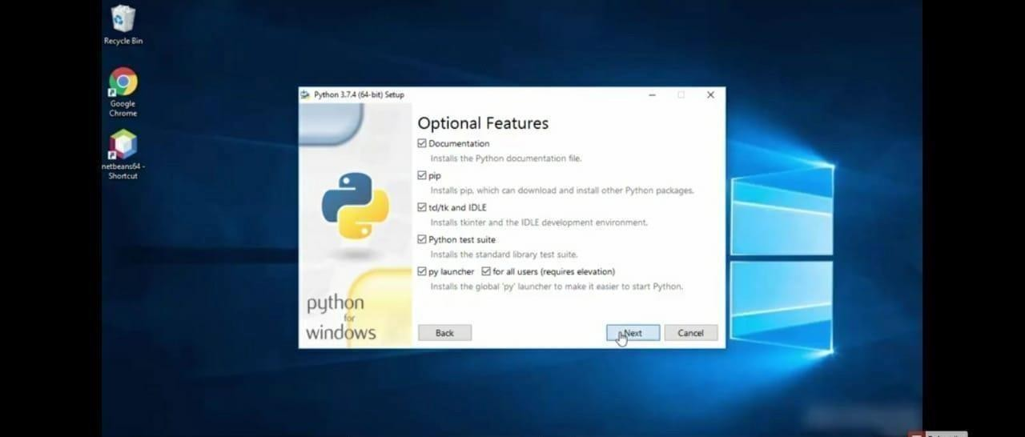

* STEP 8: You can change the path here and click on the install button.

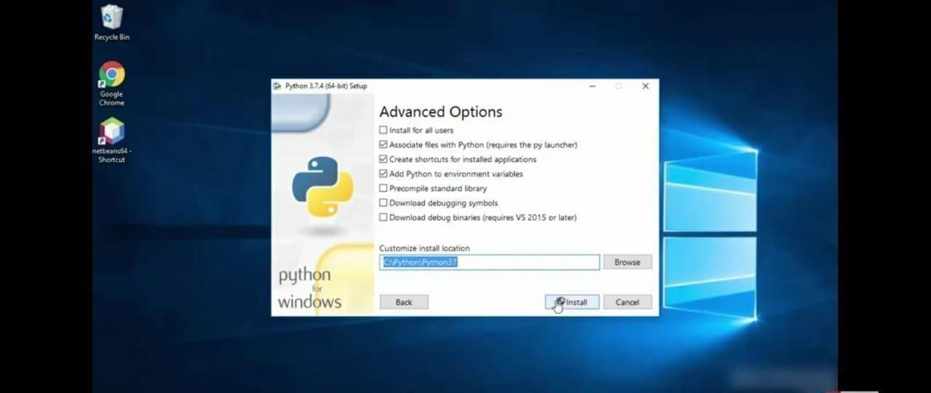

* STEP 9 : Installation process.

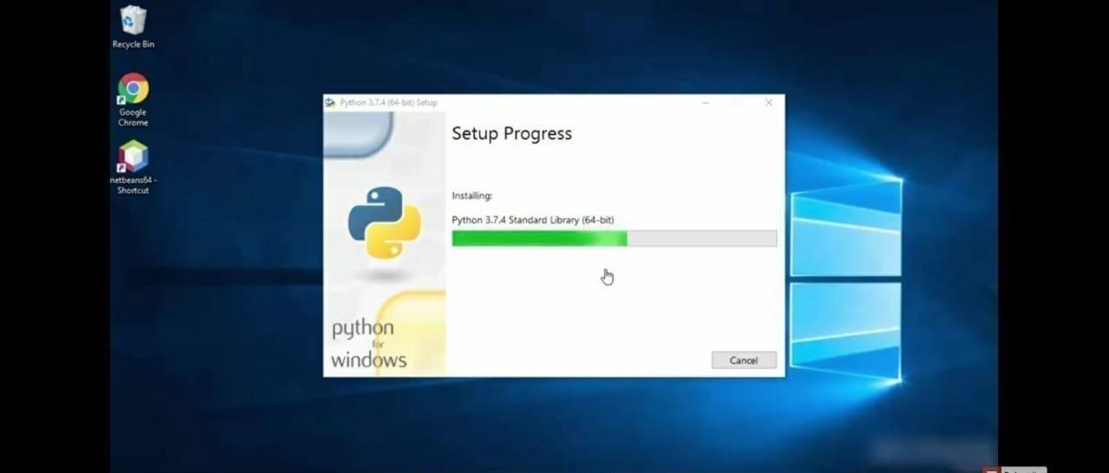

* STEP 10 : Click Yes button.

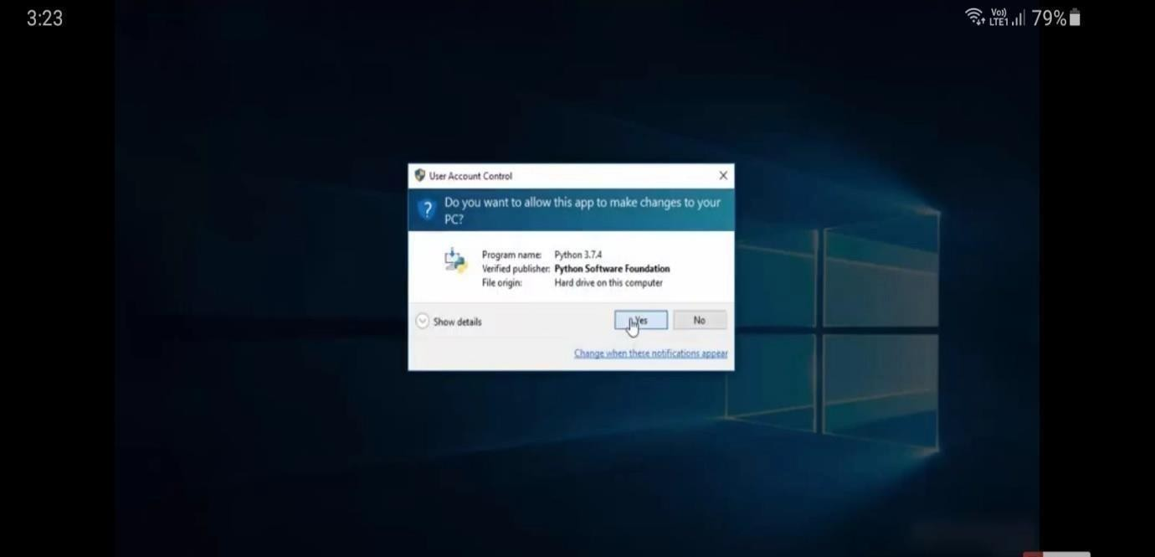

.

* STEP 11 : Click the close button.

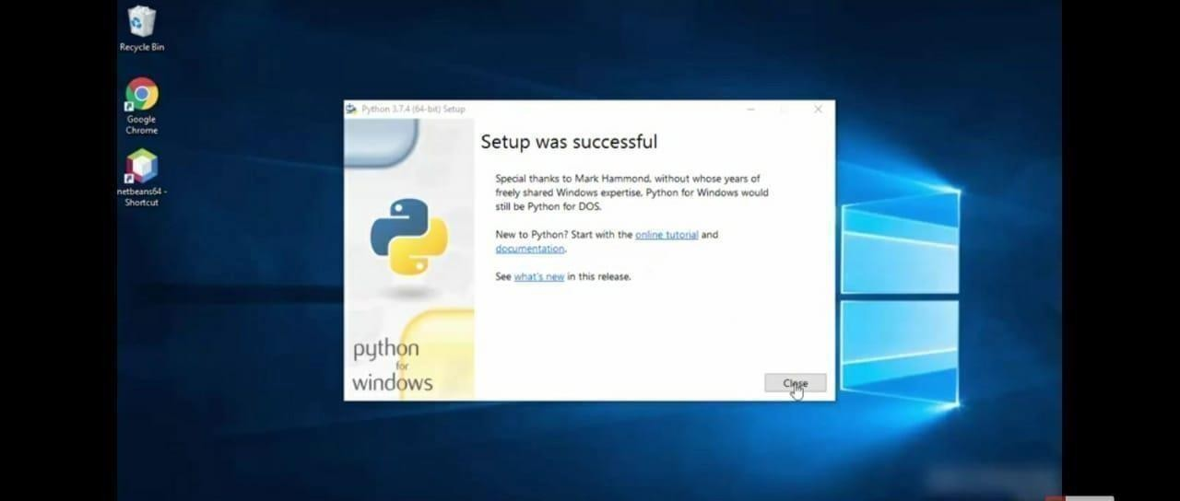

* STEP 12: To check whether it is working click the windows icon ,click the All apps.

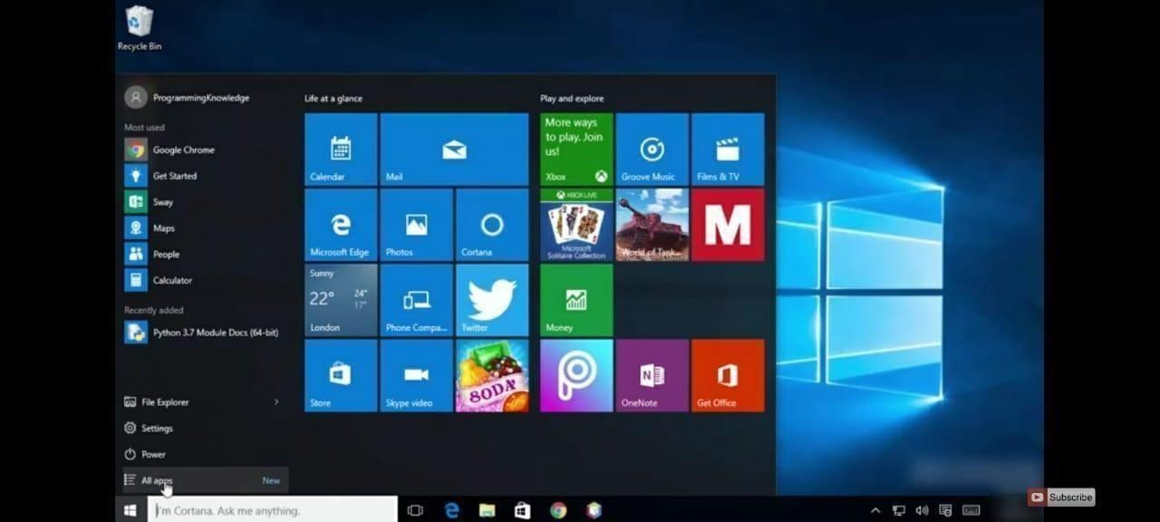

* STEP 13: Click the IDLE (python 3.7 64-bit).

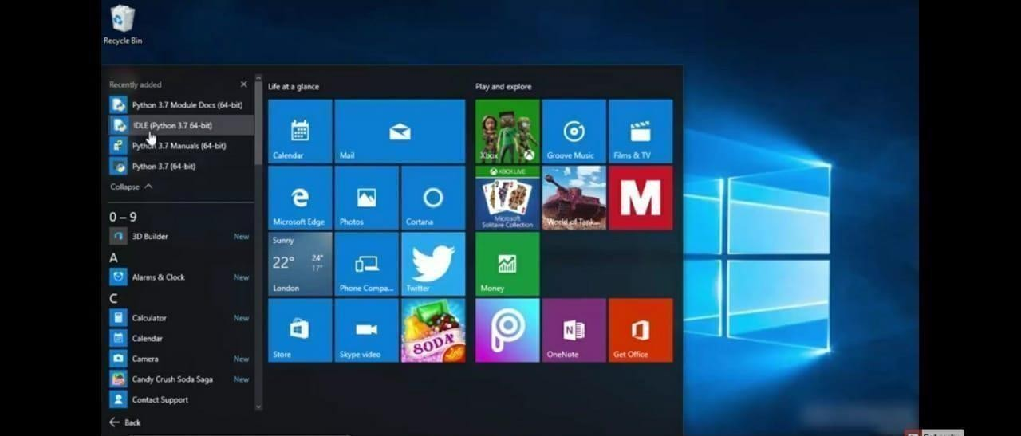

* STEP 14: This is the IDLE window.

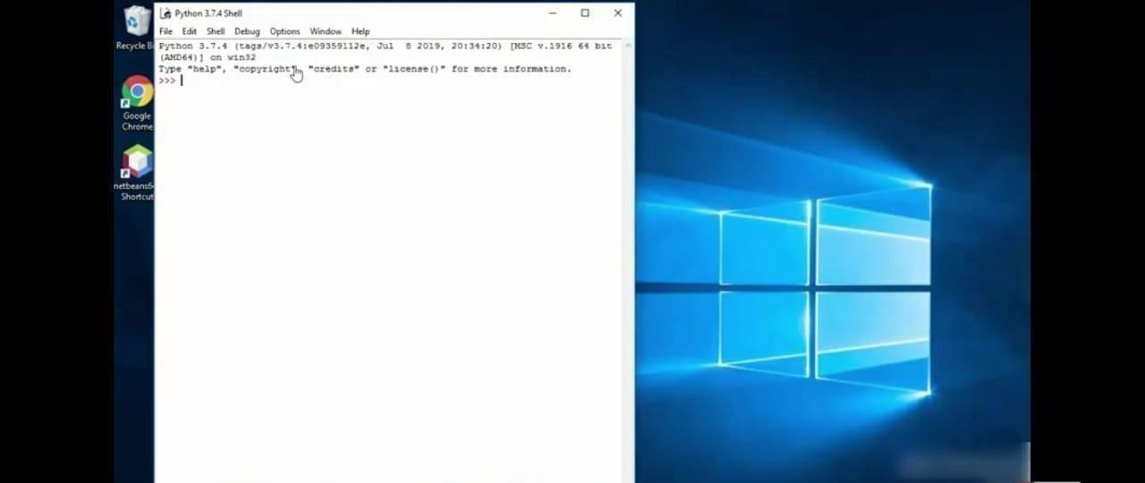

* STEP 15: Click the Python 3.7 (64-bit).

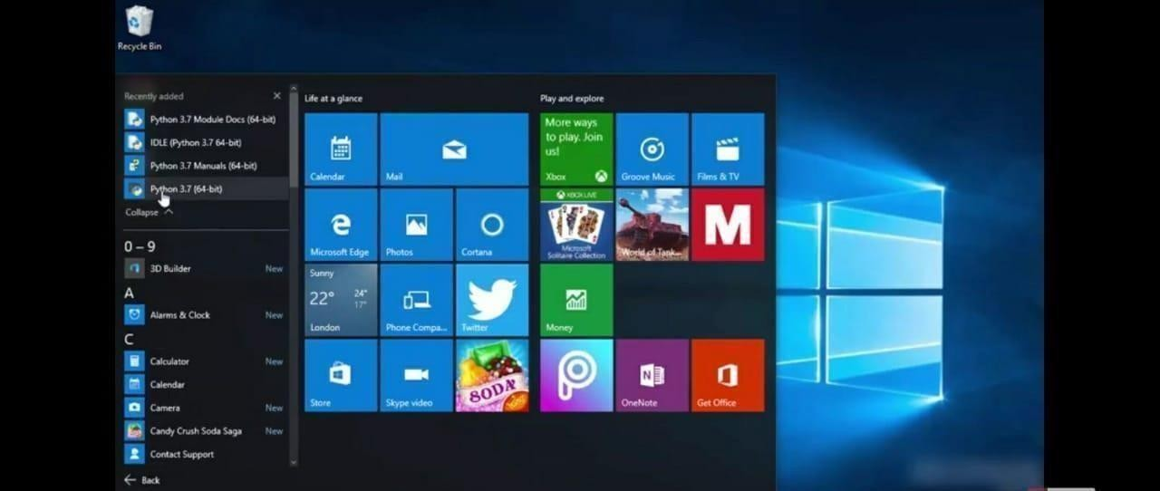

* STEP 16: This is the Python 3.7 (64-bit) command prompt.

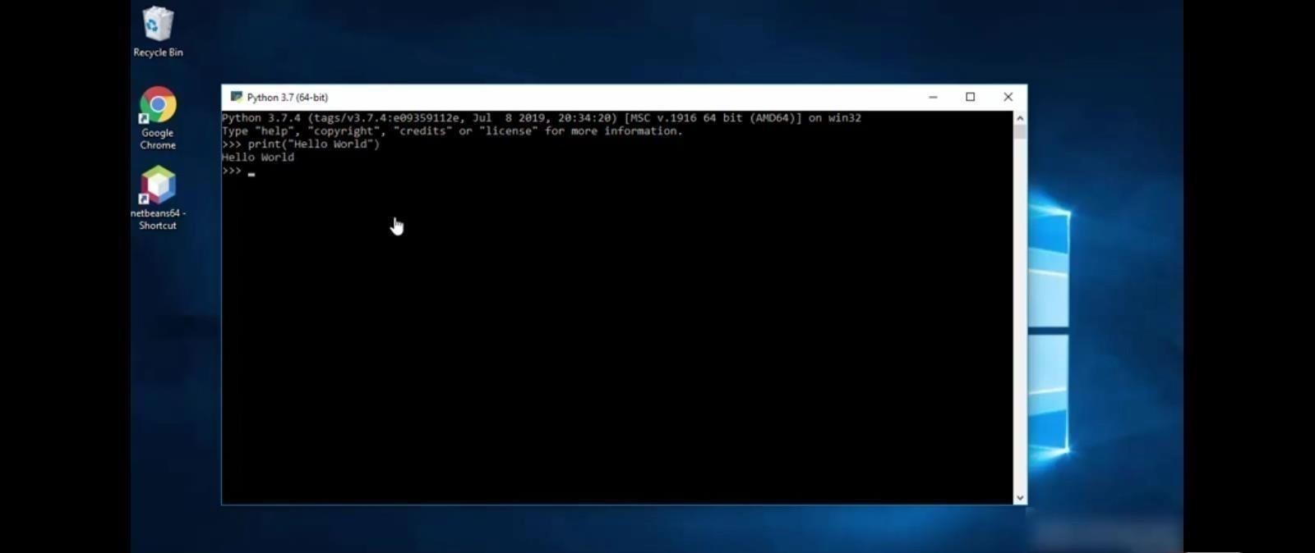

* STEP 17: To check whether the python works with windows command prompt. Right click the windows icon.

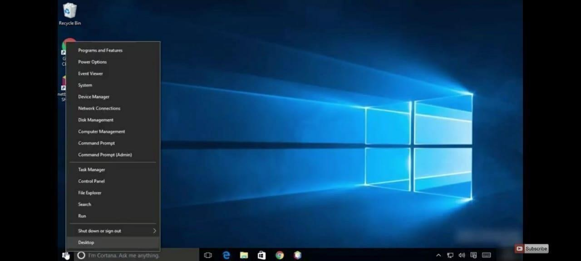

* STEP 18: Click the command prompt.

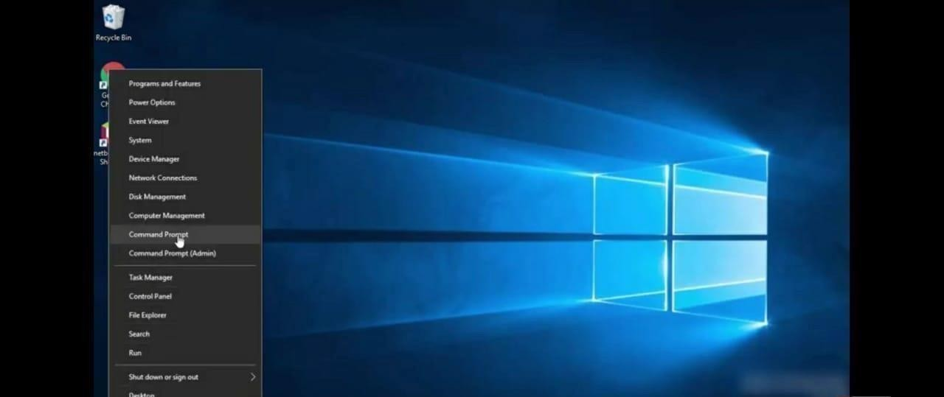

* STEP 19: Type Python in the command prompt and check whether it is working.

