INSTALLATIONOFPYTHON3.9.8

|  |  |
| --- | --- |
| Date | 19September2022 |
| TeamID | PNT2022TMID06413 |
| ProjectName | Project–Real-TimeRiverWaterQuality  MonitoringandControlSystem |

Step1:Typepythoningoogleandclickonthefirstlink

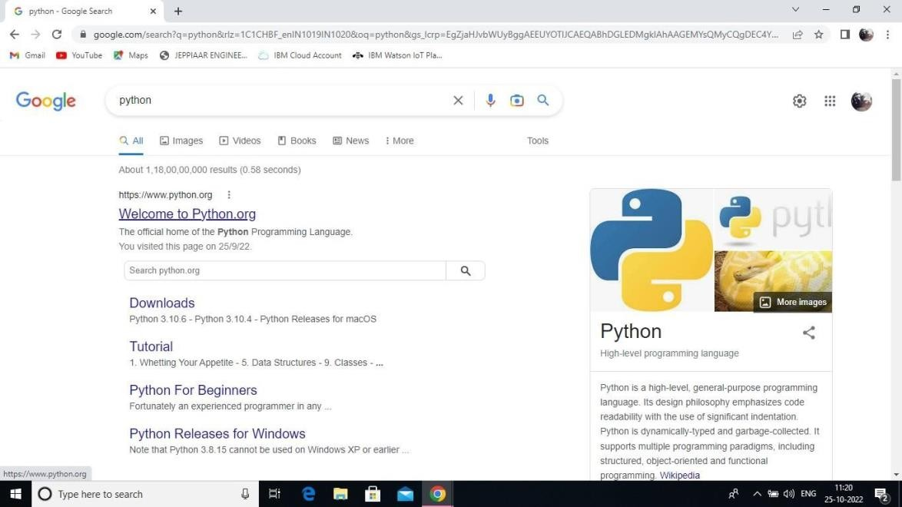

2:Clickthepython3.9.8

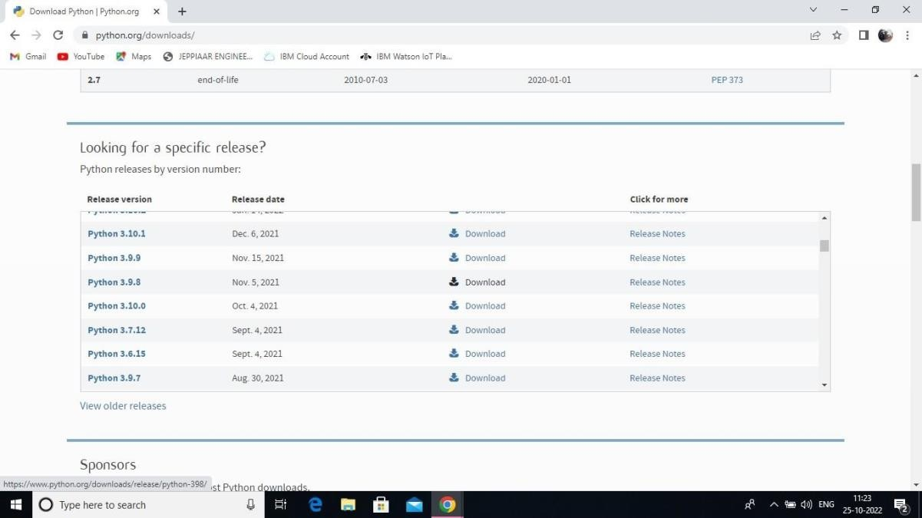

Step3:ScrolldowntoreachFilesandclickon“Windowinstaller(64bit)

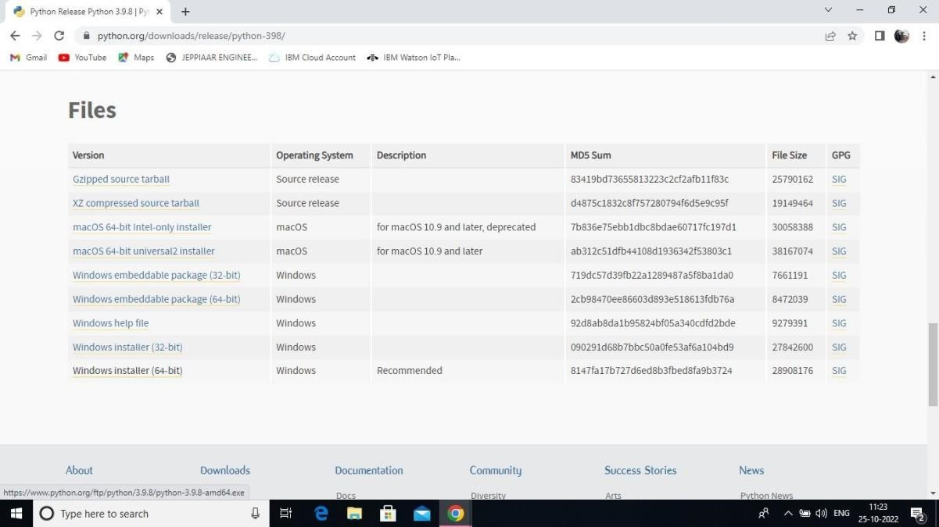

4:ClickontheInstallbutton.

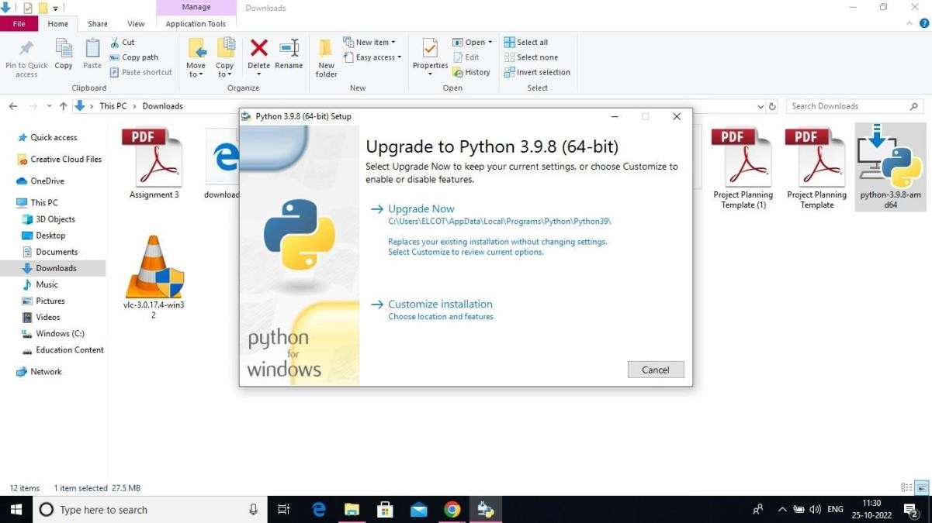

Step5:Installationonprogress

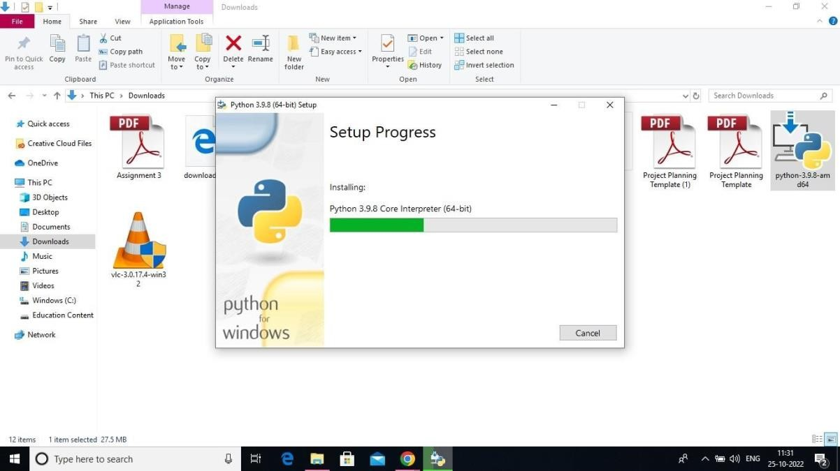

6:Closethebutton

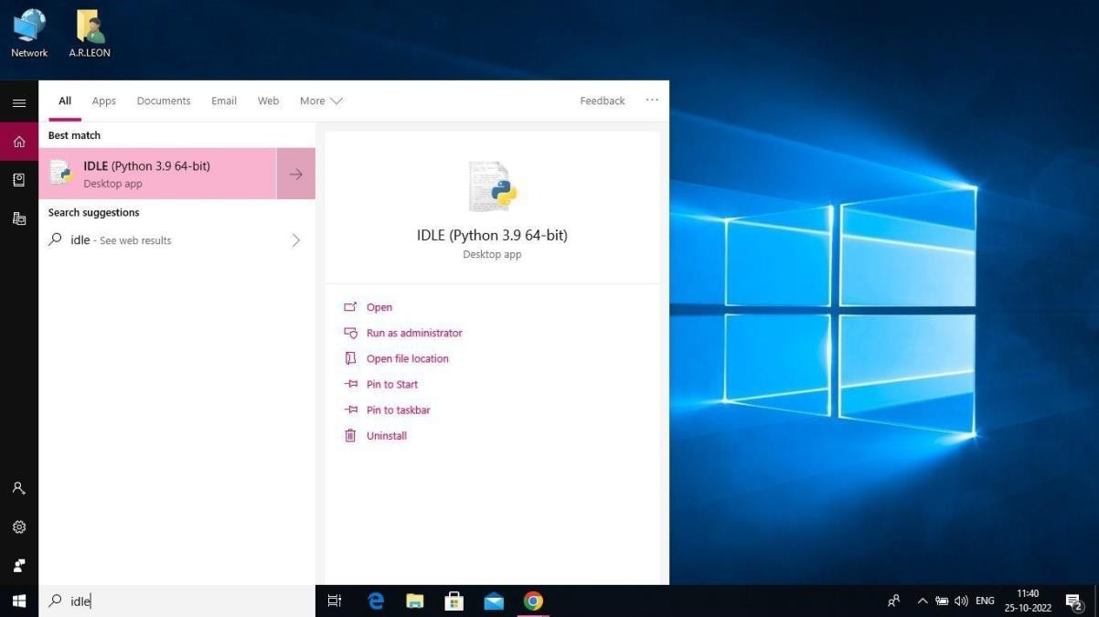

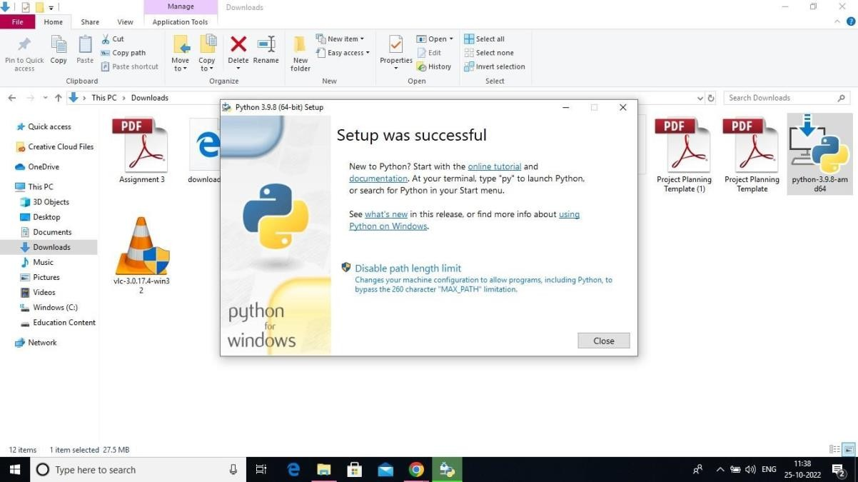

Step 7: Search IDLE8:Open it

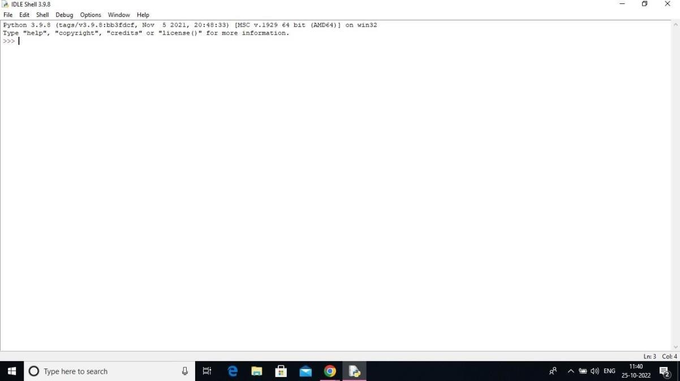

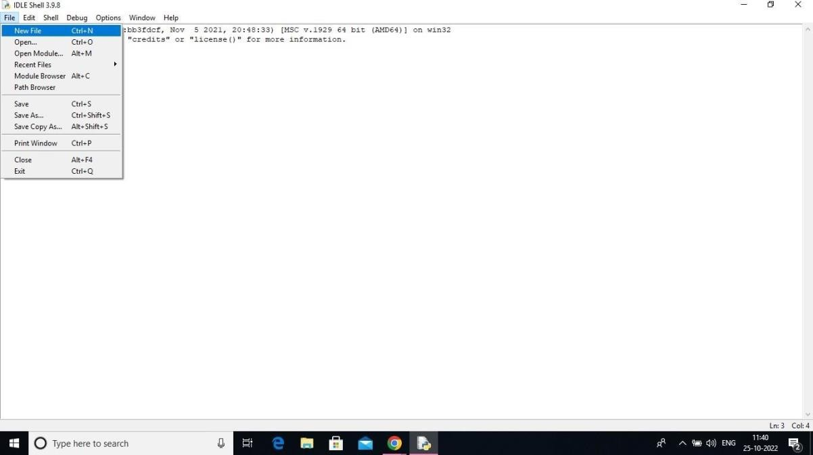Step9:GotofileandclickonNewFile

10:Openit

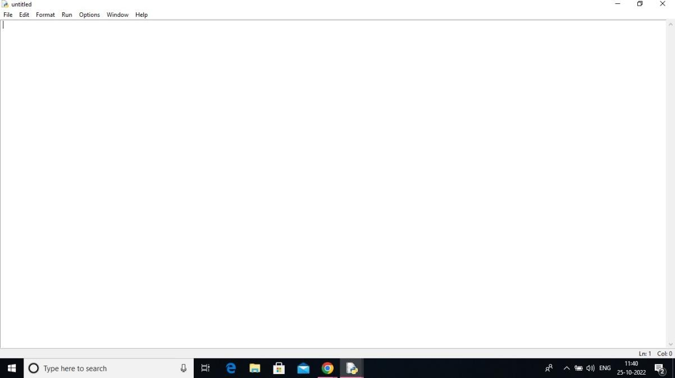

APython3.9.8isinstalledsuccessfully.