O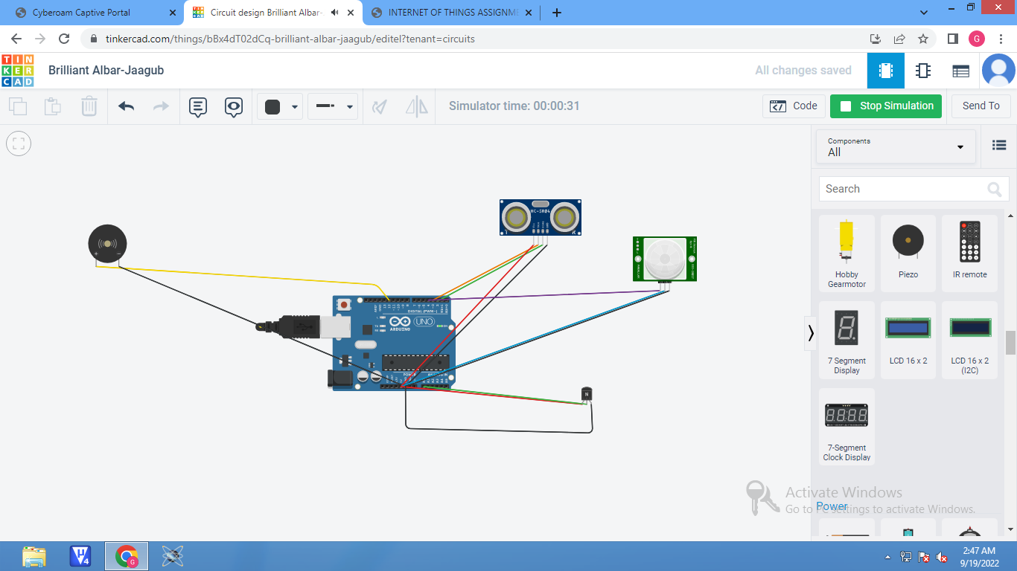

INTERNET OF THINGS

int t =3;

int e =2;

void setup()

{

Serial.begin(9600);

pinMode(t,OUTPUT);

pinMode(e,INPUT);

pinMode(13,OUTPUT);

pinMode(4,INPUT);

pinMode(12,OUTPUT);

}

void loop()

{

// OBJECT DETECTION :

digitalWrite(t,LOW);

digitalWrite(t,HIGH);

delayMicroseconds(10);

digitalWrite(t,LOW);

float dur=pulseIn(e,HIGH);

float dis=(dur\*0.0343)/2;

Serial.print("Distance :");

Serial.println(dis);

// TEMPERATURE SENSING :

double a = analogRead(A0);

[2:59 am, 19/09/2022] Mukesh Kumar: double c = (((a/1024)\*5)-0.5)\*100;

Serial.print("Temp :");

Serial.println(c);

delay(2000);

// MOTION DETECTOR

int p = digitalRead(4);

Serial.println(p);

if(p)

Serial.println("Motion Detected");

delay(1000);

// BUZZER

for(int i=0;i<=30000;i=i+10)

{

tone(12,i);

delay(1000);

noTone(12);

delay(1000);

}

}