ASSIGNMENT-1 NAME : SAGAYA PRADEEP.A

ROLL NO : 1916153

1. **Profit by State:**

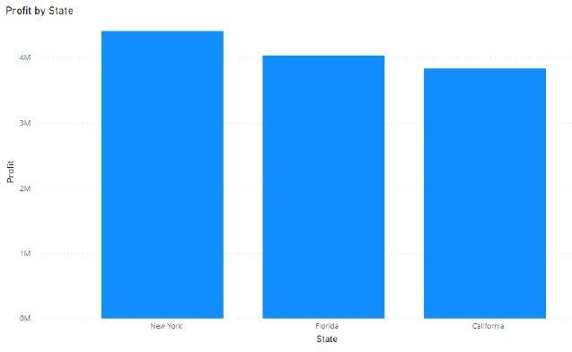

1. **Marketing Speed by State:**

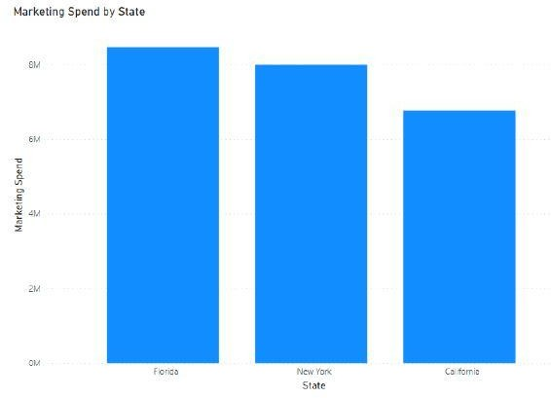

1. **R&D Spend and Profit by State:**

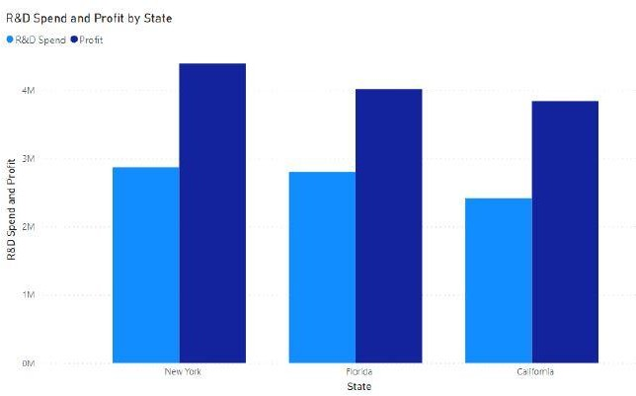

1. **Marketing Spend and Profit by State:**

