STAGES  OF  JOURNEY | MOTIVATION | SEARCH FOR WEBSITE |  | INSIDE THE SITE | SELECT TRAIN AND PASSENGER DETAILS |  |  | PAYMENT |  | TICKETS | JOURNEY
ACTIVITES  FEELINGS | Wants to book a train ticket remotely.  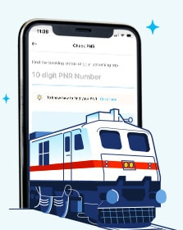 | Search online ticket  booking on search  engine.   | Neglect the adds if any.   | Fill the from, destination, date and time of travel. Proceed with search trains.  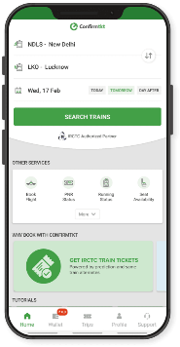 | Check seat availability and train details.  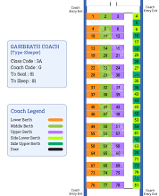 | Select appropriate train among the availability  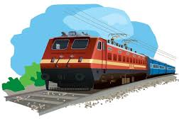 | Add passengers and fill the details   | Proceed to pay   | Contact online service for help | e-tickets with QR-Code will be send to the registered e-mail ID  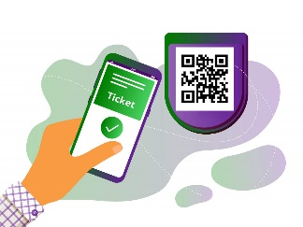 | “MY BOOKINGS” for QR Code access.  PNR Status for accessing updates regarding tickets.  GPS tracking for accessing live location.  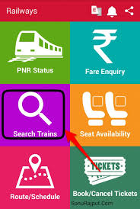
VERY  HAPPY | 
OVERALL SATISFIED |  | 
NOT  SATISFIED |  |  | 
EXPERIENCES | Exited to have a better commuting experience | Surprised to see many websites confusing about how to choose | Annoyed to choose due to unwanted adds interrupting while booking | Satisfying availability of stations | Amazed to find wide range of train availability of passengers | Confused to select the appropriate trains | Hectic process due to unnecessary data entry | Frustrated to find only restricted payment options | Satisfied with online payments but had some server delay | Delighted to have digitalized tickets | Pleasant journey experience with lots of commuting facilities
CUSTOMER  EXPECATIONS | Effective remote booking | More user friendly search engines | Allow to hide necessary adds | Clear and innovative website designs | To view categorized seat availability | Display trains based on ratings | Avoid collecting unnecessary data | More payment choices | Faster website speed | To experience digitalized ticket booking | Safe and secured travel without any inconvenience.

PROJECT TITLE: SMART SOLUTIONS FOR RAILWAYS PROJECT DESIGN PHASE-II: CUSTOMER JOURNEY MAP TEAM ID: PNT2022TMID4224

