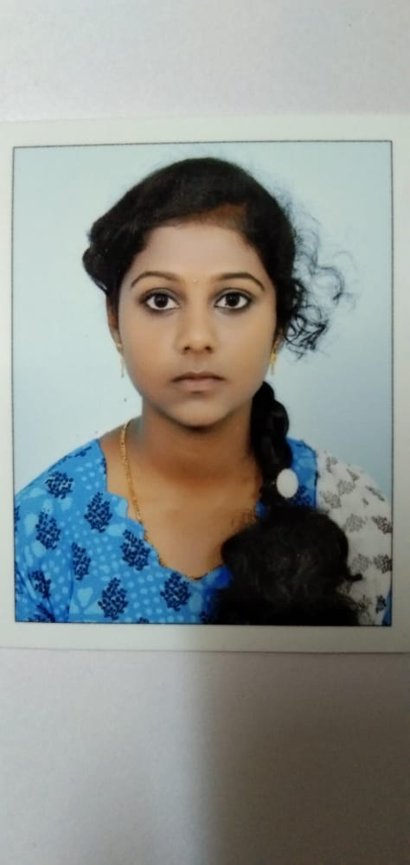**J.EVANGALIN JERSHA**

[ammujersha@gmail.com](mailto:AMMUJERSHA@GMAIL.COM)

7904454107

**OBJECTIVE:**

TO SECURE A CHALLENGING POSITION IN A REPUTABLE ORGANIZATION TO EXPAND MY LEARNINGS,KNOWLEDGE AND SKILLS.

**QUALIFICATION:**

**EDUCATIONAL:**

* PURSUING BACHALOR OF ENGINEERING WITH ELECTRONICS AND COMMUNICATION ENGINEERING AS MAJOR IN ST.JOSEPH COLLEGE OF ENGINEERING AFFILITED TO ANNA UNIVERSITY WITH 8.1 G.P.A.
* COMPLETED HIGHER SECONDARY FROM CARMAL GIRLS HIGHER SECONDARY SCHOOL IN THE YEAR 2018-19 WITH 89%.
* COMPLETED SECONDARY SCHOOL LEAVING CERTIFICATE FROM RUBEN MATRICULATION SCHOOL IN THE YEAR 2016-17 WITH 74%.

**TECHNICAL:**

* CERTIFIED IN PYTHON PROGRAMMING

**EXPERIENCE:**

WORKED FOR COMPUTER SOFTWARE COLLAGE [CSC] FOR 6 MONTHS AS A PROGRAMMING STAFF HANDLING C, PYTHON, HTML, CSS AND JAVA SCRIPT FOR 6 MONTHS.

**PERSONAL PROFILE**

NAME : J.EVANGALIN JERSHA

D.O.B : 03/02/2001

FATHERS NAME : T.JUSTIN

NATIONALITY : INDIAN

RELIGION : CHRISTIAN

MARITIAL STATUS : UNMARRIED

LANGUAGES KNOWN : TAMIL AND ENGLISH

**DECLARATION:**

I HERE BY DECLARE THAT ALL THE ABOVE MENTIONED DETAILS ARE TRUE TO THE BEST OF MY KNOWLEDGE.

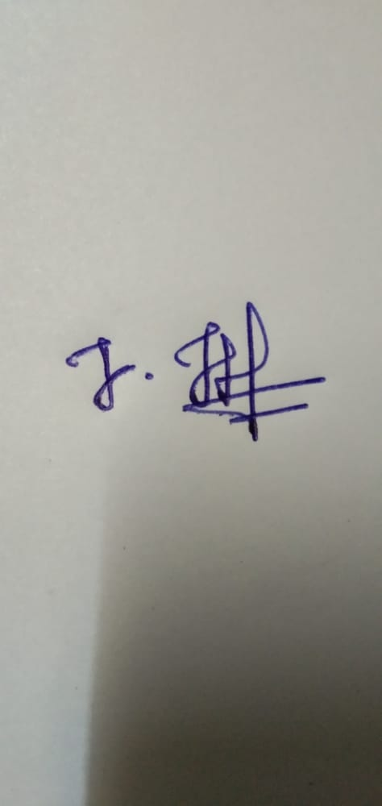

**J.EVANGALIN JERSHA**