**Assignment – 03**

|  |  |
| --- | --- |
| Team ID | PNT2022TMID07401 |
| Project Name | Nutrition Assistant Application |

# Task 1: Create a Bucket in IBM Object Storage.

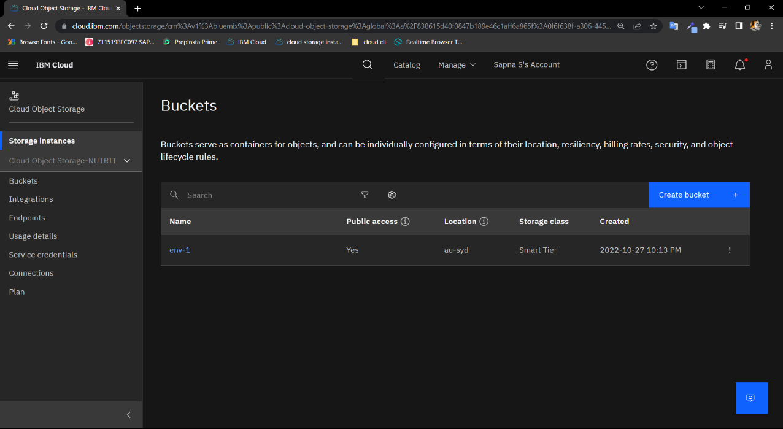

# Task 2: Upload 5 images to IBM object storage and make it public. Write html code for displaying the 5 images.

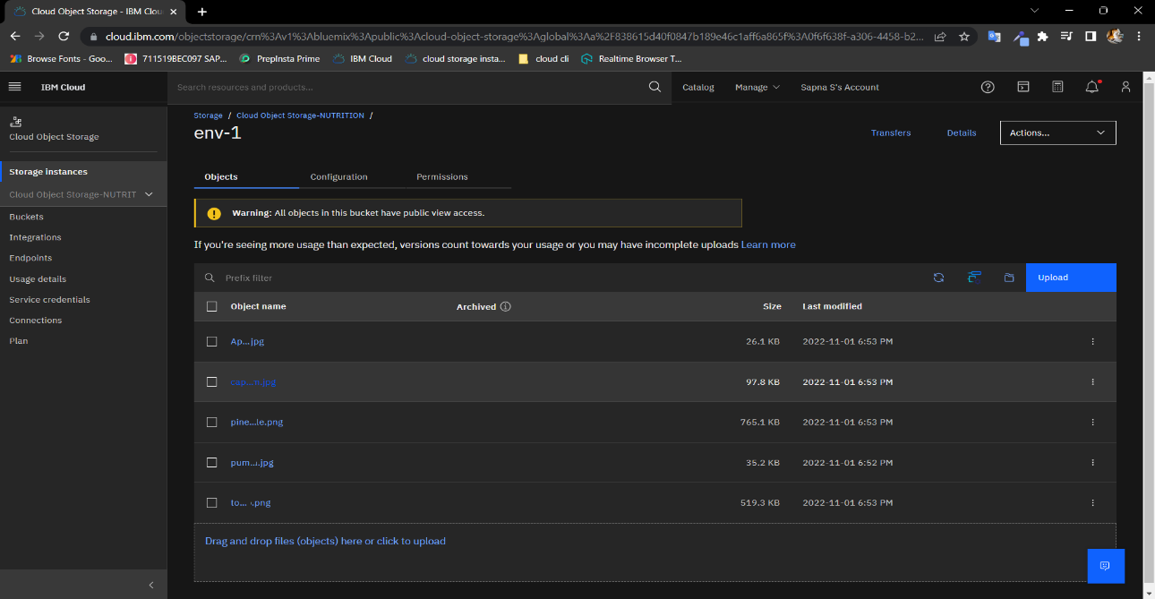

# Task 3: Upload a CSS page to the object storage and use the same page in your HTML code.

# Task 4: Design a chatbot using IBM Watson assistant for hospital. Ex: User comes with query to know the branches for that hospital in your city. Submit the web URL of that chat bot as assignment.

**https://web-chat.global.assistant.watson.appdomain.cloud/preview.html?backgroundImageURL=https%3A%2F%2Fjp-tok.assistant.watson.cloud.ibm.com%2Fpublic%2Fimages%2Fupx-4bc2d957-f1d7-4dcf-b841-d4ee8a69ef16%3A%3Aba2a4f3b-abed-4271-99a1-6ed3cd576675&integrationID=7f8eea54-3630-47f1-ba70-ead405b94a08&region=jp-tok&serviceInstanceID=4bc2d957-f1d7-4dcf-b841-d4ee8a69ef16**

# Task 5: Create Watson assistant service with 10 steps and use 3 conditions in it. Load that script in HTML page.

