ASSIGNMENT-4

|  |  |
| --- | --- |
| Team ID | PNT2022TMID07401 |
| Project Name | Nutrition Assistant Application |
| Maximum Marks | 2 Marks |
| Batch Number | B2-2M4E |

# Question-1:

Pull an Image from Docker hub and run it in Docker playground.

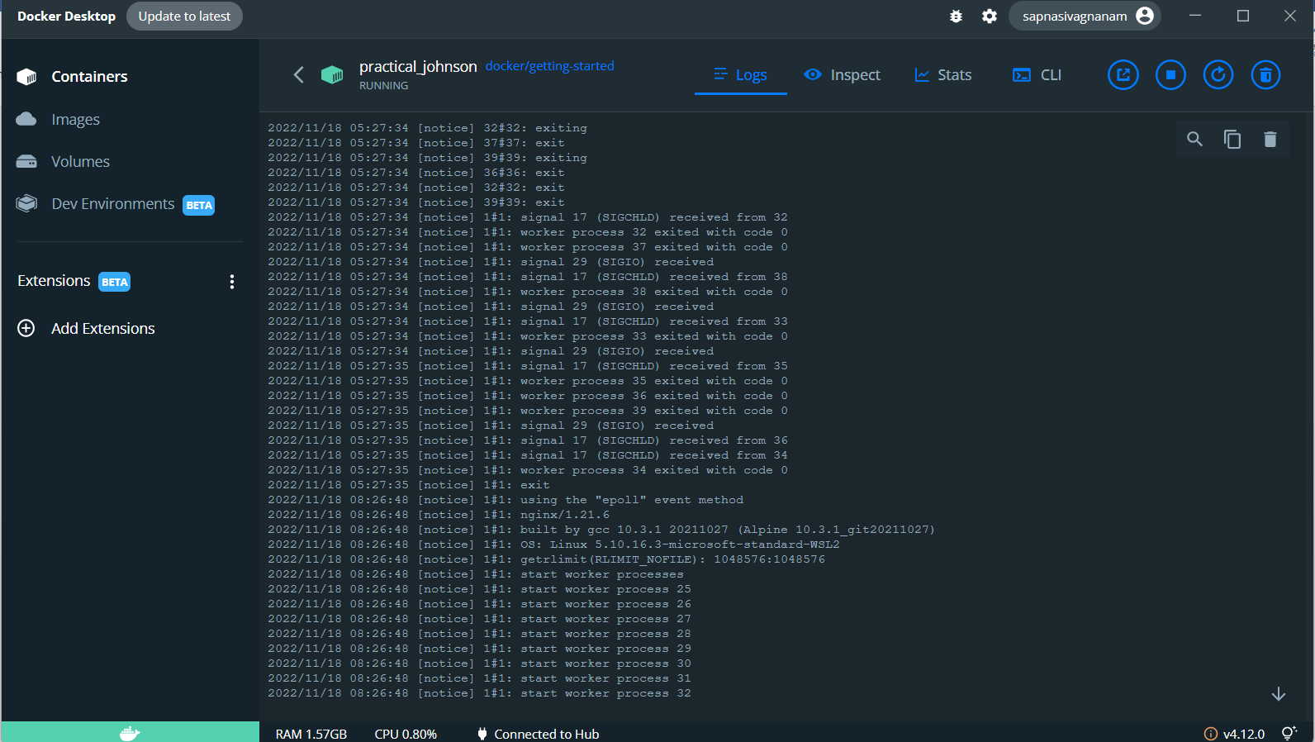

# Question-2:

Create a Docker file for the job portal application and deploy it in Docker desktop application.

# FROM jobportal1: latest WORKDIR ~/Desktop/ ADD. jobportal1/ WORKDIR ~/Desktop/html

**RUN pip install –r requirements RUN chmod + x app.sh**

# CMD [“/bin/sh”,”app.sh”] Question-3:

Create an IBM container registry and deploy hello world app or job portal app.

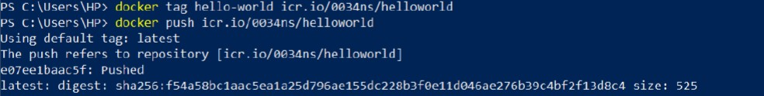

# Question-4:

Create a Kubernetes cluster in IBM cloud and deploy hello world image or job portal image and also expose the same app to run in node port.

