**Ideation Phase**

**Brainstorm & Idea Prioritization Template**

|  |  |
| --- | --- |
| Date | 26 September 2022 |
| Team ID | PNT2022TMID13566 |
| Project Name | Industry-specific intelligent fire management system |
| Maximum Marks | 4 Marks |

**REFERENCE :** [**https://app.mural.co/invitation/mural/mathavanb3266/1664197060027?sender=u3e083a7897715aec13e65405&key=d6cb599f-c0b5-4817-9246-401910539d91**](https://app.mural.co/invitation/mural/mathavanb3266/1664197060027?sender=u3e083a7897715aec13e65405&key=d6cb599f-c0b5-4817-9246-401910539d91)

**Step-1: Team Gathering, Collaboration and Select the Problem Statement**

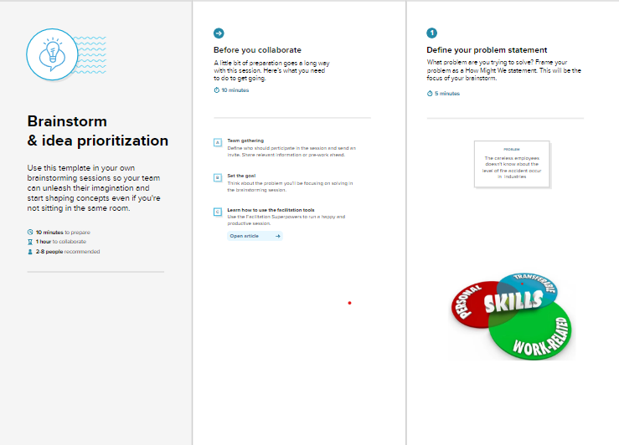

**Step-2: Brainstorm, Idea Listing and Grouping**

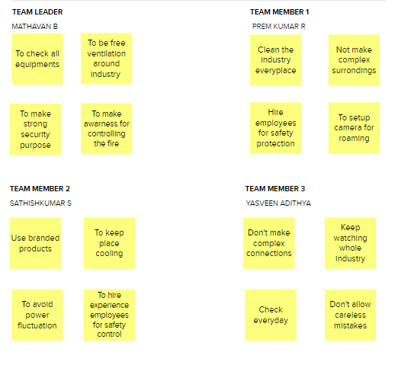

**Step-3: Idea Prioritization**

