Fertilizers Recommendation System For Disease

Prediction

***Team members :***

***S.Dhanushya***

***R.Vanisha***

***S.Bhuvaneshwari***

***K.Nithyaveni***

Abstract: Agriculture is the main aspect of country development. Many people lead their life from agriculture field, which gives fully related to agricultural products. Plant disease, especially on leaves, is one of the major factors of reductions in both quality and quantity of the food crops. In agricultural aspects, if lhe planl is affected by leaf disease lhen il reduces the growth of lhe agricultural level. Finding lhe leat disease is an impotlant role ot agricullure preservation. Afler pte-processing using a median tiller, segmenlalion is done by Guided Aclive Conlour method and finally, lhe leaf disease is identified by using Support Vector Machine. The disease-based similarity measure is used for fertilizer recommendation.

Keywords: Disease Prediction, Graph Cut Algorithm, Guided Active Contour method, Leaf segmentation, Leaf Feature Identification.

1. INTRODUCTION

## Detection and recognition of plant diseases using machine learning are very efficient in providing symptoms of identifying diseases at its earliest. Plant pathologists can analyze the digital images using digital image processing for diagnosis of plant diseases. Application of computer vision and image processing strategies simply assist farmers in all of the regions of agriculture. Generally, the plant diseases are caused by the abnormal physiological functionalities of plants. Therefore, the characteristic symptoms are generated based on the differentiation between normal physiological functionalities and abnormal physiological functionalities of the plants. Mostly, the plant leaf diseases are caused by Pathogens which are positioned on the stems of the plants. These different symptoms and diseases of leaves are predicted by different methods in image processing. These different methods include different fundamental processes like segmentation, feature ecraction and classification and so on. Mostly, the prediction and diagnosis of leaf diseases are depending on the segmentation such as segmenting the healthy tissues from diseased tissues of leaves.

1. MATERIAL AND METHODS

## A digital camera or similar devices are used to take images of different types, and then those are used to identify the affected area in leaves. Then different types of image-processing techniques are applied to them, the process those images, to get different and useful features needed for the purpose of analyzing later-Plant leaf disease identification is especially needed to predict both the quality and quantity of the

First segmentation step primarily based on a mild polygonal leaf model is first achieved and later used to guide the evolution of an energetic contour. Combining global shape descriptors given by the polygonal model with local curvature-

* *R. Neela* is *currently working as an Assistant Professor at Computer Science in A.V.C.College (Autonomous), Mannampandal, Mayiladvihvrai-6ogsos, Tamil Nadu, India. E-mail:* [*avcneela@gmail.com*](mailto:avcneela@gmail.com)
* *P. Nithiya is currently pursuing M.Phil. degree program in Computer Science in A.V.C.College (Autonomous), Mannampandal, Mayiladvihvrai-6ogsos, Tamil Nadu, India. E-mail:* [*nithyapandiyan20l9@gmail.com*](mailto:nithyapandiyan20l9@gmail.com) *agriculture plants. This technique is adapted to digital image processing, it has been organized in the*

## based features, the leaves are then classified overleaf datasets. In this research work introduce a method designed to deal with the obstacles raised by such complex images, for simple and plant leaves. A first segmentation step based on graph-cut approach is first performed and later used to guide the evolution of leaf boundaries, and implement classification algorithm to classify the diseases and recommend the fertilizers to affected leaves as shown in Figure 1.

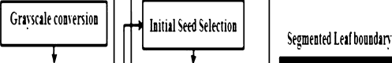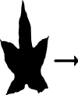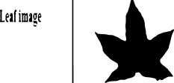



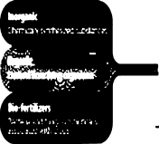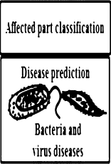

Figure.7 *Proposed Architecture*

* 1. Image Classification Steps :

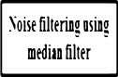

The proposed image classification technique is divided into the

following steps:

* + 1. Image acquisition:

## To get the image of a leaf so that evaluation in the direction of

a class can be accomplished.

* + 1. Preprocessing:

## The purpose of image preprocessing is improving image statistics so that undesired distortions are suppressed and image capabilities which are probably relevant for similar processing are emphasized. The preprocessing receives an image as input and generates an output image as a grayscale, an invert and a smoothed one.

### Segmentation:

Implements Guided active contour method. Unconstrained active contours applied to the difficult natural images. Dealing with unsatisfying contours, which would try and make their way through every possible grab cut in the border of the leaf. The proposed solution is used the polygonal model obtained after the first step not only as an initial leaf contour but also as a shape prior that will guide its evolution towards the real leaf boundary.

* + 1. Disease Prediction:

Leaves are affected by bacteria, lung i, virus, and other insects. Support Vector Machine (SVM) algorithm classifies the leaf image as normal or affected. Vectors are constructed based on leaf features such as color, shape, textures. Then hyperplane constructed with conditions to categorize the pre- processed leaves and also implement multiclass classified, to predict diseases in leaf image with improved accuracy.

* + 1. Fertilizer Recommendation:

Recommend the fertilizer for affected leaves based on severity level. Fertilizers may be organic or inorganic. Admin can store the fertilizers based on disease categorization with severity levels. The measurements of fertilizers suggested based on disease severity.

### 2.2. SVM Classification Algorithm:

Support Vector Machine(SVM) SVM is a binary classifier to analyze the data and recognize the pattern for classification. The main goal is to design a hyperplane that classifies all the training vectors in different classes. The objective of SVM is to identify a function Fx which obtain the hyper-plane. Hyperplane separates two classes of data sets. The linear classifier is defined as the optimal separating hyperplane. The data sets can be separated in two ways: linearly separated or nonlinearly separated. The vectors are said to be optimally separated if they are separated without error and the distance between the Mo closest vector points is maximum. For linear separable data sets, training vectors of a different class of pairs (am, bm), where m = 1,2,3,4 ...,t

am c Rn(Reference Vector) bm c ( +1, -1}

The decision boundary is placed using a maximal margin between the closest points. w is being a vector perpendicular median to the street. am be the unknown of to be positioned especially elegance according to the decision boundary, and hyperplane (w. a) + c =0 with c as constant

For classification

(w . am ) + c0 * 1, V

Therefore rearranging the above equations bm (w.am ) + c0 — 1 a 0 for points into dataset to in the gutter i.e on the decision boundary bm (w.am ) + c0 — 1 = 0.

1. RESULTS AND DISCUSSION

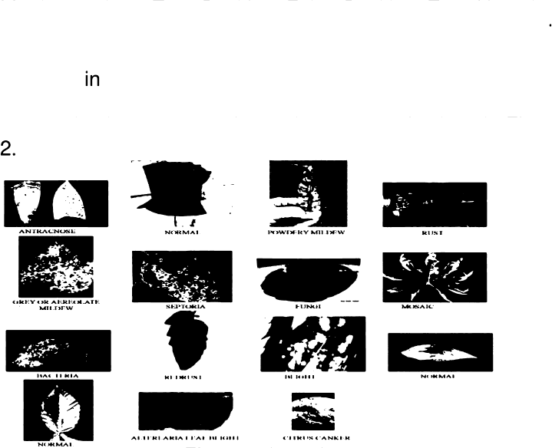To compare the performance of the proposed SVM method with the existing CNN (Convolutional Neural NeMork) method. Metrics such as True Positive, False Positive, True Negative, False Negative are used. The proposed method is implemented using .NET. The code existing CNN method was written Python was downloaded from the web [https://github.com/cs-chan/Deep-Plant]. 15 images were captured using a camera for testing purpose is given in Figure

*Figure.2 Input Images*

*Firstly some secondary metrics such as true positive (TP), true negative (TN), false positive (FP), and false-negative (FN) [18) are calculated as follows,*

True Positive: True Positive is an outcome where the model correctly predicts positive class.False Positive: False Positive is an outcome where the model incorrectly predicts positive class.True Negative: True Negative is an outcome where the model correctly predicts negative class.False Negative: False Negative is an outcome where the model incorrectly predicts negative class.The True Positive, False Positive, True Negative, and False Negative value for captured 15 images are shown in table 1. The pictorial representation of this comparison is given in Fig ure 3.

*TABLE I*

*CoiviPA iSoN or CNN AND SVM IN* DEPTS *OF TP, FP, TN, AND FN*

bm = +ve samples (w . am ) + c0 s -1, »’ bm = -ve samples

where (w.am ) has a dot product of w and am.

(1)

(2)

|  |  |  |  |  |
| --- | --- | --- | --- | --- |
| *Methods* | *To* | *rr'* | *T*/v | *FN* |
| *e ICNN* | *6* | *3* | *2* | *4* |
| *F'roposed{S VM]* | *8* | *4* | *1* | *2* |

The inequalities if added i.e multiplying equations (1) and (2) with +1, —1 and bm.

Suppose bm such that bm = 1 for +ve samples bm = -1 for -ve samples it results,

bm [ (w.am ) + c0 ] * 1

bm [(w.am ) + c0 ] a -1



8

7

5

4

3

2

2

4

++ 2

True False

**Positive Positive**

True

False

**Negative Negative**

m CNN < SVM

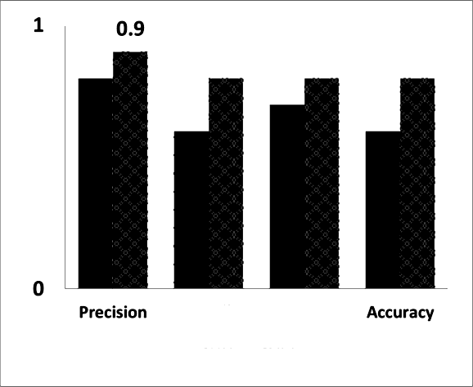

0.8

0.8

0.7

0.6 0.6

0.6

04

0.2

Recall fi-Measure

* CNM ■ SvM

*Figure.3 Performance comparison of CNN and SVM* in *terms oi True Positive, False Positive, True Negative and False Negative.*

## Precision: The proportion of positive identification is actually

*Figure.4 Precision, Recall, F-Measure and Accuracy comparison chart ior CNN and SVM*

## CONCLUSIONS

correct. The proposed method uses SVM to classify tree leaves,

Precision = TP / (TP+FP) identify the disease and suggest the fertilizer. The Recall: The proportion of actual positives is identified correctly. proposed method is compared with the existing CNN Recall = TP / (TP+FN) based leaf disease prediction. The proposed SVM

F-Measure: Defined as the weighted harmonic mean of technique gives a better result when compared to existing precision and recall. CNN. For the same set of images, F-Measure for CNN is F-Measure = 2TP / (2TP + FP + FN) 0.7and 0.8 for SVM, the accuracy of identification of leaf

# Accuracy: It refers to the closeness of a measured value to a disease of CNN is 0.6 and SVM is 0.8. standard or known value.

Accuracy = (TP + TN) / (FP + TP + FN + TN)

The Precision, Recall, F-Measure and Accuracy for the both

# 5.FUTURESGOPE

CNN and SVM are calculated and given in table 2 the This further research is implementing the proposed algorithm corresponding graph is given in Figure 4. With the existing public datasets. Also, various segmentation

algorithms can be implemented to improve accuracy. The proposed algorithm can be modified further to identify the disease that affects the various plant organs such as stems and fruits.

*PrlEGlSlON, REGALE, F-MEASURE AND Accun cv wr ues or CNN*

*AND S VM*

|  |  |  |  |  |
| --- | --- | --- | --- | --- |
| Classifiers | Pre | Re | F-M | Acc |
| CNN | 0.8 | 0.6 | 0.7 | 0.6 |
| SVM | 0.9 | 0.8 | 0.8 | 0.8 |

REFERENCES

## Reyes Angie .K, Juan C. Caicedo, and Jorge E. Camargo, "Fine-tuning Deep Convolutional Networks for Plant Recognition", In CLEF (Working Notes), 2015.

* 1. Hamrouni .L, Aiadi .0, Khaldi .B and Kherfi .M.L, "Plants Species Identification using Computer Vision Techniques", Revue des Bioressources 7, no. 1, 2018.

## Dimitrovski, Ivica, GjorgjiMadjarov, DragiKocev, and PetreLameski, "Maestra at LifeCLEF 2014 Plant Task: Plant Identification using Visual Data", In CLEF (Working Notes), pp. 705-714, 2014.

* 1. Naresh, Y. G., and H. S. Nagendraswamy, "Classification of medicinal plants: an approach using modified LBP with symbolic representation", Neurocomputing 173, pp: 1789-1797, 2016.
  2. Sue Han, CheeSeng Chan, Paul Wilkin, and Paolo Remagnino, "Deep-plant: Plant identification with convolutional neural networks", In Image Processing

3345