Prerequisites Software (Python 3.6.5)

|  |  |
| --- | --- |
| Date | 03 November 2022 |
| Team ID | PNT2022TMID49214 |
| Project Name | SMART SOLUTION FOR RAILWAYS |
| Maximum Marks | 4 Marks |

SMART SOLUTION FOR RAILWAYS

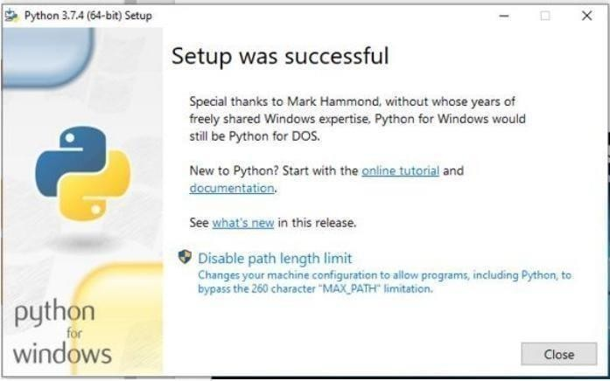

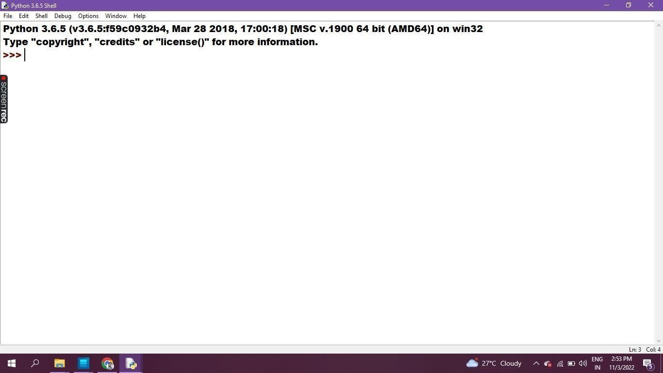

**Program & Output in Python IDLE 3.6.5 - 64bit**

