ASSIGNMENT-3

DOMAIN : IOT

NAME : JEEVA C

REGISTER NUMBER : 714019106301

COLLEGE : SRI SHAKTHI INSTITUTE OF ENGINEERING

AND TECHNOLOGY

**PROGRAM FOR TRAFFIC LIGHT**

**Python Code:**

void setup() {

  // put your setup code here, to run once:

  Serial1.begin(9600);

  pinMode(21, OUTPUT);

  pinMode(20, OUTPUT);

  pinMode(19, OUTPUT);

}

void loop() {

  // put your main code here, to run repeatedly:

  digitalWrite(21, HIGH);

  delay(3000); // this speeds up the simulation

  digitalWrite(21, LOW);

  digitalWrite(20, HIGH);

  delay(3000);

  digitalWrite(20, LOW);

  digitalWrite(19, HIGH);

  delay(3000);

  digitalWrite(19, LOW);

}

**OUTPUT:**

Traffic Lights For Raspberry Pi

Blinking Red Light:

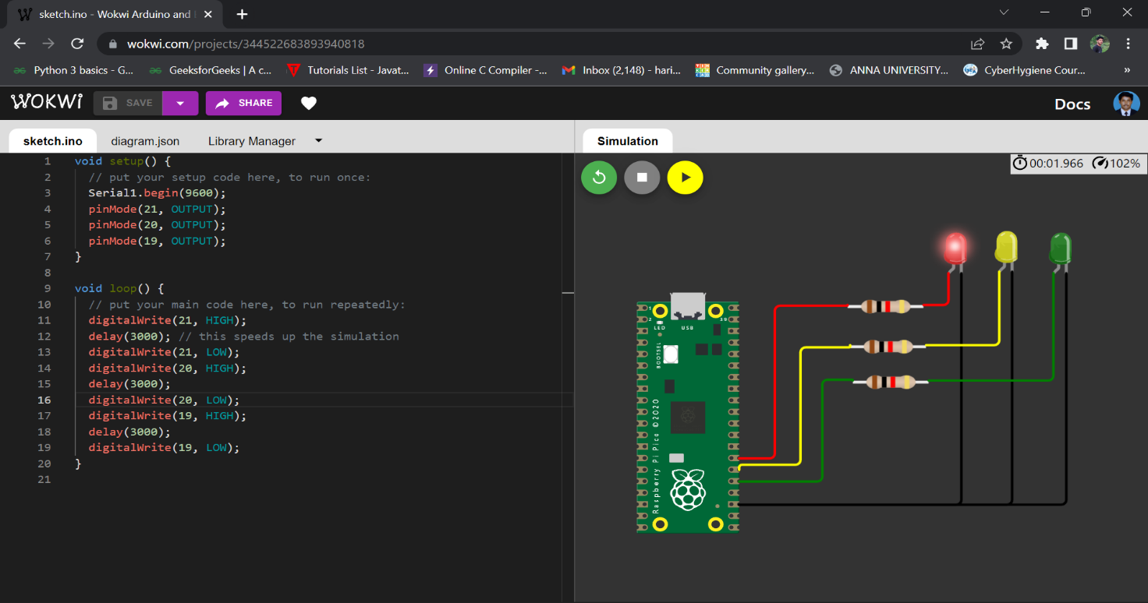

Blinking Yellow Light:

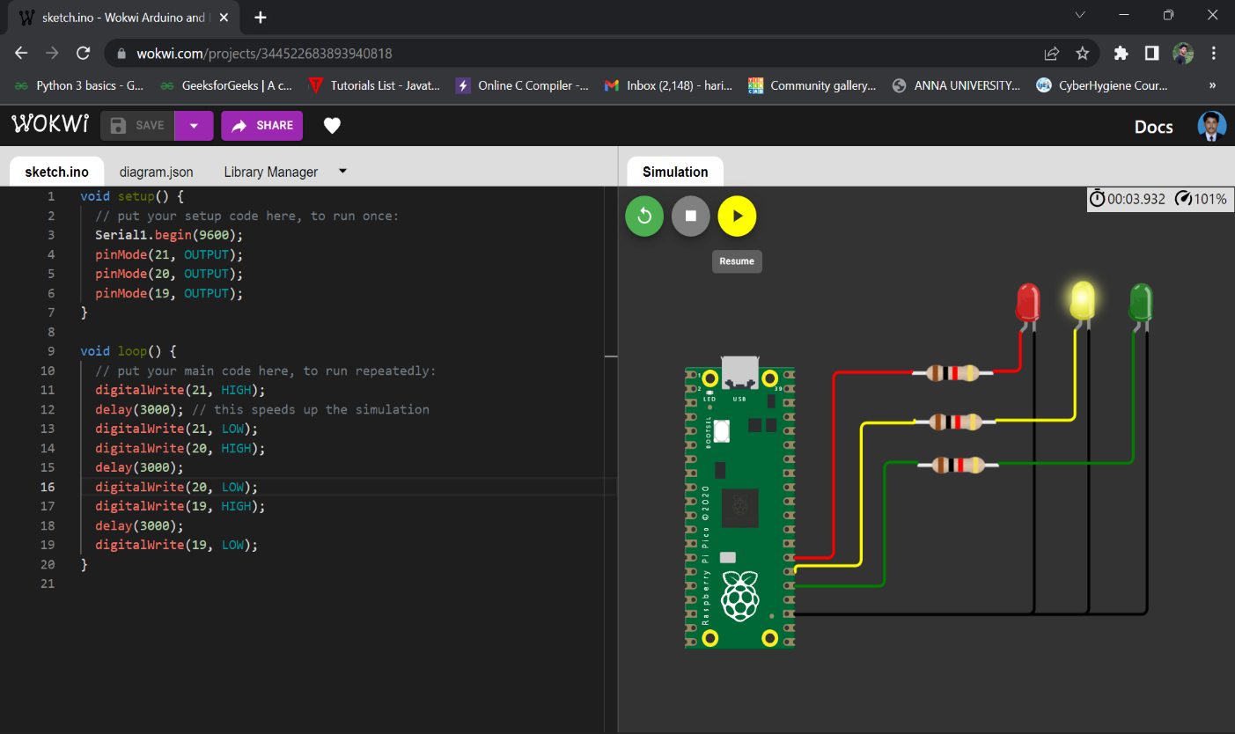



Blinking Green Light:

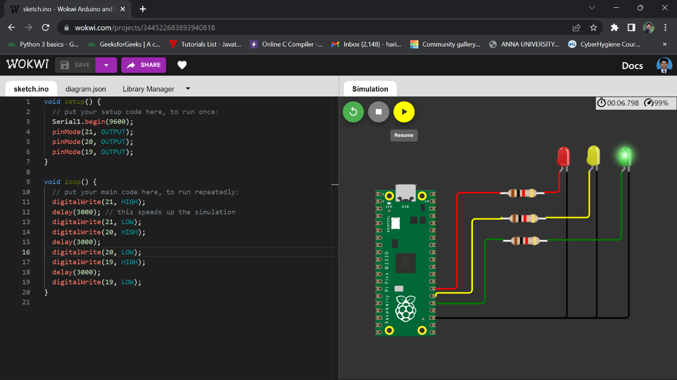

**BLINKING LED:**

PROGRAM FOR BLINKING LED

Python code:

void setup() {

  // put your setup code here, to run once:

**Serial**.begin(9600);

  pinMode(22, OUTPUT);

}

void loop() {

  // put your main code here, to run repeatedly:

  digitalWrite(22, HIGH);

**Serial**.println("LED ON");

  delay(2000);

  digitalWrite(22, LOW);

**Serial**.println("LED OFF");

  delay(2000);

}

Output:

Blinking LED For Raspberry pi:

