**RESUME**

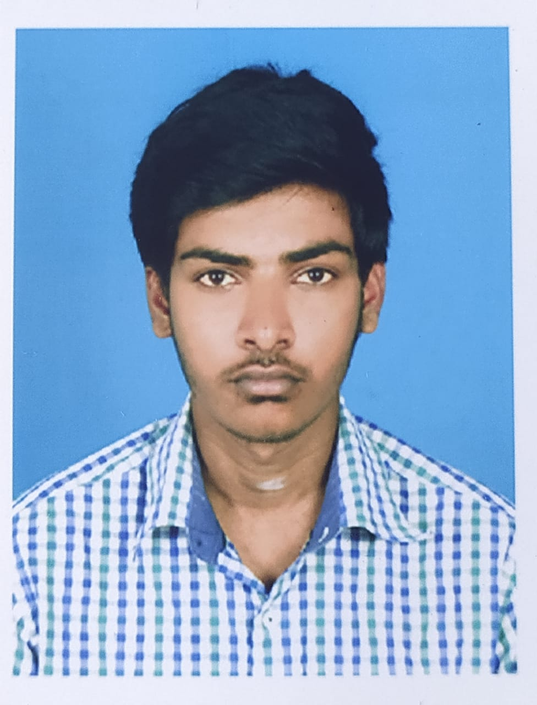

**Name : RANJITH M.S**

**Father’s Name : SARAVANAN M**

**Date of Birth : 29/09/2000**

**Age : 21**

**Gender : MALE**

**Mobile Number : 6382406060 , 6382912780**

**E-mail ID : ranjithbhatmesh@gmail.com**

**Education Qualification:**

|  |  |  |  |  |
| --- | --- | --- | --- | --- |
| **SI.NO** | **Educational Qualification** | **Name of the College /School/ Board** | **Year of**  **Passing** | **Aggregate**  **Percentage of Marks** |
| 1 | Bachelor of Computer Science Engineering | KIT- KalaignarKarunanidhi Institute of Technology Coimbatore-641402 | Pursuing  VII  Semester | 8.4 CGPA Upto  VI Semester |
| 2 | Diploma in Computer Engineering | CIT Sandwich Polytechnic College  Coimbatore-641014 | 2020 | 70% |
| 3 | SSLC | T.A. Ramalingam Chettiar Hr Sec School Coimbatore-641038 | 2017 | 73% |

**Detail of Diploma Project Work- Title: Web Based People Information System**

**Brief description of the Project Work:**

|  |  |
| --- | --- |
| |  | | --- | | I completed my project on Web Based People Information System. In our project we alert the people who didn’t know about what are the product available in Ration Shop and we also included the electricity complaints and people can visit our Website to know the details of Electricity Shutdown date in their Street or area. | |

**Industrial Training / Internship:**

|  |  |  |  |
| --- | --- | --- | --- |
| **SI.NO.** | **Industry Name & Address** | **Nature of Training** | **Training Period** |
| 1 | Vasantha Advanced System | Assemble and Testing | 08/07/2021 to 07/08/2021 |

2 IIIT Kottayam(AIC) Seed fund allocation 03/05/2022 to 31/05/2022

**Description:**

My role in Internship is to take the company material like Cables and Gland to assemble it in together with the help of assemble tools like fitting machine and spanner and also assemble the components like Gates, Wires and Led’s with the Motherboard. This products are mainly used for the Petrol Bunks and Gas Stations

**Skills**

|  |  |
| --- | --- |
| 1 | Python |
| 2  3  4 | Basic of Cloud  Basic Linux Commands  HTML |

**Area of Interest in Academic:**

|  |  |
| --- | --- |
| 1. | Hardware Servicing |
| 2. | Network Administrator |

**Computer Proficiency:**

|  |  |
| --- | --- |
| 1. | Animation Editing |
| 2.  3. | Hardware Servicing  Poster Designing |

**Co-Curricular Activities:**

|  |  |  |
| --- | --- | --- |
| **Activity** | **Period** | **Detail- Holding Certificate/ Award** |
| **Certificate Course** | July 16 to Oct 5 | C Programming |
| Dec 2 to Dec 6 | PC Maintenance and Troubleshooting |
|  | Mar 1 to Mar 15 | Introduction of Python |

**Extra-Curricular Activities:**

|  |  |  |  |  |
| --- | --- | --- | --- | --- |
| |  |  | | --- | --- | | **Activity** | **Detail** | | NCC | A-Grade in School | |

**Hobby:**

|  |  |
| --- | --- |
| 1. | Travelling To Nature Destination |
| 2. | Playing BallBatmiton |
| 3. | Cycling |

**Achievements:**

|  |
| --- |
| Winner and Man of the Match in School Football Team.  Third in BallBatmiton conducted by Inter School Competition |

**Declaration:**

The details given above are true to the best of my knowledge and belief.



**Place:**

**Date:**  **Signature of the Candidate**