**Project Report**

**1.INTRODUCTION**

1.1 Project Overview

Daily Expense Tracker System is a system which will keep a track of Income-Expense of a House-Wife on a day to day basics, This System takes Income from House-Wife and divides in daily expense allowed, If u exceed that days expense it will cut if from your income and give new daily expense allowed Amt, and if that days expense is less it will add it in savings. Daily expense tracking System will generate report at the end of month to show Income-Expense Curve. It will let you add the savings amt which you had saved for some particular Festivals or day like Birthday or Anniversary.

1.2 Purpose

Tracking your spending can also help you identify [serious problems](https://www.thebalancemoney.com/signs-you-have-spending-issues-2385517) in how you manage your money. For example, as you gauge your expenses over a period of months or even years, you might observe that your annually increasing monthly rent now makes up an outsized percentage of your monthly income or that you aren't earning enough to lead the lifestyle you imagined. To correct problems like these, you might have to make more drastic life changes such as moving to a more affordable residence or getting a second job to earn more money. It won't be easy, but it will be worthwhile if it puts you on track financially.

**2. LITERATURE SURVEY**

2.1 Existing Problem

Earlier, our parents use to track all their expenses by writing down in a small notebook and calculating it on their own Even still many of them follow the same to maintain their financial expenses even some of them don’t care of their expenses and spendings.

Not only in our homes, Expenses are need to be tracked in many large scale and small scale sectors such as in many schools, colleges, marketing companies , departmental stores , etc

In short, tracking our financial expenses is a great deal especially in this scenario so making those tracking easier is the job of this application.

2.2 Problem Statement Defintion

A well-articulated customer problem statement allows us to find the ideal solution for the challenges our customers face. Throughout the process, you’ll also be able to empathize with your customers, which helps you better understand how they perceive your product or service.

|  |  |  |  |  |  |
| --- | --- | --- | --- | --- | --- |
| **Problem Statement (PS)** | **I am (Customer)** | **I’m trying to** | **But** | **Because** | **Which makes me feel** |
| PS-1 | an employee. | Make a monthly budget. | There are no facilities to set a  budget. | I need to save money for my future plans. | Frustrated. |
| PS-2 | A manager. | Keep track of my expenses. | Can’t categorize the various types of  expenses. | There is no option to organize the various expenses. | Uncomfortable. |

**3.IDEATION & PROPOSED SOLUTION**

3.1 Empathy Map Canvas

3.2 Ideation & Brainstorming

3.3 Proposed Solution

|  |  |  |
| --- | --- | --- |
| 1. | Idea / Solution description | Due to the busy and hectic lifestyle people tend to overlook their budget and end up spending an excessive amount of money since they  usually didn’t plan their budget wisely. user cannot predict future expenses. While they can write down their expenses in a excel spreadsheet, their lack of knowledge in  managing finances will be a problem |
| 2. | Novelty / Uniqueness | This application tracks your every expenses anywhere and anytime without using the paper work. Just click and enter your expenditure. to avoid data loss, quick settlements and reduce human error. To provide the pie chart or graph lines in this application. |
| 3. | Social Impact / Customer Satisfaction | Using this application one can track their personal expenses and frame a monthly/annual budget. If your expense exceeded than specified limit, the application will show you an  alert message in form of a pie chart. |
| 4. | Business Model (Revenue Model) | Business people can use subscription/premium feature of this application to gain revenue. |
| 5. | Scalability of the Solution | IBM cloud will automatically allocate the storage for the users. |

**4.REQUIREMENT ANALYSIS**

4.1 Functional Requirements

|  |  |  |
| --- | --- | --- |
| **FR No.** | **Functional Requirement (Epic)** | **Sub Requirement (Story / Sub-Task)** |
| FR-1 | User Registration | User should Register using their Email. |
| FR-2 | Login | Enter username (Email) and password |
| FR-3 | Select Method | Two methods are provided  1-Manual (Manually Enter the expenses) 2-Bank (Link Bank Account) |
| FR-4 | Manual Method | Manually user can enter the expenses by using voice recognition by simply saying category and amount spent on that also can use Barcode Scanner by using Bill provided while purchasing. |
| FR-5 | Bank Method | In Bank method user have to Enter their Bank details in prior and all the Bank using transactions are detected and tracker accordingly. |
| FR-6 | Expense Tracker | This application should graphically represent the expense in the form of report. |
| FR-7 | Report generation | Graphical representation of report must be generated. |
| FR-8 | Category | This application shall allow users to add categories of their expenses. |

4.2 Non Functional Requirements

|  |  |  |
| --- | --- | --- |
| **FR No.** | **Non-Functional Requirement** | **Description** |
| NFR-1 | **Usability** | Helps to keep an accurate record of your income and expenses. |
| NFR-2 | **Security** | Budget tracking apps are considered very safe from those who commit cyber crimes. |
| NFR-3 | **Reliability** | Each data record is stored on a well built efficient database schema. There is no risk of data loss. |
| NFR-4 | **Performance** | The types of expense are categories along with an option. Throughput of the system is increased due to light weight database support. |
| NFR-5 | **Availability** | The application must have a 100% up-time. |
| NFR-6 | **Scalability** | The ability to appropriately handle increasing demands. |

**5.PROJECT DESIGN**

5.1 Data Flow Diagram

5.2 Solution & Technical Architecture

5.3 User Stories

|  |  |  |  |  |  |  |
| --- | --- | --- | --- | --- | --- | --- |
| **User Type** | **Functional Requirement**  **(Epic)** | **User Story Number** | **User Story / Task** | **Acceptance criteria** | **Priority** | **Release** |
| Customer (Mobile user) | Registration | USN-1 | As a user, I can register for the application by entering my email, and password, and confirming my password. | I can access my account / dashboard | High | Sprint-1 |
|  |  | USN-2 | As a user, I will receive a confirmation email  once I have registered for the application | I can receive a  confirmation email & click confirm | High | Sprint-1 |
|  |  | USN-3 | As a user, I can register for the application  through Facebook | I can register & access the  dashboard with Facebook Login | Low | Sprint-2 |
|  |  | USN-4 | As a user, I can register for the application  through Gmail |  | Medium | Sprint-1 |
|  | Login | USN-5 | As a user, I can log into the application by  entering email & password |  | High | Sprint-1 |
|  | Dashboard | USN-8 | As a user, I need to enter my income and expenses | I can view my insights about spending | High | Sprint-2 |
|  |  | USN-9 | As a user, I need to set a budget alert for a month or a week | I can set spending alerts for a month or a week | Medium | Sprint-2 |
|  |  | USN-10 | As a user, I need to get email notifications about my weekly and monthly spendings and earning | I can see my insights through mail about weekly and monthly insights | Medium | Sprint-2 |
| Customer Care Executive |  | USN-11 | As a customer care executive, I can solve login issues and other issues of the application | I can provide customer support 24/7 | Medium | Sprint-3 |
| Administrator |  | USN-12 | As an administrator, I can update the features  and roll out a new version of application | I can fix the bugs and add  features as per the request of the user | Low | Sprint-4 |

**6.PROJECT PLANNING & SCHEDULING**

6.1 Sprint Planning & Estimation

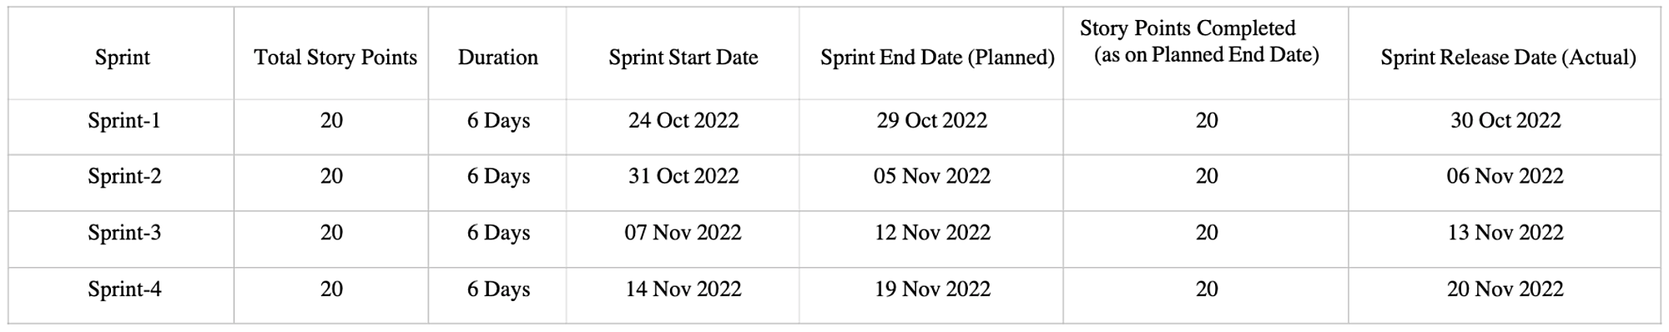

6.2 Sprint Delivery Schedule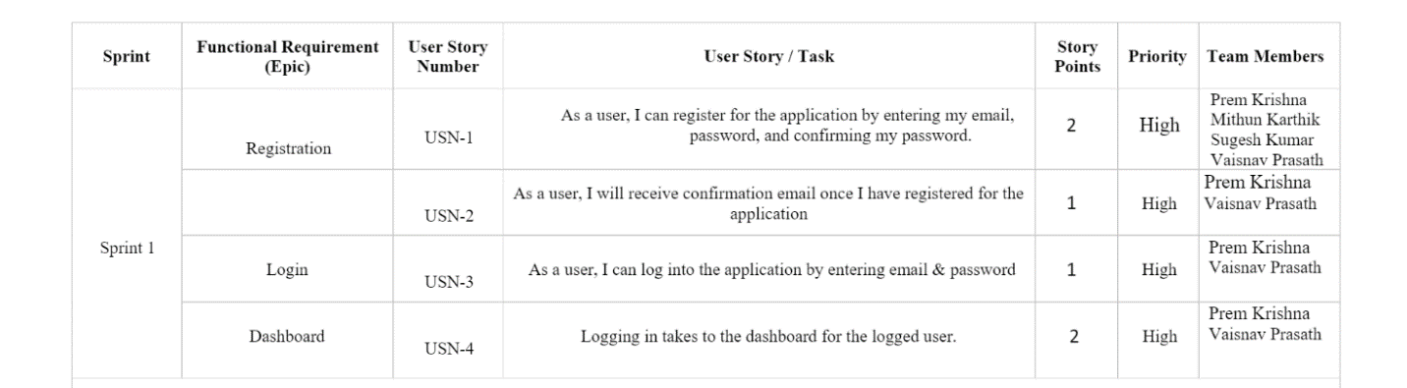

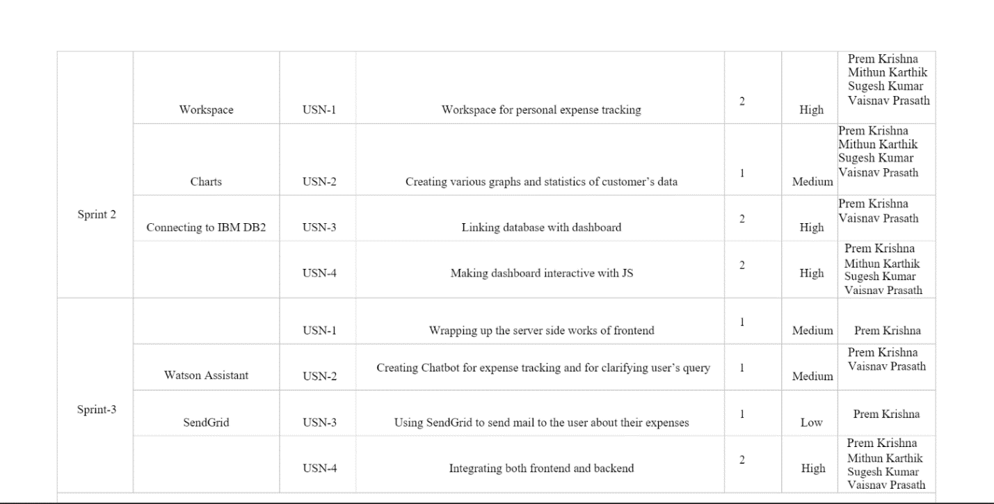

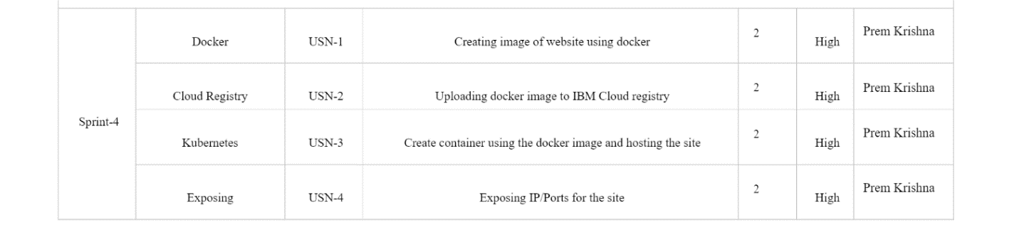

6.3 Reports from Jira

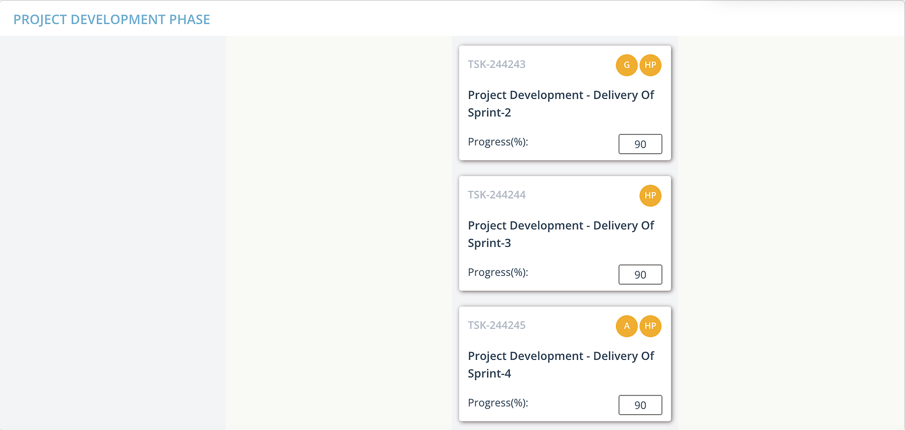

**7.CODING AND SOLUTIONING**

**7.1 LOGIN PAGE**

CODE:

<!doctype html>

<html lang="en">

<head>

<!-- Required meta tags -->

<meta charset="utf-8">

<meta name="viewport" content="width=device-width, initial-scale=1">

<!-- Bootstrap CSS -->

<link href="https://cdn.jsdelivr.net/npm/bootstrap@5.0.2/dist/css/bootstrap.min.css" rel="stylesheet" integrity="sha384-EVSTQN3/azprG1Anm3QDgpJLIm9Nao0Yz1ztcQTwFspd3yD65VohhpuuCOmLASjC" crossorigin="anonymous">

<title>Login</title>

</head>

<script src="https://cdn.jsdelivr.net/npm/bootstrap@5.0.2/dist/js/bootstrap.bundle.min.js" integrity="sha384-MrcW6ZMFYlzcLA8Nl+NtUVF0sA7MsXsP1UyJoMp4YLEuNSfAP+JcXn/tWtIaxVXM" crossorigin="anonymous"></script>

<body style="background-color:white">

<div class="container mt-3">

<h1 style="color: black; text-align: center;">

Personal Expense Tracker <img src="../static/images/bank.png" style="width:50px;height: 50px;">

</h1>

<div class="container mt-5" style="width: 600px;">

<div class="card shadow-lg bg-white rounded">

<div class="card-header" style="text-align: center;">

<h4>Login</h4>

</div>

<div class="card-body">

<form action="/login" method="POST">

<div class="mb-3">

<label for="email" class="form-label">Email: </label>

<input type="email" class="form-control" name="email" id="email" placeholder="abc@gmail.com">

</div>

<div class="mb-3">

<label for="passowrd" class="form-label">Password: </label>

<input type="password" class="form-control" name="password" id="password"></input>

</div>

<button type="submit" style="background-color:rgb(22, 7, 104);color: white; border-radius:5px;">Login</button>

</form>

</div>

<div class="card-footer text-muted" style="text-align:center">

New user? <span><a href="/Sprint 1/templates/registration.html">Register Here</a></span>

</div>

</div>

</div>

</div>

</body>

</html>

**7.2 REGISTER PAGE**

**CODE :**

<!doctype html>

<html lang="en">

<head>

<!-- Required meta tags -->

<meta charset="utf-8">

<meta name="viewport" content="width=device-width, initial-scale=1">

<!-- Bootstrap CSS -->

<link href="https://cdn.jsdelivr.net/npm/bootstrap@5.0.2/dist/css/bootstrap.min.css" rel="stylesheet" integrity="sha384-EVSTQN3/azprG1Anm3QDgpJLIm9Nao0Yz1ztcQTwFspd3yD65VohhpuuCOmLASjC" crossorigin="anonymous">

<title>Registration</title>

</head>

<script src="https://cdn.jsdelivr.net/npm/bootstrap@5.0.2/dist/js/bootstrap.bundle.min.js" integrity="sha384-MrcW6ZMFYlzcLA8Nl+NtUVF0sA7MsXsP1UyJoMp4YLEuNSfAP+JcXn/tWtIaxVXM" crossorigin="anonymous"></script>

<body style="background-color:white">

<div class="container mt-3">

<h1 style="color: black; text-align: center;">

Personal Expense Tracker <img src="../static/images/bank.png" style="width:50px;height: 45px;">

</h1>

<div class="container mt-2" style="width: 600px;">

<div class="card shadow-lg bg-white rounded">

<div class="card-header" style="text-align: center;">

<h4>Registration Form</h4>

</div>

<div class="card-body">

<form action="/" method="POST">

<div class="mb-3">

<label for="email" class="form-label">Email: </label>

<input type="email" class="form-control" name="email" id="email" placeholder="abc@gmail.com">

</div>

<div class="mb-3">

<label for="passowrd" class="form-label">Password: </label>

<input type="password" class="form-control" name="password" id="password"></input>

<p style="color: gray;" class="mt-3">Please make sure that the password meets the following requirements:</p>

<ol style="color: gray;"><li>Minimum of 8 characters</li><li>Contains an upper case and a special character</li></ol>

</div>

<div class="mb-3">

<label for="confirmpassword" class="form-label">Confrim Password: </label>

<input type="password" class="form-control" name="confirmpassword" id="confirmpassword" placeholder="********">

</div>

<div class="mb-3">

<label for="wallet" class="form-label">Initial Wallet Amount (Rs): </label>

<input type="number" class="form-control" name="wallet" id="wallet" placeholder="10000.00">

</div>

<button type="submit" style="background-color:rgb(22, 7, 104);color: white; border-radius:5px;">Register</button>

</form>

</div>

<div class="card-footer text-muted" style="text-align:center">

Already an existing user? <span><a href="/Sprint 1/templates/login.html">Login Here</a></span>

</div>

</div>

</div>

</div>

</body>

</html>

**7.3 DASHBOARD PAGE**

**CODE :**

<!DOCTYPE html>

<html lang="en">

<head>

<!-- Required meta tags -->

<meta charset="utf-8" />

<meta name="viewport" content="width=device-width, initial-scale=1" />

<!-- Bootstrap CSS -->

<link

href="https://cdn.jsdelivr.net/npm/bootstrap@5.0.2/dist/css/bootstrap.min.css"

rel="stylesheet"

integrity="sha384-EVSTQN3/azprG1Anm3QDgpJLIm9Nao0Yz1ztcQTwFspd3yD65VohhpuuCOmLASjC"

crossorigin="anonymous"

/>

<link rel="preconnect" href="https://fonts.googleapis.com" />

<link rel="preconnect" href="https://fonts.gstatic.com" crossorigin />

<link

href="https://fonts.googleapis.com/css2?family=Nunito:ital,wght@1,200&display=swap"

rel="stylesheet"/>

<style>

li:active{

background-color: rgb(13, 2, 72);

padding:2px 8px;

width:100%

}

li:hover{

background-color: rgb(13, 2, 72);

padding:2px 8px;

width:100%

}

</style>

</head>

<script

src="https://cdn.jsdelivr.net/npm/bootstrap@5.0.2/dist/js/bootstrap.bundle.min.js"

integrity="sha384-MrcW6ZMFYlzcLA8Nl+NtUVF0sA7MsXsP1UyJoMp4YLEuNSfAP+JcXn/tWtIaxVXM"

crossorigin="anonymous"

></script>

<div

style="

font-family: Verdana, Geneva, Tahoma, sans-serif;

font-family: 800;

color: white;

background-color: rgb(14, 3, 79);

padding: 8px 20px;

display: flex;

flex-direction: row;

justify-content: space-between;

align-items: center;

"

>

Dashboard

<div class="nav-item mt-2">

<a

href="/Sprint 1/templates/login.html"

class="nav-link px-0 align-middle"

style="color: white !important"

>

<span class="ms-1 d-none d-sm-inline">LOGOUT</span>

</a>

</div>

</div>

<div class="container-fluid">

<div class="row flex-nowrap">

<div

class="col-auto col-md-3 col-xl-2 px-sm-2 px-0"

style="background-color: rgb(22, 7, 104)"

>

<div

class="d-flex flex-column align-items-center align-items-sm-start px-3 pt-2 min-vh-100"

style="color: black"

>

<p

class="d-flex align-items-center pb-3 mb-md-0 me-md-auto text-white text-decoration-none"

>

<span

class="fs-5 d-none d-sm-inline"

style="

color: white;

font-weight: 800;

font-size: 17px !important;

font-family: nunito;

"

>Personal Expense Tracker</span

>

</p>

<ul

class="nav nav-pills flex-column mb-sm-auto mb-0 align-items-center align-items-sm-start"

id="menu"

>

<li class="sidetext">

<a

href="dashboard.html"

class="nav-link align-middle px-0"

style="color: white !important"

>

<span class="ms-1 d-none d-sm-inline">Home</span>

</a>

</li>

<li class="sidetext">

<a

href="/Sprint 1/templates/addexpense.html"

class="nav-link px-0 align-middle"

style="color: white !important"

>

<span class="ms-1 d-none d-sm-inline">Add Expense</span>

</a>

</li>

<li class="nav-item mt-2">

<a

href="/Sprint 1/templates/updatebalance.html"

class="nav-link px-0 align-middle"

style="color: white !important"

>

<span class="ms-1 d-none d-sm-inline">Update Balances</span>

</a>

</li>

<li class="nav-item mt-2">

<a

href="/Sprint 1/templates/analysis.html"

class="nav-link px-0 align-middle"

style="color: white !important"

>

<span class="ms-1 d-none d-sm-inline">View Analysis</span>

</a>

</li>

</ul>

</div>

</div>

<div class="col py-3" style="background-color: rgb(255, 255, 255)">

<h3

style="

color: rgb(27, 24, 24);

text-align: center;

font-family: Nunito;

"

>

Welcome Back! Here are your expenses:

</h3>

</div>

</div>

</div>

</html>

**7.4 ADDEXPENSES PAGE**

**CODE:**

<!doctype html>

<html lang="en">

<head>

<!-- Required meta tags -->

<meta charset="utf-8">

<meta name="viewport" content="width=device-width, initial-scale=1">

<!-- Bootstrap CSS -->

<link href="https://cdn.jsdelivr.net/npm/bootstrap@5.0.2/dist/css/bootstrap.min.css" rel="stylesheet" integrity="sha384-EVSTQN3/azprG1Anm3QDgpJLIm9Nao0Yz1ztcQTwFspd3yD65VohhpuuCOmLASjC" crossorigin="anonymous">

<link rel="preconnect" href="https://fonts.googleapis.com" />

<link rel="preconnect" href="https://fonts.gstatic.com" crossorigin />

<link

href="https://fonts.googleapis.com/css2?family=Nunito:ital,wght@1,200&display=swap"

rel="stylesheet"/>

<title>AddExpense</title>

<style>

li:active{

background-color: rgb(13, 2, 72);

padding:2px 8px;

width:100%

}

li:hover{

background-color: rgb(13, 2, 72);

padding:2px 8px;

width:100%

}

</style>

</head>

<script src="https://cdn.jsdelivr.net/npm/bootstrap@5.0.2/dist/js/bootstrap.bundle.min.js" integrity="sha384-MrcW6ZMFYlzcLA8Nl+NtUVF0sA7MsXsP1UyJoMp4YLEuNSfAP+JcXn/tWtIaxVXM" crossorigin="anonymous"></script>

<div

style="

font-family: Verdana, Geneva, Tahoma, sans-serif;

font-family: 800;

color: white;

background-color: rgb(14, 3, 79);

padding: 8px 20px;

display: flex;

flex-direction: row;

justify-content: space-between;

align-items: center;

"

>

Add Expense

<div class="nav-item mt-2">

<a

href="/Sprint 1/templates/login.html"

class="nav-link px-0 align-middle"

style="color: white !important"

>

<span class="ms-1 d-none d-sm-inline">LOGOUT</span>

</a>

</div>

</div>

<div class="container-fluid" >

<div class="row flex-nowrap">

<div

class="col-auto col-md-3 col-xl-2 px-sm-2 px-0"

style="background-color: rgb(22, 7, 104)"

>

<div

class="d-flex flex-column align-items-center align-items-sm-start px-3 pt-2 min-vh-100"

style="color: black"

>

<span

class="fs-5 d-none d-sm-inline"

style="

color: white;

font-weight: 800;

font-size: 17px !important;

font-family: nunito !important;

"

>Personal Expense Tracker</span

>

<ul

class="nav nav-pills flex-column mb-sm-auto mb-0 align-items-center align-items-sm-start"

id="menu"

>

<li class="sidetext">

<a

href="dashboard.html"

class="nav-link align-middle px-0"

style="color: white !important"

>

<span class="ms-1 d-none d-sm-inline">Home</span>

</a>

</li>

<li class="sidetext">

<a

href="/Sprint 1/templates/addexpense.html"

class="nav-link px-0 align-middle"

style="color: white !important"

>

<span class="ms-1 d-none d-sm-inline">Add Expense</span>

</a>

</li>

<li class="nav-item mt-2">

<a

href="/Sprint 1/templates/updatebalance.html"

class="nav-link px-0 align-middle"

style="color: white !important"

>

<span class="ms-1 d-none d-sm-inline">Update Balances</span>

</a>

</li>

<li class="nav-item mt-2">

<a

href="/Sprint 1/templates/analysis.html"

class="nav-link px-0 align-middle"

style="color: white !important"

>

<span class="ms-1 d-none d-sm-inline">View Analysis</span>

</a>

</li>

</ul>

</div>

</div>

<div class="col py-3" style="background-color:white">

<h3 style="color:white; text-align: center;">Add expense</h3>

<div class="container mt-3" style="width: 600px;">

<div class="card shadow-lg bg-white rounded">

<div class="card-header" style="text-align: center;">

<span style="display:inline-flex"><h4>Expense Made</h4><img src="../static/images/pay.png" style=" margin-left:10px; width:30px; height:30px"></span>

</div>

<div class="card-body">

<form>

<div class="mb-3">

<label for="amountspent" class="form-label">Amount Spent: (Rs) </label>

<input type="number" class="form-control" name="amountspent" id="amountspent" placeholder="100.00">

</div>

<div class="mb-3">

<label for="expensecategory" class="form-label">Expense Category: </label>

<input type="text" class="form-control" name="expensecategory" id="expensecategory"></input>

</div>

<div class="mb-3">

<label for="date" class="form-label">Date of Expense: </label>

<input type="date" class="form-control" name="date" id="date"></input>

</div>

<div class="mb-3">

<label for="description" class="form-label">Description of Expense: </label>

<input type="text" class="form-control" name="description" id="description"></input>

</div>

</form>

</div>

<div class="card-footer text-muted" style="text-align:center">

<button type="submit" style="background-color:rgb(22, 7, 104);color: white; border-radius:5px;">Submit Expense</button>

</div>

</div>

</div>

</div>

</div>

</div>

</html>

**7.5 ANALYSIS PAGE**

**CODE :**

<!DOCTYPE html>

<html lang="en">

<head>

<meta charset="UTF-8">

<meta http-equiv="X-UA-Compatible" content="IE=edge">

<meta name="viewport" content="width=device-width, initial-scale=1.0">

<link rel="stylesheet"

href="https://maxcdn.bootstrapcdn.com/bootstrap/4.0.0/css/bootstrap.min.css"

integrity="sha384-Gn5384xqQ1aoWXA+058RXPxPg6fy4IWvTNh0E263XmFcJlSAwiGgFAW/dAiS6JXm" crossorigin="anonymous">

<script src="https://cdn.jsdelivr.net/npm/chart.js@2.8.0"></script>

<style>

li:active{

background-color: rgb(13, 2, 72);

padding:2px 8px;

width:100%

}

li:hover{

background-color: rgb(13, 2, 72);

padding:2px 8px;

width:100%

}

</style>

<!-- Bootstrap CSS -->

<link href="https://cdn.jsdelivr.net/npm/bootstrap@5.0.2/dist/css/bootstrap.min.css" rel="stylesheet" integrity="sha384-EVSTQN3/azprG1Anm3QDgpJLIm9Nao0Yz1ztcQTwFspd3yD65VohhpuuCOmLASjC" crossorigin="anonymous">

<!-- bootstrap for the cards -->

<link rel="stylesheet" href="https://cdn.jsdelivr.net/npm/bootstrap@4.0.0/dist/css/bootstrap.min.css" integrity="sha384-Gn5384xqQ1aoWXA+058RXPxPg6fy4IWvTNh0E263XmFcJlSAwiGgFAW/dAiS6JXm" crossorigin="anonymous">

<title>Analysis</title>

</head>

<script src="https://cdn.jsdelivr.net/npm/bootstrap@5.0.2/dist/js/bootstrap.bundle.min.js" integrity="sha384-MrcW6ZMFYlzcLA8Nl+NtUVF0sA7MsXsP1UyJoMp4YLEuNSfAP+JcXn/tWtIaxVXM" crossorigin="anonymous"></script>

<body>

<div

style="

font-family: Verdana, Geneva, Tahoma, sans-serif;

font-family: 800;

color: white;

background-color: rgb(14, 3, 79);

padding: 8px 20px;

display: flex;

flex-direction: row;

justify-content: space-between;

align-items: center;

"

>

Analysis

<div class="nav-item mt-2">

<a

href="/Sprint 1/templates/login.html"

class="nav-link px-0 align-middle"

style="color: white !important"

>

<span class="ms-1 d-none d-sm-inline">LOGOUT</span>

</a>

</div>

</div>

<div class="container-fluid" >

<div class="row flex-nowrap">

<div

class="col-auto col-md-3 col-xl-2 px-sm-2 px-0"

style="background-color: rgb(22, 7, 104)"

>

<div

class="d-flex flex-column align-items-center align-items-sm-start px-3 pt-2 min-vh-100"

style="color: black"

>

<span

class="fs-5 d-none d-sm-inline"

style="

color: white;

font-weight: 800;

font-size: 17px !important;

font-family: nunito !important;

"

>Personal Expense Tracker</span

>

<ul

class="nav nav-pills flex-column mb-sm-auto mb-0 align-items-center align-items-sm-start"

id="menu"

>

<li class="sidetext">

<a

href="dashboard.html"

class="nav-link align-middle px-0"

style="color: white !important"

>

<span class="ms-1 d-none d-sm-inline">Home</span>

</a>

</li>

<li class="sidetext">

<a

href="/Sprint 1/templates/addexpense.html"

class="nav-link px-0 align-middle"

style="color: white !important"

>

<span class="ms-1 d-none d-sm-inline">Add Expense</span>

</a>

</li>

<li class="nav-item mt-2">

<a

href="/Sprint 1/templates/updatebalance.html"

class="nav-link px-0 align-middle"

style="color: white !important"

>

<span class="ms-1 d-none d-sm-inline">Update Balances</span>

</a>

</li>

<li class="nav-item mt-2">

<a

href="/Sprint 1/templates/analysis.html"

class="nav-link px-0 align-middle"

style="color: white !important"

>

<span class="ms-1 d-none d-sm-inline">View Analysis</span>

</a>

</li>

</ul>

</div>

</div> <div class="col py-3" style="background-color:white; background-image :url('../static/images/backgrd1.jpeg');">

<h4 style="color:red;">{{ msg }}</h4>

<h3 style="color:black; text-align: center;">Welcome Back! {{ email }}</h3>

<div class="d-flex justify-content-end">

<img src="../static/images/wallet_money.webp"

style="height: 30px; width:30px">

<h4 style="margin-left:10px;">Wallet Balance: <span><h5 style="display:inline"><i>{{wallet}}</i></h5></span></h4>

<a href="updatebalance"><img src="../static/images/edit_pencil.png"

style="margin-left:5px; height: 30px; width:30px"></a>

</div>

<h3>Analysis Of Income,Categories</h3>

<div class="card-deck">

<div class="col-xs-5, col-sm-5">

<div class="card card-style mb-3">

<div class="card-body">

<div class="chart-container" style="position: relative;">

<canvas id="income_vs_expense"></canvas>

</div>

</div>

</div>

</div>

<div class="col-xs-5, col-sm-5">

<div class="card card-style mb-3">

<div class="card-body">

<div class="chart-container" style="position: relative;">

<canvas id="income_vs_category"></canvas>

</div>

</div>

</div>

</div>

<div class="col-xs-5, col-sm-5">

<div class="card card-style mb-2">

<div class="card-body">

<div class="chart-container" style="position: relative;">

<canvas id="expenses_over_time"></canvas>

</div>

</div>

</div>

</div>

</body>

</div>

</div>

</div>

<!--chatbot-->

<script>

window.watsonAssistantChatOptions = {

integrationID: "506c7f66-f831-4e32-9e08-210986a6b823", // The ID of this integration.

region: "us-south", // The region your integration is hosted in.

serviceInstanceID: "872bca5b-fa57-46ee-9e4d-cea0e3ff4da0", // The ID of your service instance.

onLoad: function(instance) { instance.render(); }

};

setTimeout(function(){

const t=document.createElement('script');

t.src="https://web-chat.global.assistant.watson.appdomain.cloud/versions/" + (window.watsonAssistantChatOptions.clientVersion || 'latest') + "/WatsonAssistantChatEntry.js";

document.head.appendChild(t);

});

</script>

<!--end chatbot-->

</div>

<!-- <canvas id="myChart" width="400" height="400"></canvas> -->

<script>

let income_vs_expense_data = [4250,15000]

Chart.scaleService.updateScaleDefaults('linear', {

ticks: {

min: 0

}

});

let income_vs_expense_chart = new Chart(income_vs_expense, {

type: 'pie',

data: {

labels: ['expense', 'income'],

datasets: [{

label: "Income Vs Expenses",

data: income_vs_expense_data,

backgroundColor: ['#5DA5DA ', '#FAA43A', '#60BD68',

'#B276B2', '#E16851', '#FB8267'],

borderWidth: 1,

hoverBorderColor: "black",

hoverBorderWidth: 2,

hoverBackgroundColor: 'rgba(154, 245, 140)',

pointHoverRadius: 5

}],

},

options: {

title: {

display: true,

text: "Income Vs Expenses",

fontSize: 20,

},

legend: {

position: "right",

labels: {

fontColor: "gray"

},

display: true,

},

elements: {

hitRadius: 3,

}

}

})

let dates = ['2022-11-13','2022-11-13','2022-11-13','2022-11-13','2022-11-13']

let amounts = [4291,123,35,678.2000]

new Chart(document.getElementById("expenses_over_time"), {

type: "line",

data:

{

labels: dates,

datasets: [{

label: "Expenditure Over Time",

data: amounts,

fill: false,

borderColor: "rgb(75, 192, 192)",

lineTension: 0.1

}]

},

options: {}

});

let income_vs_category_chart = new Chart(income_vs_category, {

type: 'bar',

data: {

labels: ['Food', 'shopping', 'rent', 'medical'],

datasets: [{

label: "Categories Of Income",

data: [2012,4567,6000,400],

backgroundColor: ['#5DA5DA ', '#FAA43A', '#60BD68',

'#B276B2', '#E16851', '#FB8267'],

borderWidth: 1,

hoverBorderColor: "black",

hoverBorderWidth: 2,

hoverBackgroundColor: 'rgba(154, 245, 140)',

pointHoverRadius: 5

}],

},

options: {

title: {

display: true,

text: "Income Categories",

fontSize: 20,

},

legend: {

position: "right",

labels: {

fontColor: "gray"

},

display: true,

},

elements: {

hitRadius: 3,

}

}

})

</script>

</html>

**7.6 UPDATE BALANCE PAGE**

**CODE:**

<!doctype html>

<html lang="en">

<head>

<!-- Required meta tags -->

<meta charset="utf-8">

<meta name="viewport" content="width=device-width, initial-scale=1">

<!-- Bootstrap CSS -->

<link href="https://cdn.jsdelivr.net/npm/bootstrap@5.0.2/dist/css/bootstrap.min.css" rel="stylesheet" integrity="sha384-EVSTQN3/azprG1Anm3QDgpJLIm9Nao0Yz1ztcQTwFspd3yD65VohhpuuCOmLASjC" crossorigin="anonymous">

<style>

li:active{

background-color: rgb(13, 2, 72);

padding:2px 8px;

width:100%

}

li:hover{

background-color: rgb(13, 2, 72);

padding:2px 8px;

width:100%

}

</style>

<title>Update Balance</title>

</head>

<script src="https://cdn.jsdelivr.net/npm/bootstrap@5.0.2/dist/js/bootstrap.bundle.min.js" integrity="sha384-MrcW6ZMFYlzcLA8Nl+NtUVF0sA7MsXsP1UyJoMp4YLEuNSfAP+JcXn/tWtIaxVXM" crossorigin="anonymous"></script>

<div

style="

font-family: Verdana, Geneva, Tahoma, sans-serif;

font-family: 800;

color: white;

background-color: rgb(14, 3, 79);

padding: 8px 20px;

display: flex;

flex-direction: row;

justify-content: space-between;

align-items: center;

"

>

Update Balance

<div class="nav-item mt-2">

<a

href="/Sprint 1/templates/login.html"

class="nav-link px-0 align-middle"

style="color: white !important"

>

<span class="ms-1 d-none d-sm-inline">LOGOUT</span>

</a>

</div>

</div>

<div class="container-fluid" >

<div class="row flex-nowrap">

<div

class="col-auto col-md-3 col-xl-2 px-sm-2 px-0"

style="background-color: rgb(22, 7, 104)"

>

<div

class="d-flex flex-column align-items-center align-items-sm-start px-3 pt-2 min-vh-100"

style="color: black"

>

<span

class="fs-5 d-none d-sm-inline"

style="

color: white;

font-weight: 800;

font-size: 17px !important;

font-family: nunito !important;

"

>Personal Expense Tracker</span

>

<ul

class="nav nav-pills flex-column mb-sm-auto mb-0 align-items-center align-items-sm-start"

id="menu"

>

<li class="sidetext">

<a

href="dashboard.html"

class="nav-link align-middle px-0"

style="color: white !important"

>

<span class="ms-1 d-none d-sm-inline">Home</span>

</a>

</li>

<li class="sidetext">

<a

href="/Sprint 1/templates/addexpense.html"

class="nav-link px-0 align-middle"

style="color: white !important"

>

<span class="ms-1 d-none d-sm-inline">Add Expense</span>

</a>

</li>

<li class="nav-item mt-2">

<a

href="/Sprint 1/templates/updatebalance.html"

class="nav-link px-0 align-middle"

style="color: white !important"

>

<span class="ms-1 d-none d-sm-inline">Update Balances</span>

</a>

</li>

<li class="nav-item mt-2">

<a

href="/Sprint 1/templates/analysis.html"

class="nav-link px-0 align-middle"

style="color: white !important"

>

<span class="ms-1 d-none d-sm-inline">View Analysis</span>

</a>

</li>

</ul>

</div>

</div> <div class="col py-3" style="background-color:white; background-image :url('../static/images/backgrd1.jpeg');">

<h3 style="color:white; text-align: center;">Update Balance</h3>

<div class="container mt-3" style="width: 600px;">

<div class="card shadow-lg bg-white rounded">

<form action="/updatebalance" method="POST">

<div class="card-header" style="text-align: center;">

<span style="display:inline-flex"><h4>Wallet Balance</h4></span>

</div>

<div class="card-body">

<div class="mb-3">

<label for="category" class="form-label">Current Balance: </label>

<input type="text" value={{wallet}} readonly>

</div>

<div class="mb-3">

<label for="description" class="form-label">New Balance: </label>

<input type="text" class="form-control" name="balanceupdated" id="balanceupdated"></input>

</div>

</div>

<div class="card-footer text-muted" style="text-align:center">

<button type="submit" style="background-color:rgb(22, 7, 104);color: white; border-radius:5px;">Update Balance</button>

</div>

</form>

</div>

</div>

</div>

</div>

</div>

</html>

**7.7 IBM WATSON CHATBOT**

<script>

window.watsonAssistantChatOptions = {

integrationID: "506c7f66-f831-4e32-9e08-210986a6b823", // The ID of this integration.

region: "us-south", // The region your integration is hosted in.

serviceInstanceID: "872bca5b-fa57-46ee-9e4d-cea0e3ff4da0", // The ID of your service instance.

onLoad: function(instance) { instance.render(); }

};

setTimeout(function(){

const t=document.createElement('script');

t.src="https://web-chat.global.assistant.watson.appdomain.cloud/versions/" + (window.watsonAssistantChatOptions.clientVersion || 'latest') + "/WatsonAssistantChatEntry.js";

document.head.appendChild(t);

});

</script>

**8. ADVANTAGES AND DISADVANTAGES**

8.1 Advantages

It’s simple to set up and use. When you’re creating your own method of tracking your finances, you first have to figure out how you’re going to do that. Are you going to use pen and paper, or software, or an excel spreadsheet? What are you going to track? How are you going to input that data, and how often are you going to do it? With an automated app, it tracks everything for you in real time. It has a wealth of information, so no matter what data you feel is important to track, it is all there and available for you – you just need to take a look to see it. There’s an easy user interface for everything as well. Whether you want to [set up a budget](https://maplemoney.com/control-your-spending-with-a-budget/), track a type of expense, or look over your financial history, there’s a tab or an option ready and waiting for you.

8.2 Disadvantages

Even with constant tracking of one's spending habits, there is no guarantee that financial goals will be met. Although this can be considered to be a con of tracking spending, it could be changed into a pro if one makes up his or her mind to keep trying to properly manage all finances. Another con that may occur when spending is being tracked is an error, but this may also be able to be changed into a pro if the person does regular tracking. Frequent tracking of cash spending can allow one to catch and correct errors so that the budget plan is still able to be adhered to despite the mistake.

**9. CONCLUSION**

In conclusion, developing a personal budget and tracking all expenses and spending is acrucial aspect of personal finances. Set aside a fixed amount in a savings account, they say youshould always have three months work of your living expenses in a savings account in case ofemergencies. Lastly, educating the children early in life about personal finances should be amandatory class in every school. Parents need to proactive in teaching their children aboutbanking, credit card, interest rates, and credit. The importance of actually seeing my spending onmy budget sheet was enlightening. However, I know now where I can trim the fat, and bychanging just a few items and cutting back on others, I will see a substantial increase in moneythat I can put into savings.

**10. FUTURE SCOPE**

**11. APPENDIX**

**SOURCE CODE :**

**FULL CODE:**

**KUBERNETES FILES:**

**DOCKERFILE**

FROM python:3.10.6

WORKDIR /app

COPY requirements.txt ./

RUN pip install -r requirements.txt

COPY . .

EXPOSE 5000

CMD ["python","./app.py"]

**GITHUB AND PROJECT DEMO LINK**

GITHUB :

DEMO LINK :