IBM Cloud assignment-1

Sidarth S

2019115097

Q1

1)Insert Integer at position

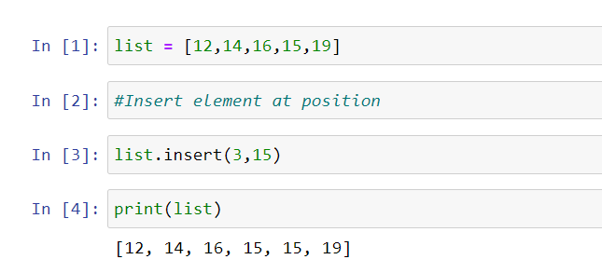

2)Delete first occurrence of integer

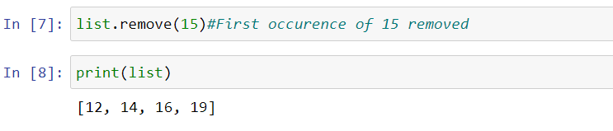

3)Append to end of list

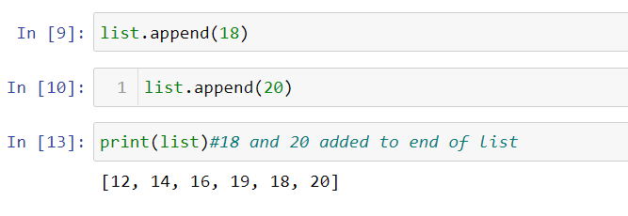

4)Sort the list

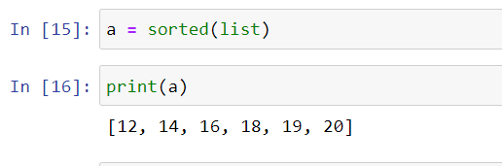

5)Pop the list

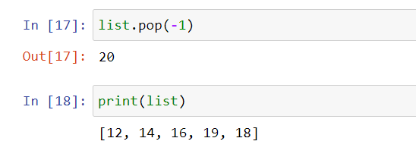

6)Reverse the list

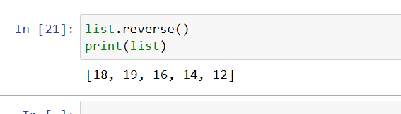

Q2)

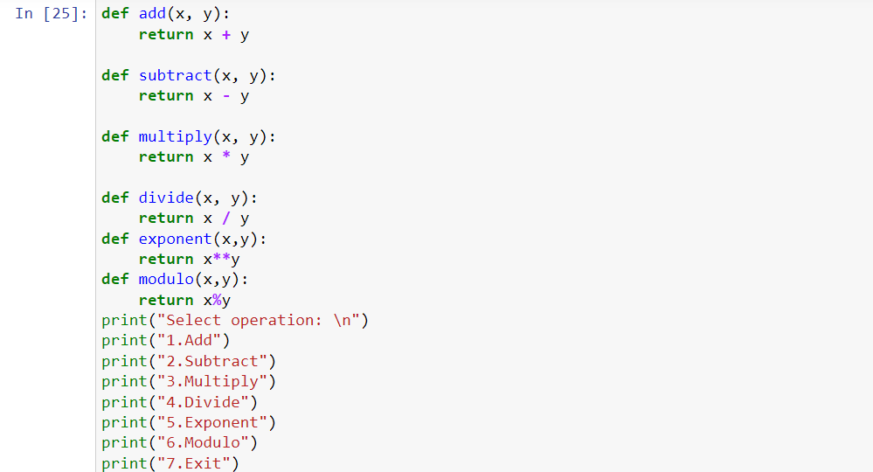

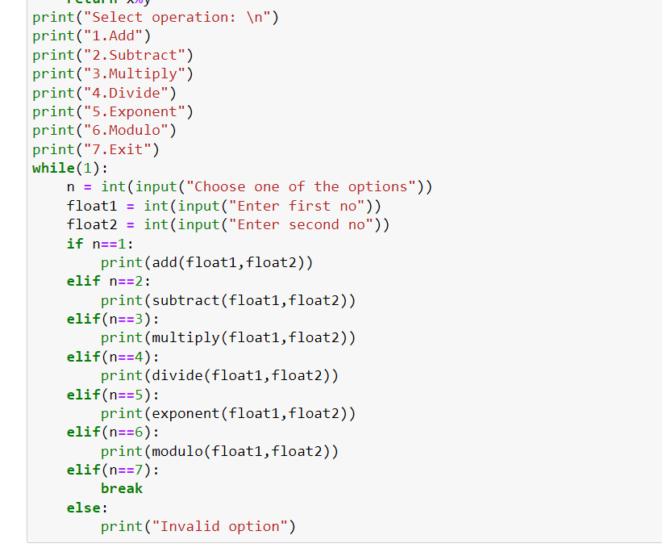

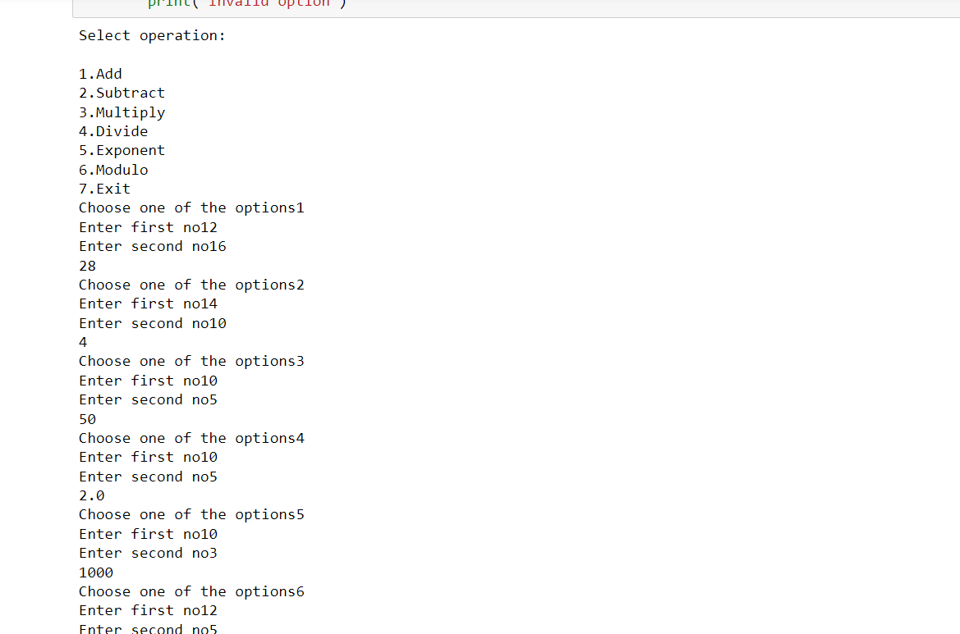

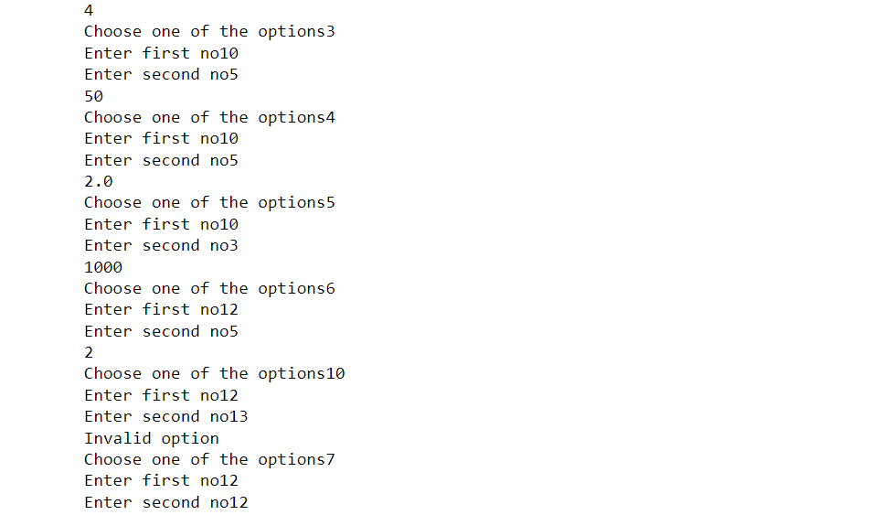

Q3)

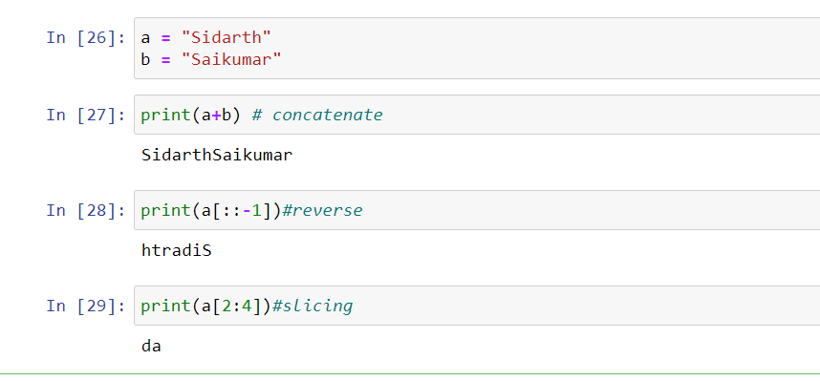

4)Why is python popular?

* Easy to learn and use
* Mature and supportive community
* Hundreds of python libraries and frameworks
* Versitality,effieciency,speed
* Big data,machine learning and cloud computing

5)Frameworks used in python are Django,Turbogears,CherryPy,Flask,Bottle,Web2py,Dash and Falcon

6)WSGI-Web Server Gate Interface