PRE REQUISTIES

PYTHON INSTALLATION IN WINDOWS 11

|  |  |
| --- | --- |
| **TEAM ID** | **PNT2022TMID53703** |
| **PROJECT NAME** | **IOT BASED SMART CROP PROTECTION SYSTEM FOR AGRICULTURE** |

**STEP 1:**

Download python 3.7.0 using <https://www.python.org/downloads/release/python-370/>this link.

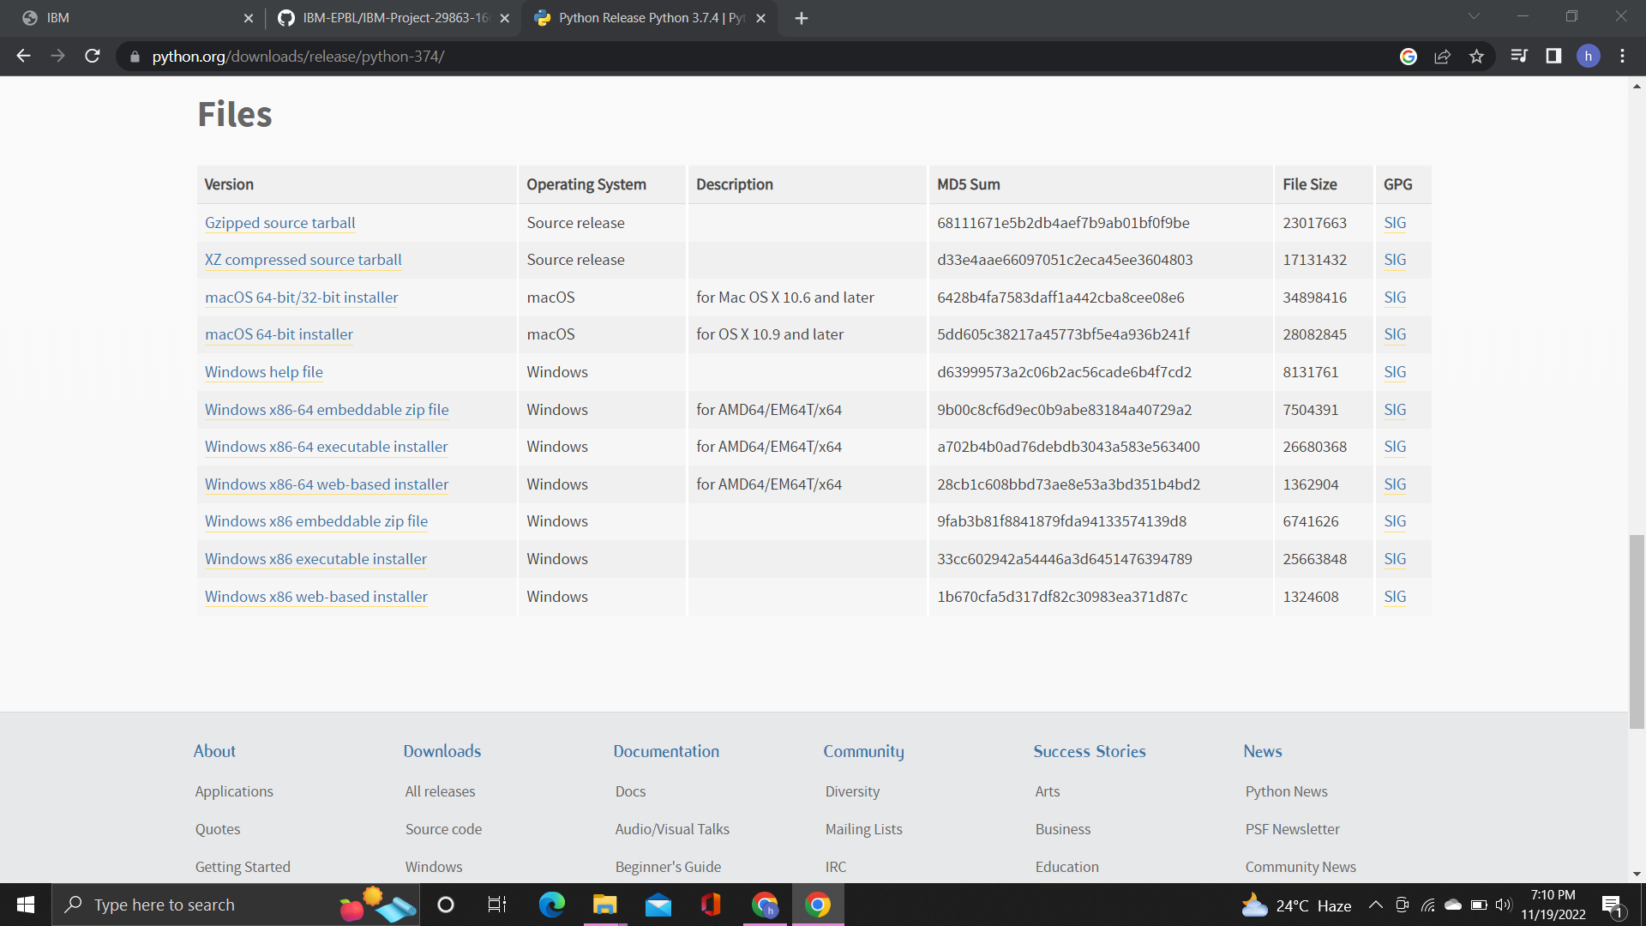

**STEP 2:**

Double click to install the python3.7.0 version and click next, then wait some time to install the software. Last it shows finish button to finish the installation.

Note: while installing please check add path 3.7.0 to path.

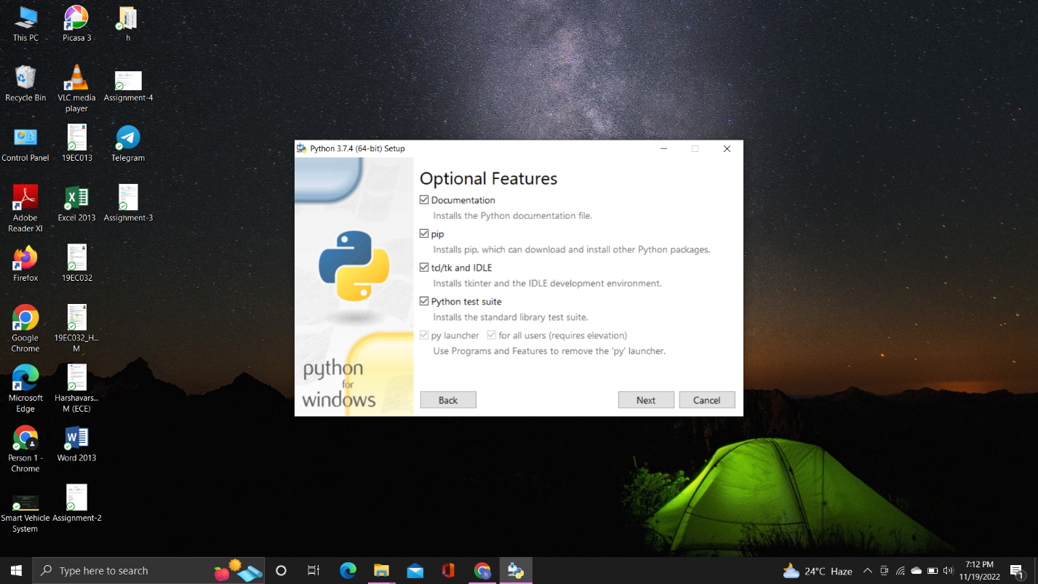

**STEP 3:**

Search IDLE in search bar then click IDLE (Python 3.7 64-bit) to open python IDLE.

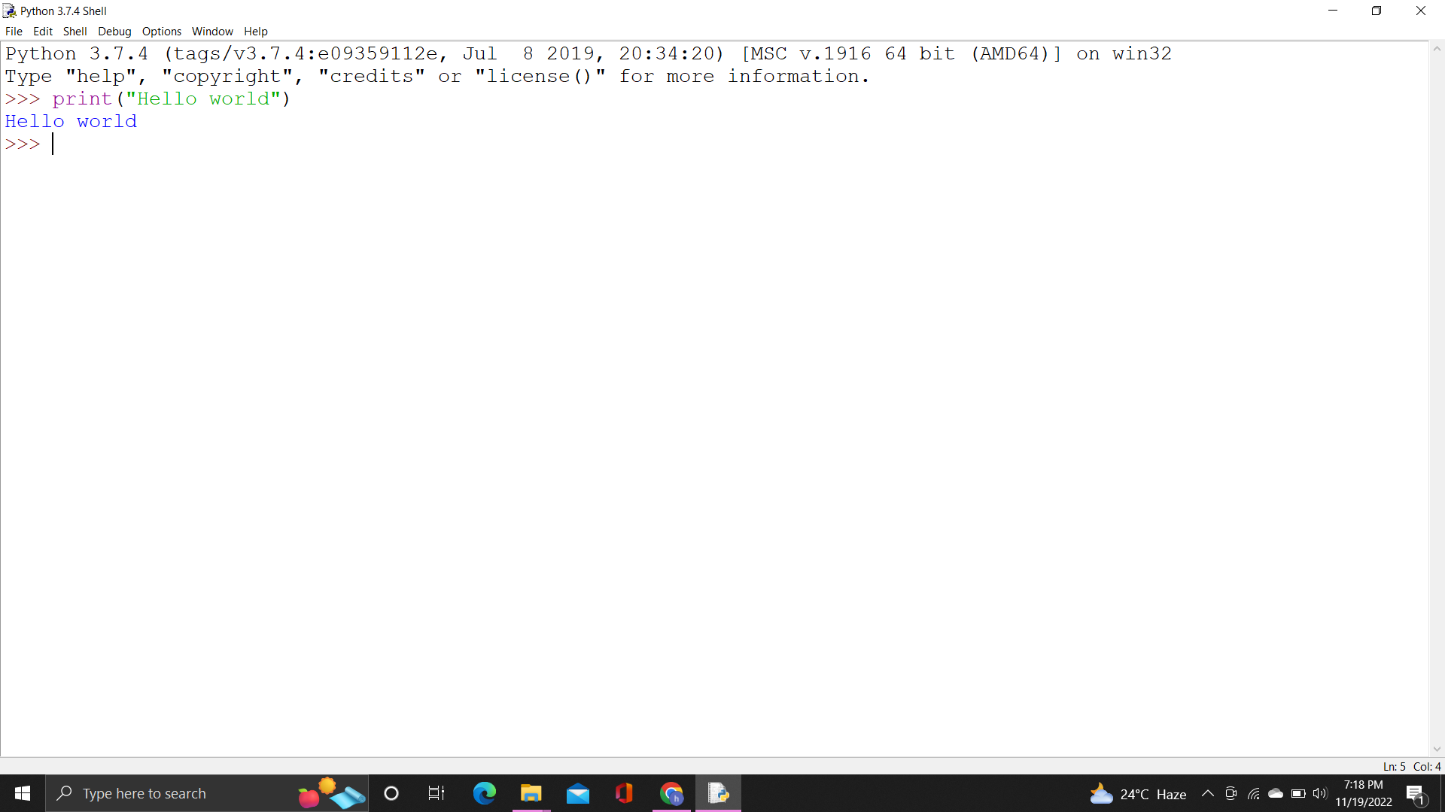

**STEP 4:**

Type python -m pip install –upgrade pip in cmd then enter to upgrade pip in python.

