Date:25.09.2022

Name:Nandhini B

Roll No:737919ITR050

**Assignment-2 Data Visualization and Preprocessing**

## Download the dataset from the source [link](https://drive.google.com/file/d/1_HcM0K8wt4b7FMLkc1V1dv0y6I_9ULzy/view)

About the dataset: This dataset is all about churn modelling of a credit company. It has the

details about the end user who are using credit card and also it has some variables to depicit the churn of the customer.

**RowNumber** - Serial number of the rows

**CustomerId** - Unique identification of customer

**Surname** - Name of the customer

**CreditScore** - Cipil score of the customer **Geography** - Location of the bank **Gender** - Sex of the customer

**Age** - Age of the customer

**Tenure** - Repayment period for the credit amount

**Balance** - Current balance in thier creidt card

**NumOfProducts** - Products owned by the customer from the company

**HasCrCard** - Has credit card or not (0 - no , 1 - yes)

**IsactiveMember** - Is a active member or not List item

**EstimatedSalary** - Salary of the customer

**Exited** - Churn of the customer

import warnings

warnings.filterwarnings("ignore")

import pandas as pd import numpy as np

import seaborn as sns

import matplotlib.pyplot as plt

# Loading the dataset

df = pd.read_csv("Churn_Modelling.csv")

df.head()

|  |  |  |  |  |  |  |  |  |
| --- | --- | --- | --- | --- | --- | --- | --- | --- |
| **RowNumber** | **CustomerId** | **Surname** | **CreditScore** | **Geography** | **Gender** | **Age** | **Tenure** | **Ba** |
| **0** 1 | 15634602 | Hargrave | 619 | France | Female | 42 | 2 |  |
| **1** 2 | 15647311 | Hill | 608 | Spain | Female | 41 | 1 | 838 |
| **2** 3 | 15619304 | Onio | 502 | France | Female | 42 | 8 | 1596 |
| **3** 4 | 15701354 | Boni | 699 | France | Female | 39 | 1 |  |
| **4** 5 | 15737888 | Mitchell | 850 | Spain | Female | 43 | 2 | 1255 |

# Performing Visualizations

### Univariate Analysis

#checking for categorical variables

category = df.select_dtypes(include=[np.object]) print("Categorical Variables: ",category.shape[1])

#checking for numerical variables

numerical = df.select_dtypes(include=[np.int64,np.float64]) print("Numerical Variables: ",numerical.shape[1])

Categorical Variables: 3

Numerical Variables: 11

df.columns

Index(['RowNumber', 'CustomerId', 'Surname', 'CreditScore', 'Geography',

'Gender', 'Age', 'Tenure', 'Balance', 'NumOfProducts', 'HasCrCard', 'IsActiveMember', 'EstimatedSalary', 'Exited'],

dtype='object')

df.shape

(10000, 14)

credit = df['CreditScore']

credit.plot(kind="hist",figsize=(7,4))

<matplotlib.axes._subplots.AxesSubplot at 0x7fc976a55210>

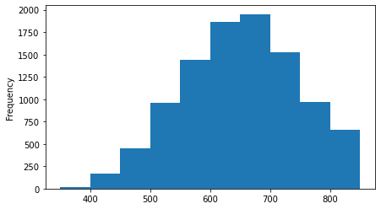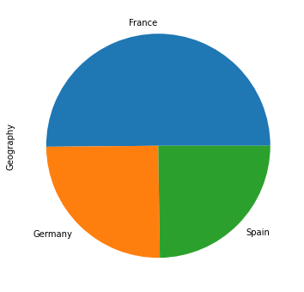

geo = df['Geography'].value_counts() geo.plot(kind="pie",figsize=(8,6))

<matplotlib.axes._subplots.AxesSubplot at 0x7fc97696e110>

sns.countplot(df['Gender'])

<matplotlib.axes._subplots.AxesSubplot at 0x7fc9769e2dd0>

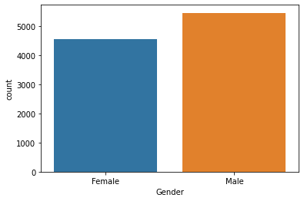

sns.distplot(df['Age'],hist=False)

<matplotlib.axes._subplots.AxesSubplot at 0x7fc97692be90>

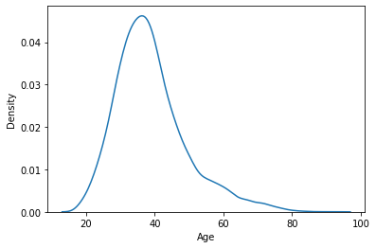

plt.figure(figsize=(8,6))

sns.countplot(df['Tenure'])

<matplotlib.axes._subplots.AxesSubplot at 0x7fc9767ab590>

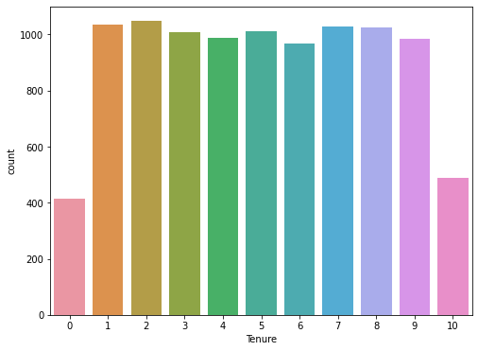

product = df['NumOfProducts'].value_counts() product.plot(kind="pie",figsize=(8,6))

<matplotlib.axes._subplots.AxesSubplot at 0x7fc9767abf50>

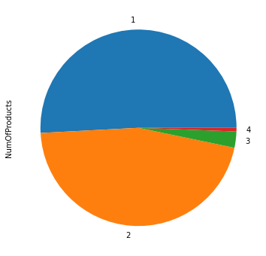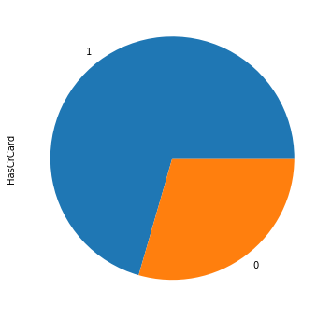

cr = df['HasCrCard'].value_counts() cr.plot(kind="pie",figsize=(8,6))

<matplotlib.axes._subplots.AxesSubplot at 0x7fc97671b3d0>

plt.figure(figsize=(7,4))

sns.countplot(df['IsActiveMember'])

<matplotlib.axes._subplots.AxesSubplot at 0x7fc976746d90>

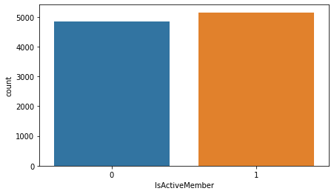

sns.distplot(df['EstimatedSalary'],hist=False)

<matplotlib.axes._subplots.AxesSubplot at 0x7fc976642510>

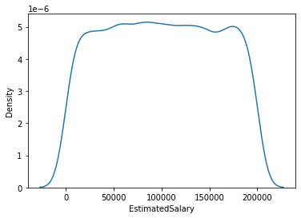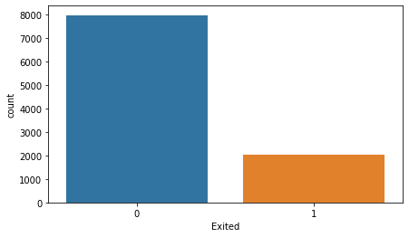

plt.figure(figsize=(7,4))

sns.countplot(df['Exited'])

<matplotlib.axes._subplots.AxesSubplot at 0x7fc97691ae50>

### Inference:

* 1. The data has 11 numerical variables and 3 categorical variables.
  2. It has 10000 rows and 14 columns
  3. The normalized credit score is around 700, More than 500 people have credit score greater than 800.
  4. France occupies 50% of customers, where as Germany and Spain shared equal.
  5. Dataset is dominated by Male Customers.
  6. Median age is around 40 to 45.
  7. Highest number of customer has thier tenure period for 2 years.
  8. Credit company has maximum customers, who uses single product.
  9. Most of the customer has credit card.
  10. More than 40% of the population is not an active member.
  11. The Churn is less compared to the satisfaction. Dataset is imbalanced.

### Bi-Variate Analysis

sns.barplot(x='Gender',y='CreditScore',hue='Geography',data=df)

<matplotlib.axes._subplots.AxesSubplot at 0x7fc97674d0d0>

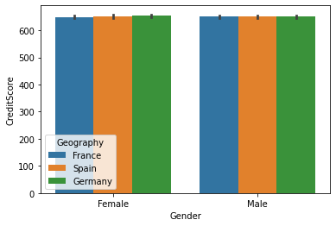

sns.violinplot(x='Geography',y='Balance',data=df)

<matplotlib.axes._subplots.AxesSubplot at 0x7fc976558550>

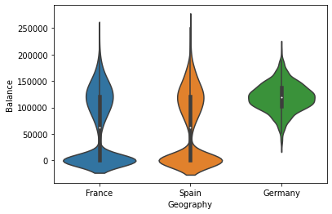

sns.violinplot(x='Geography',y='EstimatedSalary',data=df)

<matplotlib.axes._subplots.AxesSubplot at 0x7fc97647be50>

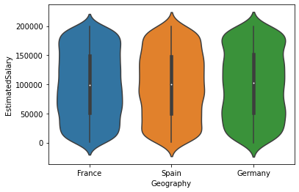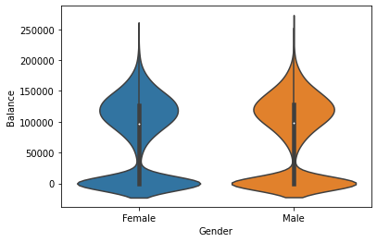

sns.violinplot(x='Gender',y='Balance',data=df)

<matplotlib.axes._subplots.AxesSubplot at 0x7fc9763f41d0>

sns.barplot(x='Exited',y='CreditScore',hue='Gender',data=df)

<matplotlib.axes._subplots.AxesSubplot at 0x7fc976403e90>

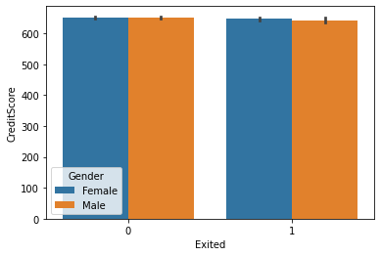

sns.barplot(x='Exited',y='CreditScore',hue='Geography',data=df)

<matplotlib.axes._subplots.AxesSubplot at 0x7fc9763d1090>

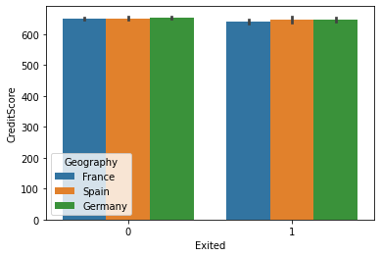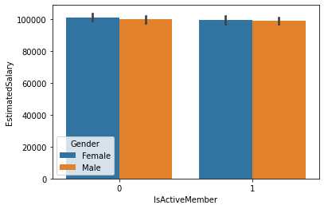

sns.barplot(x='IsActiveMember',y='EstimatedSalary',hue='Gender',data=df)

<matplotlib.axes._subplots.AxesSubplot at 0x7fc97626f4d0>

sns.barplot(x='Exited',y='Tenure',data=df)

<matplotlib.axes._subplots.AxesSubplot at 0x7fc9761f6d10>

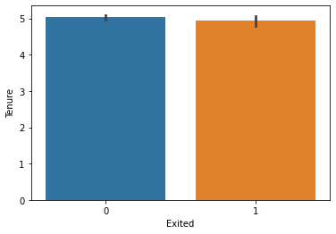

### Inference:

1. Credit score for Male is higher in Spain.
2. Average bank salary lies in the range of 100k to 150k.
3. Estimated salary is normalized and same for all country.
4. Credit score for churn is low.
5. Churn in Germany is higher compared to other countries.
6. Exited people tenure period is around 6 years.

### Multi-Variate Analysis

gp1 = df.groupby('Gender')['Geography'].value_counts() gp1.plot(kind='pie',figsize=(10,8))

print(gp1)

|  |  |  |
| --- | --- | --- |
| Gender  Female | Geography  France | 2261 |
|  | Germany | 1193 |
|  | Spain | 1089 |
| Male | France | 2753 |
|  | Spain | 1388 |
|  | Germany | 1316 |
| Name: | Geography, | dtype: int64 |

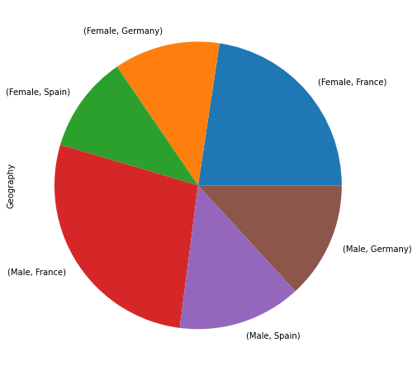

gp2 = df.groupby('Gender')['Age'].mean() print(gp2)

|  |  |
| --- | --- |
| Gender |  |
| Female | 39.238389 |
| Male | 38.658237 |

Name: Age, dtype: float64

gp3 = df.groupby(['Gender','Geography'])['Tenure'].mean() print(gp3)

|  |  |
| --- | --- |
| Gender Geography |  |
| Female France | 4.950022 |
| Germany | 4.965633 |

|  |  |
| --- | --- |
| Spain | 5.000000 |
| Male France | 5.049401 |
| Germany | 5.050152 |
| Spain | 5.057637 |
| Name: Tenure, dtype: | float64 |

gp4 = df.groupby(['HasCrCard','IsActiveMember'])['Geography'].value_counts() gp4.plot(kind="bar",figsize=(8,5))

print(gp4)

|  |  |
| --- | --- |
| HasCrCard IsActiveMember Geography  0 0 France | 706 |
| Spain | 352 |
| Germany | 343 |
| 1 France | 765 |
| Spain | 404 |
| Germany | 375 |
| 1 0 France | 1717 |
| Germany | 918 |
| Spain | 813 |
| 1 France | 1826 |
| Spain | 908 |
| Germany | 873 |
| Name: Geography, dtype: int64 |  |

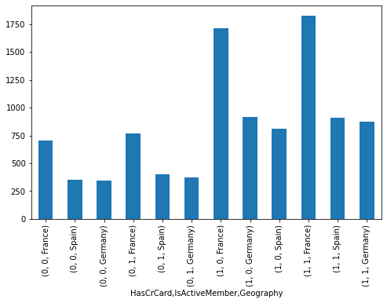

gp5 = df.groupby(['Gender','HasCrCard','IsActiveMember'])['EstimatedSalary'].mean() gp5.plot(kind="line",figsize=(8,6))

print(gp5)

|  |  |  |  |
| --- | --- | --- | --- |
| Gender  Female | HasCrCard  0 | IsActiveMember  0 | 102006.080352 |
|  |  | 1 | 102648.996944 |
|  | 1 | 0 | 101208.014567 |
|  |  | 1 | 98510.152300 |
| Male | 0 | 0 | 99756.431151 |
|  |  | 1 | 99873.931251 |
|  | 1 | 0 | 100353.378996 |
|  |  | 1 | 98914.378703 |

Name: EstimatedSalary, dtype: float64

gp6 = df.groupby(['Gender','IsActiveMember'])['Exited'].value_counts() gp6.plot(kind='bar',figsize=(8,6))

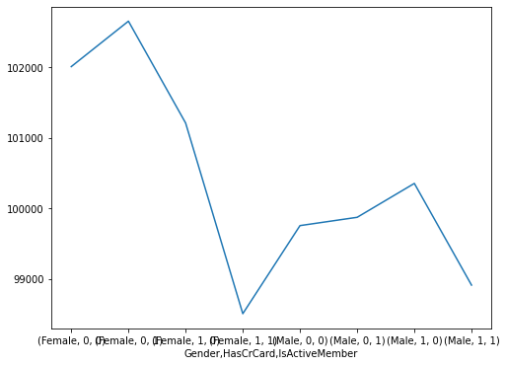

print(gp6)

|  |  |  |  |
| --- | --- | --- | --- |
| Gender  Female | IsActiveMember  0 | Exited  0 | 1534 |
|  |  | 1 | 725 |
|  | 1 | 0 | 1870 |
|  |  | 1 | 414 |
| Male | 0 | 0 | 2013 |

gp7 = df.groupby('Exited')['Balance','EstimatedSalary'].mean() print(gp7)

1 577

1 0 2546

1 321

Name: Exited, dtype: int64

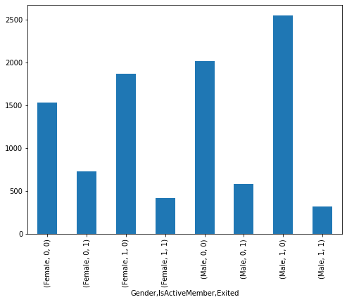

|  |  |  |
| --- | --- | --- |
| Exited | Balance | EstimatedSalary |
| 0 | 72745.296779 | 99738.391772 |
| 1 | 91108.539337 | 101465.677531 |

gp8 = df.groupby(['Geography','Exited'])['Gender'].value_counts() gp8.plot(kind='bar',figsize=(10,8))

print (gp8)

|  |  |  |  |
| --- | --- | --- | --- |
| Geography  France | Exited  0 | Gender  Male | 2403 |
|  |  | Female | 1801 |
|  | 1 | Female | 460 |
|  |  | Male | 350 |
| Germany | 0 | Male | 950 |
|  |  | Female | 745 |
|  | 1 | Female | 448 |

### Inference:

Male 366

Spain 0 Male 1206

Female 858

1 Female 231

Male 182

Name: Gender, dtype: int64

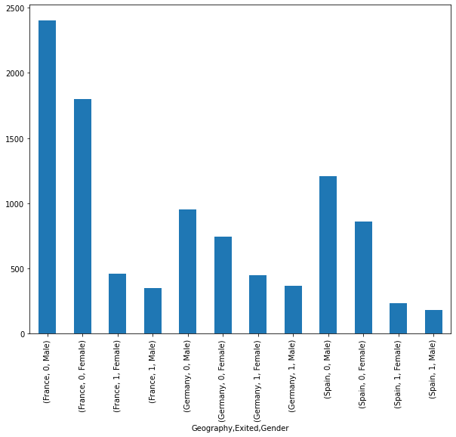

1. Germany has more female customers compared to male customers.
2. Average age of Male is 38, whereas average age of Female is 39.
3. Tenure period for both male and female is high in Spain.
4. It is observed that, those who have credit card are very active member in the company.
5. The estimated salary for a person who is not having credit card is high when compared to those having them.
6. Churn for inactive member is high compared to active member.
7. Those who churn has thier estimated salary very low.
8. France has the more churn rate.

# Performing descriptive statistics on dataset

|  |  |  |  |  |  |  |
| --- | --- | --- | --- | --- | --- | --- |
| df.describe().T | **count** | **mean** | **std** | **min** | **25%** |  |
| **RowNumber** | 10000.0 | 5.000500e+03 | 2886.895680 | 1.00 | 2500.75 | 5.00050 |
| **CustomerId** | 10000.0 | 1.569094e+07 | 71936.186123 | 15565701.00 | 15628528.25 | 1.56907 |
| **CreditScore** | 10000.0 | 6.505288e+02 | 96.653299 | 350.00 | 584.00 | 6.52000 |
| **Age** | 10000.0 | 3.892180e+01 | 10.487806 | 18.00 | 32.00 | 3.70000 |
| **Tenure** | 10000.0 | 5.012800e+00 | 2.892174 | 0.00 | 3.00 | 5.00000 |
| **Balance** | 10000.0 | 7.648589e+04 | 62397.405202 | 0.00 | 0.00 | 9.71985 |
| **NumOfProducts** | 10000.0 | 1.530200e+00 | 0.581654 | 1.00 | 1.00 | 1.00000 |
| **HasCrCard** | 10000.0 | 7.055000e-01 | 0.455840 | 0.00 | 0.00 | 1.00000 |
| **IsActiveMember** | 10000.0 | 5.151000e-01 | 0.499797 | 0.00 | 0.00 | 1.00000 |
| **EstimatedSalary** | 10000.0 | 1.000902e+05 | 57510.492818 | 11.58 | 51002.11 | 1.00193 |
| **Exited** | 10000.0 | 2.037000e-01 | 0.402769 | 0.00 | 0.00 | 0.00000 |

1. **Handle the Missing values**

df.isnull().sum()

RowNumber 0

CustomerId 0

Surname 0

CreditScore 0

Geography 0

Gender 0

Age 0

Tenure 0

Balance 0

NumOfProducts 0

HasCrCard 0

IsActiveMember 0

EstimatedSalary 0

Exited 0

dtype: int64

There is no missing value in dataset

# Finding the outliers and replacing it

def replace_outliers(df, field_name):

Q1 = np.percentile(df[field_name],25,interpolation='midpoint') Q3 = np.percentile(df[field_name],75,interpolation='midpoint')

IQR = Q3-Q1

maxi = Q3+1.5*IQR mini = Q1-1.5*IQR

df[field_name]=df[field_name].mask(df[field_name]>maxi,maxi) df[field_name]=df[field_name].mask(df[field_name]<mini,mini)

plt.title("Before removing outliers") sns.boxplot(df['CreditScore'])

plt.show()

plt.title("After removing outliers") replace_outliers(df, 'CreditScore') sns.boxplot(df['CreditScore'])

plt.show()

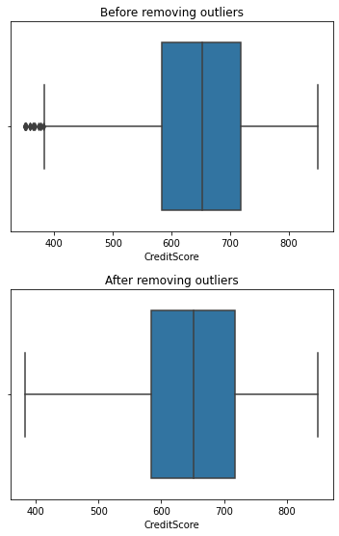

plt.title("Before removing outliers") sns.boxplot(df['Age'])

plt.show()

plt.title("After removing outliers") replace_outliers(df, 'Age')

sns.boxplot(df['Age']) plt.show()

sns.boxplot(df['Balance'])

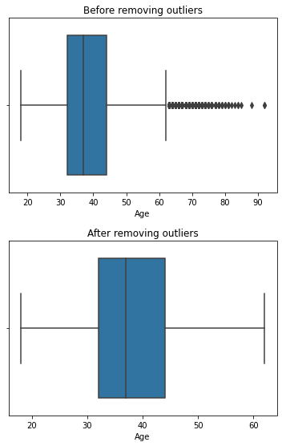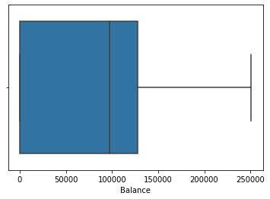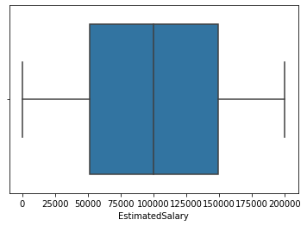

<matplotlib.axes._subplots.AxesSubplot at 0x7fc95ba3cf50>

sns.boxplot(df['EstimatedSalary'])

<matplotlib.axes._subplots.AxesSubplot at 0x7fc95b94a790>

The Outliers from Age and Credit Score columns are removed.

# Check for categorical column and perform encoding

from sklearn.preprocessing import LabelEncoder le = LabelEncoder()

df['Gender'] = le.fit_transform(df['Gender'])

df['Geography'] = le.fit_transform(df['Geography'])

df.head()

|  |  |  |  |  |  |  |  |  |
| --- | --- | --- | --- | --- | --- | --- | --- | --- |
| **RowNumber** | **CustomerId** | **Surname** | **CreditScore** | **Geography** | **Gender** | **Age** | **Tenure** | **Ba** |
| **0** 1 | 15634602 | Hargrave | 619.0 | 0 | 0 | 42.0 | 2 |  |
| **1** 2 | 15647311 | Hill | 608.0 | 2 | 0 | 41.0 | 1 | 83 |
| **2** 3 | 15619304 | Onio | 502.0 | 0 | 0 | 42.0 | 8 | 159 |
| **3** 4 | 15701354 | Boni | 699.0 | 0 | 0 | 39.0 | 1 |  |
| **4** 5 | 15737888 | Mitchell | 850.0 | 2 | 0 | 43.0 | 2 | 125 |

Only two columns Gender and Geography is label encoded.

**Removing unwanted columns and checking for feature importance**

df = df.drop(['RowNumber','CustomerId','Surname'],axis=1)

df.head()

|  |  |  |  |  |  |  |  |
| --- | --- | --- | --- | --- | --- | --- | --- |
| **CreditScore** | **Geography** | **Gender** | **Age** | **Tenure** | **Balance** | **NumOfProducts** | **HasCrCard** |
| **0** 619.0 | 0 | 0 | 42.0 | 2 | 0.00 | 1 | 1 |
| **1** 608.0 | 2 | 0 | 41.0 | 1 | 83807.86 | 1 | 0 |
| **2** 502.0 | 0 | 0 | 42.0 | 8 | 159660.80 | 3 | 1 |
| **3** 699.0 | 0 | 0 | 39.0 | 1 | 0.00 | 2 | 0 |
| **4** 850.0 | 2 | 0 | 43.0 | 2 | 125510.82 | 1 | 1 |

plt.figure(figsize=(20,10))

df_lt = df.corr(method = "pearson")

df_lt1 = df_lt.where(np.tril(np.ones(df_lt.shape)).astype(np.bool)) sns.heatmap(df_lt1,annot=True,cmap="coolwarm")

<matplotlib.axes._subplots.AxesSubplot at 0x7fc95b0fefd0>

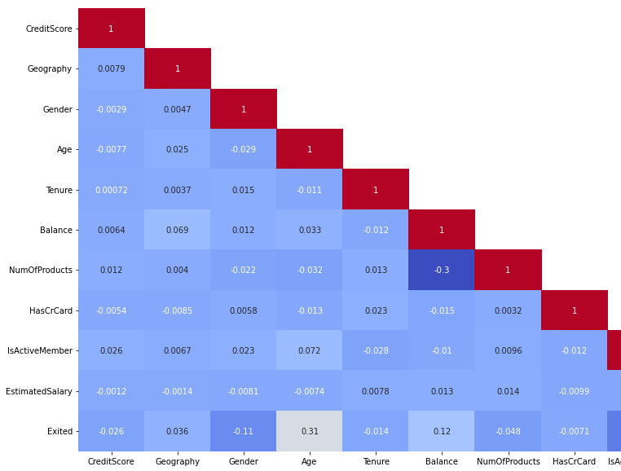

1. The Removed columns are nothing to do with model building.
2. Feature importance also checked using pearson correlation.

**8) Splitting the data into dependent and independent**

**variables**

target = df['Exited']

data = df.drop(['Exited'],axis=1)

print(data.shape)

print(target.shape)

(10000, 10)

(10000,)

# Scaling the independent variables

from sklearn.preprocessing import StandardScaler se = StandardScaler()

data['CreditScore'] = se.fit_transform(pd.DataFrame(data['CreditScore'])) data['Age'] = se.fit_transform(pd.DataFrame(data['Age']))

data['Balance'] = se.fit_transform(pd.DataFrame(data['Balance']))

data['EstimatedSalary'] = se.fit_transform(pd.DataFrame(data['EstimatedSalary']))

data.head()

|  |  |  |  |  |  |  |  |
| --- | --- | --- | --- | --- | --- | --- | --- |
| **CreditScore** | **Geography** | **Gender** | **Age** | **Tenure** | **Balance** | **NumOfProducts** | **HasCrC** |
| **0** -0.326878 | 0 | 0 | 0.342615 | 2 | -1.225848 | 1 |  |
| **1** -0.440804 | 2 | 0 | 0.240011 | 1 | 0.117350 | 1 |  |
| **2** -1.538636 | 0 | 0 | 0.342615 | 8 | 1.333053 | 3 |  |
| **3** 0.501675 | 0 | 0 | 0.034803 | 1 | -1.225848 | 2 |  |
| **4** 2.065569 | 2 | 0 | 0.445219 | 2 | 0.785728 | 1 |  |

## Splitting the data into training and testing

from sklearn.model_selection import train_test_split

X_train,X_test,y_train,y_test = train_test_split(data,target,test_size=0.25,random_state=1

print(X_train.shape) print(X_test.shape) print(y_train.shape) print(y_test.shape)

(7500, 10)

(2500, 10)

(7500,)

(2500,)

**Conclusion:** The model is scaled using StandarScaler method. The train and test split ratio is 15:5. As it is a classification problem, basic algorithms can be used to build ML models