Program we coded in arduino

int temppin=A0;//for the tempsensor working

float temp=0;

int piezoPin= 8;

float PIR=3;//for the pirsensor working

void setup() {

Serial.begin(9600);

pinMode(temppin,INPUT);

pinMode(PIR,INPUT);

pinMode(piezoPin,OUTPUT);

}

void loop() {

if(digitalRead(PIR)==HIGH){

digitalWrite(piezoPin,HIGH);

tone(piezoPin,1000);

delay(1000);

noTone(piezoPin);

Serial.println("Movement Detected");

}

double data=analogRead(temppin);

double n=data/1024;

double temp=((n\*5)-0.5)\*100;

Serial.print("temp: ");

Serial.println(temp);

if (temp >60) {

digitalWrite(piezoPin,HIGH);

tone(piezoPin,45,50);

Serial.println(" It's hot");

}

}

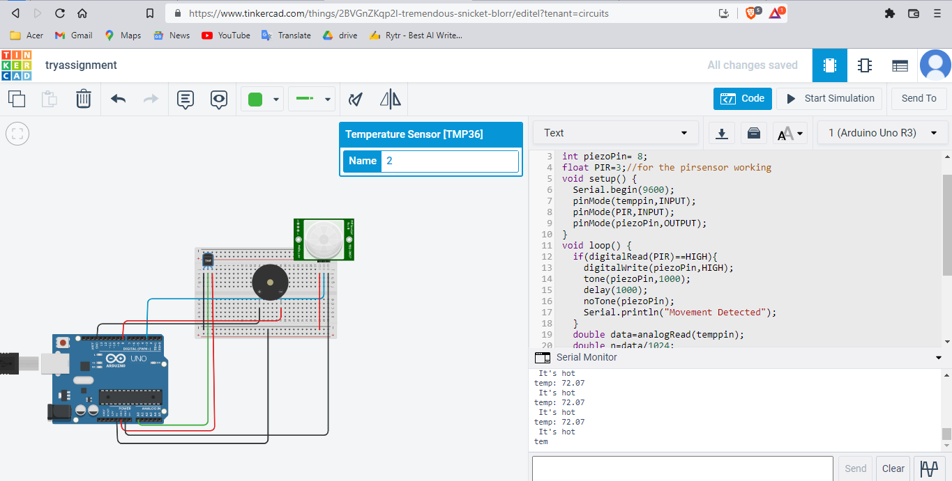

The code didn’t for the pir sensor, maybe the connection is wrong.