|  |  |
| --- | --- |
| Date | 21 October 2022 |
| Student Name | ARTHI.M |
| Student Register Number | 211419106035 |
| Maximum Marks | 2 Marks |

**WOKWI WEB URL:**

https://wokwi.com/projects/347856982420488786

**SNAPSHOTS OF SIMULATION:**

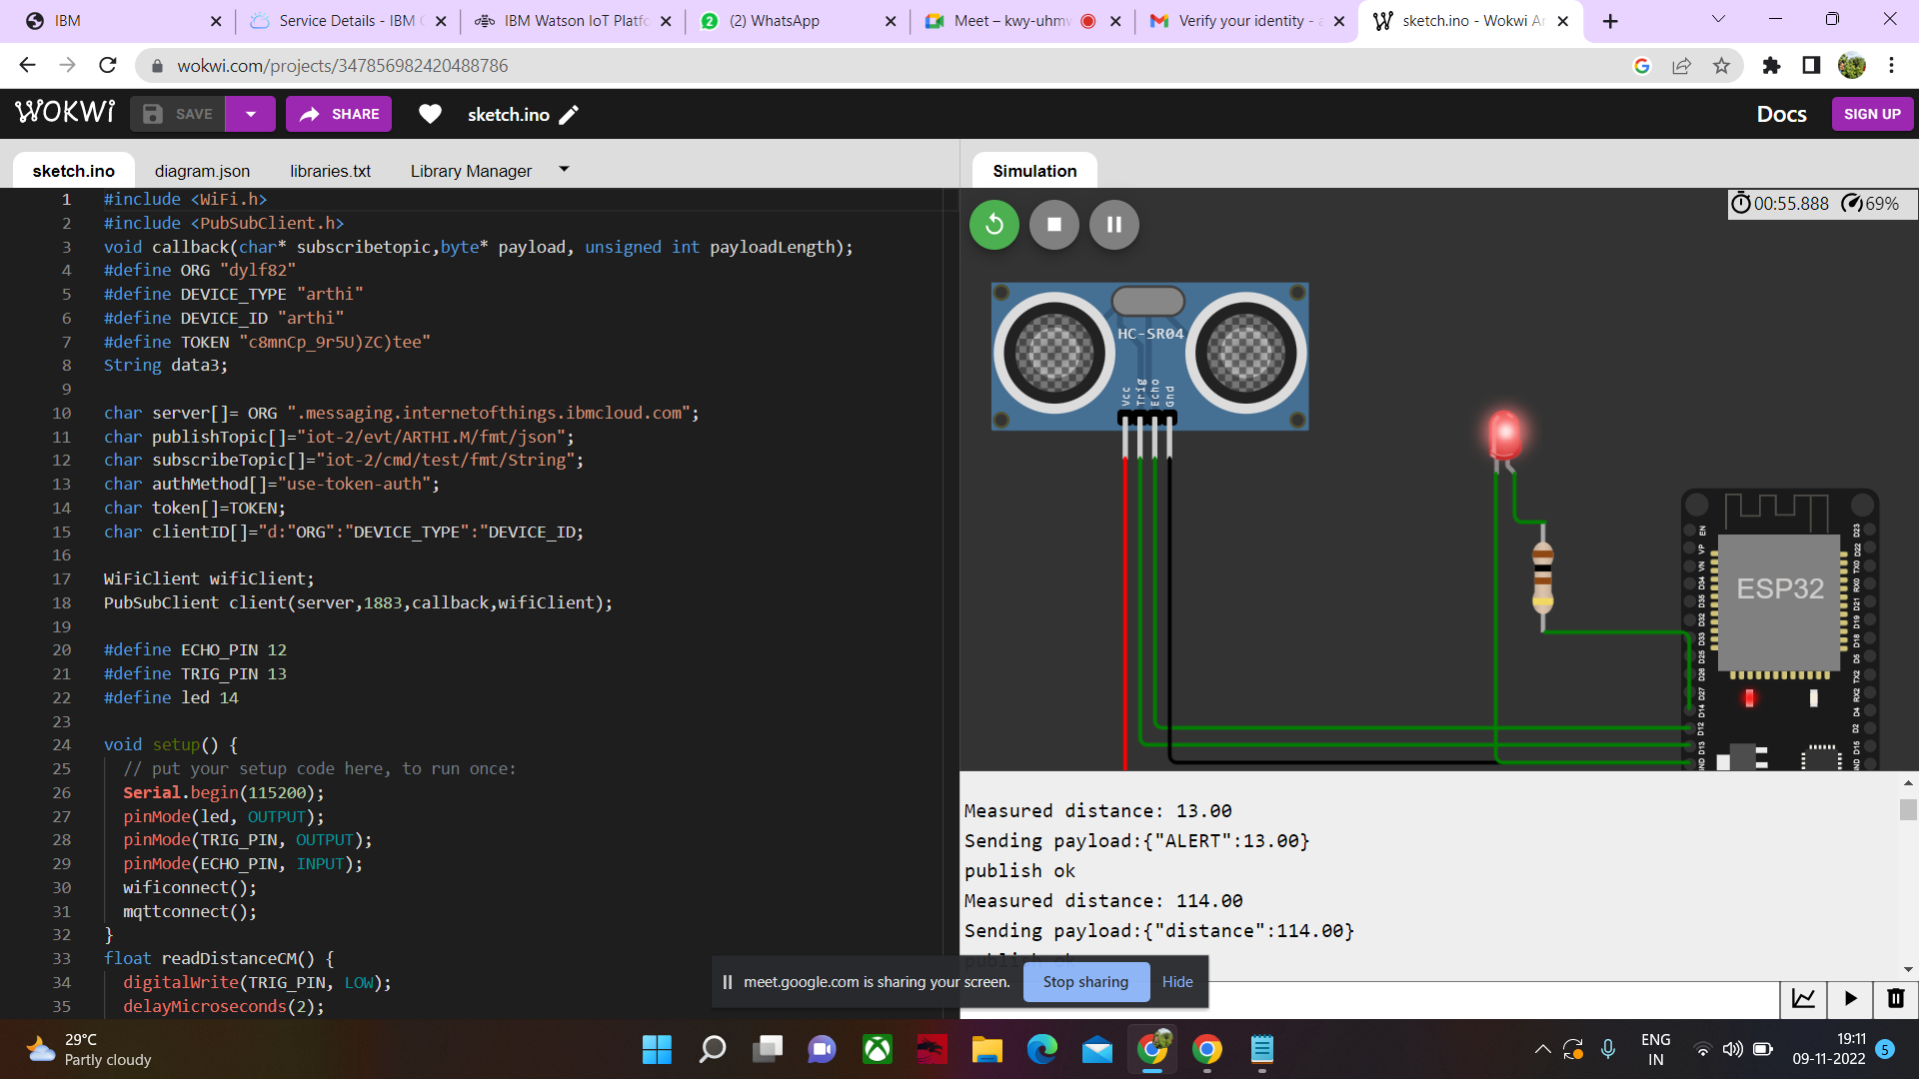

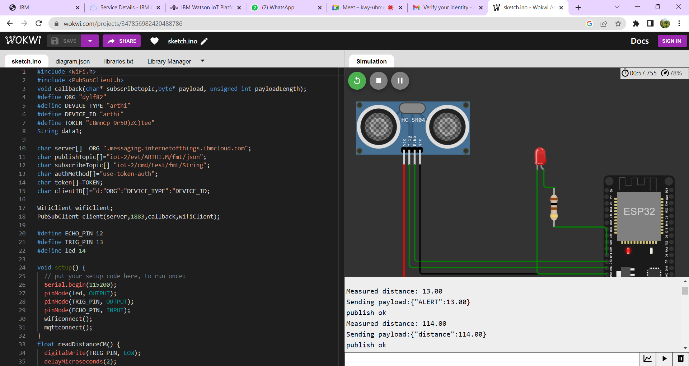

**IMAGES OF IBM CLOUD:**

