|  |  |
| --- | --- |
| Date | 21 October 2022 |
| Student Name | EVANGELINE.A |
| Student Register Number | 211419106081 |
| Maximum Marks | 2 Marks |

**WOKWI WEB URL:**

<https://wokwi.com/projects/347862475949998675>

**SNAPSHOTS OF SIMULATION:**

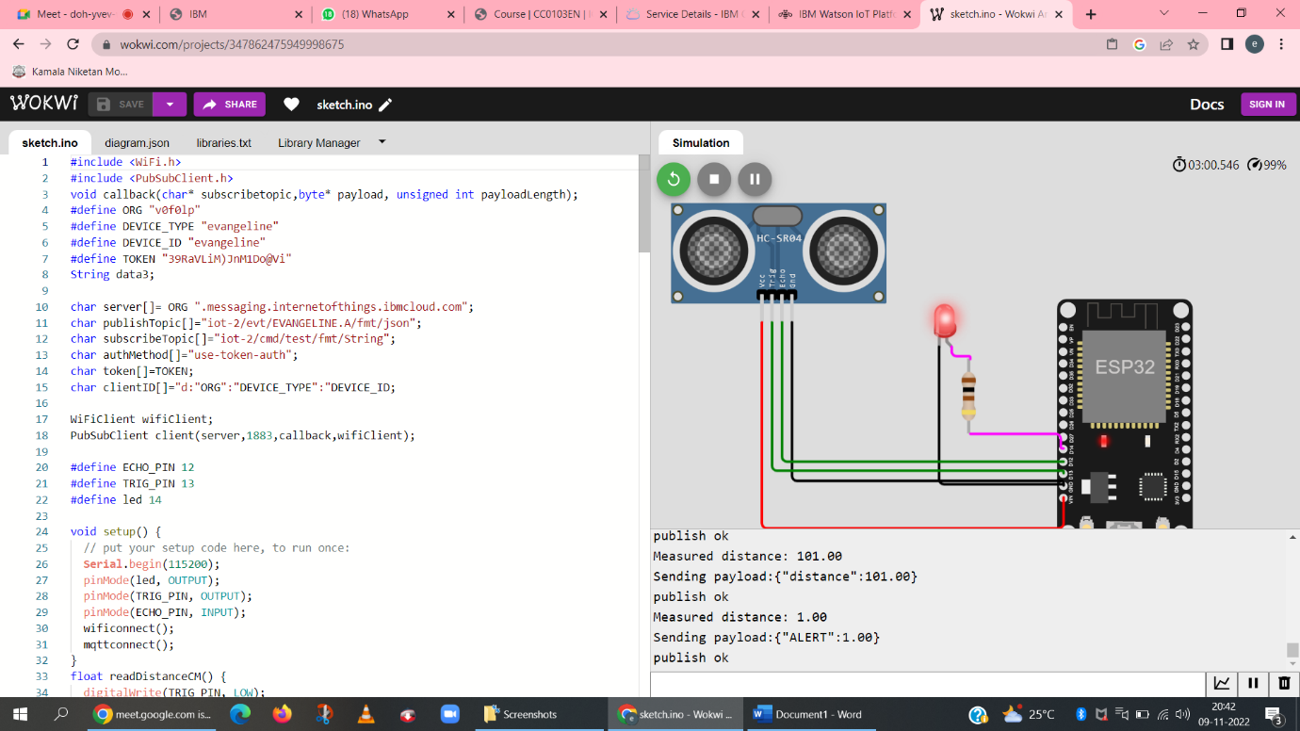

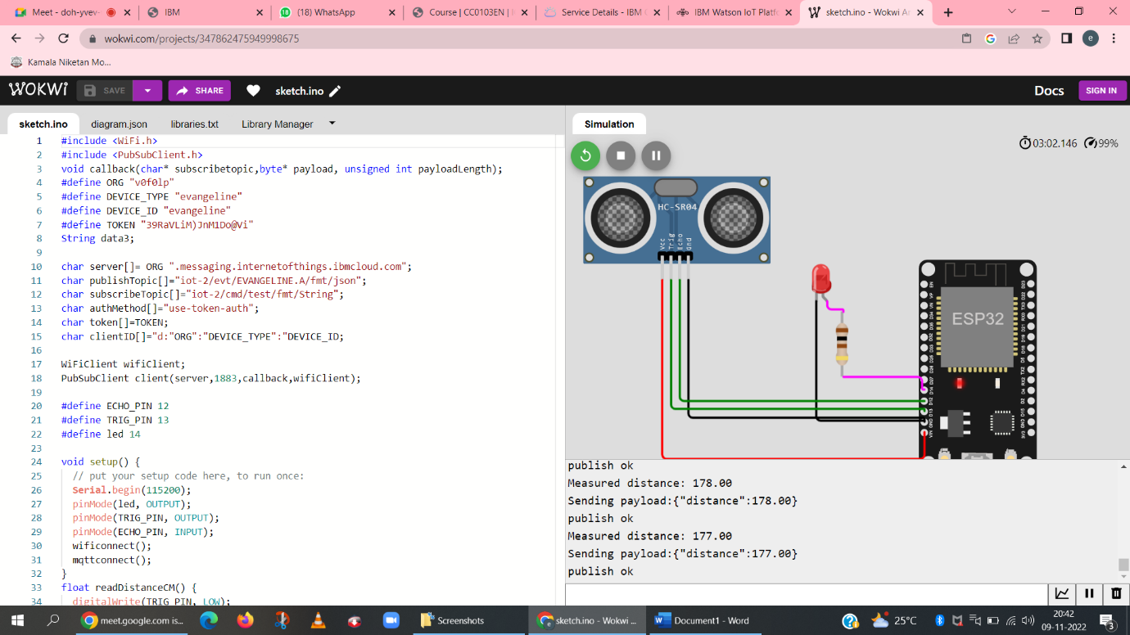

**IMAGES OF IBM CLOUD:**

