Assignment- 1

Domain :IOT

TOPIC :SMARTHOME

NAME. : Keerthivasan.R

REG.NUMBER :714019106047

COLLEGE :SRISHAKTHIINSTITUTEOFENGINEERINGANDTECHNOLOGY

SmartHome: Circuit:

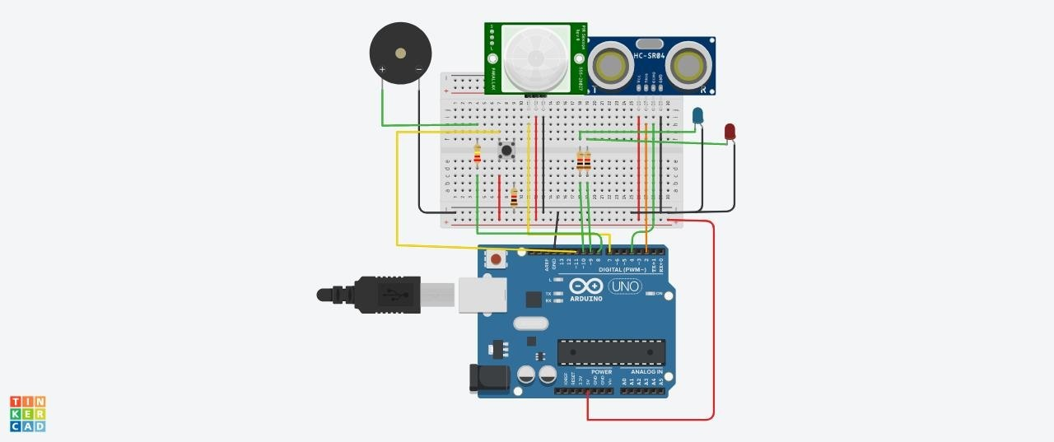

Components:

|  |  |
| --- | --- |
| Quantity | Components |
| 1 | PushButton |
| 1 | RedLED |
| 1 | BlueLED |
| 1 | PIEZOBuzzer |
| 1 | UltrasonicDistanceSenso r |
| 2 | PIR Sensor |
| 2 | Resistor(220,560,10K) |
| 1 | ArduinoR3 |

|  |  |
| --- | --- |
| 1 | BreadboardSmall |

Code:

const inttrigPin = 2; //thetrig pin of theultrasonic sensor; sends signalconstintechoPin=4;//theechopinoftheultrasonicsensor;detectssi gnal

constintpirPin=7;//thePIRsensorpin

intpirState=LOW;//basicallymeansthatthePIRsensorstartsaslowandde tectsnomotion

constintbuzzerPin=8;//thebuzzerhasbeenconnectedtopin8

constintredLED=9;//theredLED;intensitycanbecontrolledtochangethecolour emitted

intredBright=0; //howbrighttheLEDis intredFade=5; //howmanypointstofadetheLEDby

constintgreenLED=10;//thegreenLED;intensitycanbecontrolledtochangethe colouremitted

intgreenBright=0; //howbrighttheLEDis intgreenFade=5; //howmanypointstofadetheLEDby

constintbutton=13;//buttontomomentarilyresetallthesensorsbacktono rmal

voidsetup(){

pinMode(echoPin,INPUT);

pinMode(pirPin,INPUT);pinMod e(button,INPUT);

pinMode(trigPin,OUTPUT);pinM ode(redLED,OUTPUT);pinMode (greenLED,OUTPUT);pinMode( buzzerPin,OUTPUT);

Serial.begin(9600);//initializeserialcommunicationat9600bitspersecond

}

voiddistance(){

longdurationInDigit;lon gdistanceInInches;

digitalWrite(trigPin, LOW); //setthis to LOW to start withdelayMicroseconds(2);//delayinmicrosecondsbetweendifferentcomm ands

digitalWrite(trigPin,HIGH);//here,thetrigpinsendssignalsorvibrationstobed etected

delayMicroseconds(10); digitalWrite(trigPin,LOW);//setthethetrigpinbacktolow

durationInDigit=pulseIn(echoPin, HIGH);distanceInInches=durationInDigit/74/2;

Serial.println(distanceInInches);

if(distanceInInches> 15 && distanceInInches< 30)

{digitalWrite(greenLED, HIGH);digitalWrite(redLED,LOW);

}

if (distanceInInches< 10)

{digitalWrite(redLED,HIGH);digitalWrite(gre enLED,LOW);

}

if(distanceInInches> 10 && distanceInInches< 15){digitalWrite(redLED, LOW);digitalWrite(greenLED,LOW);

}

if (distanceInInches< 5)

{digitalWrite(redLED,HIGH);t one(8,250,2000);

digitalWrite(greenLED,0);

}

if(distanceInInches> 5 && distanceInInches< 10){digitalWrite(redLED,HIGH);digitalWrite(buzze rPin,0);

digitalWrite(greenLED,0);

}

if(distanceInInches>30||distanceInInches<0){Serial.println("Distance Incalculable");

}

delay(500);

}

voidreset(){ if

(digitalRead(button),HIGH);digi talWrite(pirState,LOW);digital Write(redLED,LOW);digitalWrit e(greenLED,HIGH);digitalWrite( buzzerPin,0);

//digitalWrite(echoPin,0);

}

voidloop(){

distance();

intpirState=digitalRead(pirPin);

if

(pirState==1){Serial.println("Motio nDetected!!!");digitalWrite(greenLE D,LOW);digitalWrite(redLED,HIGH);

digitalWrite(buzzerPin,1);delay (500);

}

if

(pirState==0){Serial.println("D etecting...");digitalWrite(green LED,HIGH);digitalWrite(redLE D,LOW);digitalWrite(buzzerPin, 0);delay(500);

}

}