**Assignment -2**

Python

Programming

| Assignment Date | 30 September 2022 |
| --- | --- |
| Project Name | Real-Time River Water Quality Monitoring and Control System |
| Team ID | PNT2022TMID23214 |
| Maximum Marks | 2 Marks |

**Question-1:**

**Build a python code, assume u get temperature and humidity values (generated with random function to a variable) and write a condition to continuously detect alarm in case of high temperature**.

**CODE:** import

random import os

for i in

range(30,70):

h=random.randint(55,65

)

t=random.randint(35,40)

temp= t humidity= h

print(t) print(h)

if(humidity>=65 or temp>=40 ):{

print("!! HIGH ALERT !!")

} else:{

print("Low

")

}

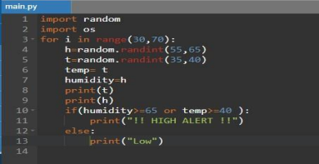**OUTPUT:**

